# Summary

Table 1. Summary of new detections of Delta Smelt (DSM) captured by the Lodi USFWS Office since the last Smelt Monitoring Team meeting. Further detail on each fish is included in the following tables depending on capture date. Fish that are crossed out are previously-reported fish that are no longer identified as DSM.

|  |  |  |  |  |  |
| --- | --- | --- | --- | --- | --- |
| **Sampling Method** | **New DSM Detections** | **Date** | **Region** | **Stratum** | **Fork Length (mm)** |
| EDSM 20mm | 1 | 05/08/2023 | West | Suisun Marsh | 7.1 |
| EDSM 20mm | 1 | 05/08/2023 | West | Suisun Marsh | 9.5 |
| EDSM 20mm | 1 | 05/08/2023 | West | Suisun Marsh | 10.0 |

EDSM WY2023 Delta Smelt total: **40**

Chipps Island WY2023 Delta Smelt total: **2**

# Enhanced Delta Smelt Monitoring Program

## 20mm

Table 2. Summary of all Delta Smelt (DSM) and Longfin Smelt (LFS) catch data from EDSM Phase 2 (20mm larval surface trawling) by week and life stage or mark type (L=larvae, J=juvenile, A=adult, M=marked). Survey week dates are defined in Table 3, fork length ranges used to designate life stage are defined in Table 4. Please see the EDSM daily report for fork length ranges and detailed sample data.

Total number of EDSM 20mm sites sampled: **40**

Week 41 20mm DSM abundance estimate: **599,217** with 95% CI (64,737; 2,380,828)

| **Survey Week** | **Stratum** | **# Sites** | **DSM Confirmed ID** | | | | **LFS Confirmed ID** | | |
| --- | --- | --- | --- | --- | --- | --- | --- | --- | --- |
| **L** | **J** | **A** | **M** | **L** | **J** | **A** |
| 36 | Suisun Bay | 5 | **1** | 0 | 0 | 0 | **4** | 0 | 0 |
| 36 | Suisun Marsh | 5 | 0 | 0 | 0 | 0 | 0 | **3** | 0 |
| 36 | Lower Sacramento | 10 | 0 | 0 | 0 | 0 | 0 | 0 | 0 |
| 36 | Cache Slough LI | 5 | 0 | 0 | 0 | 0 | 0 | 0 | 0 |
| 36 | Sac DW Ship Chan | 5 | 0 | 0 | 0 | 0 | **1** | 0 | 0 |
| 36 | Lower San Joaquin | 10 | 0 | 0 | 0 | 0 | 0 | 0 | 0 |
| 37 | Suisun Bay | 10 | **2** | 0 | 0 | 0 | **61** | **1** | 0 |
| 37 | Suisun Marsh | 10 | **1** | 0 | 0 | 0 | **11** | 0 | 0 |
| 37 | Lower Sacramento | 5 | 0 | 0 | 0 | 0 | **1** | 0 | 0 |
| 37 | Cache Slough LI | 5 | 0 | 0 | 0 | 0 | 0 | 0 | 0 |
| 37 | Sac DW Ship Chan | 5 | 0 | 0 | 0 | 0 | 0 | 0 | 0 |
| 37 | Lower San Joaquin | 5 | 0 | 0 | 0 | 0 | 0 | 0 | 0 |
| 38 | Suisun Bay | 5 | **1** | 0 | 0 | 0 | **132** | **4** | 0 |
| 38 | Suisun Marsh | 5 | **1** | 0 | 0 | 0 | **26** | 0 | 0 |
| 38 | Lower Sacramento | 5 | 0 | 0 | 0 | 0 | 0 | 0 | 0 |
| 38 | Cache Slough LI | 10 | 0 | 0 | 0 | 0 | 0 | 0 | 0 |
| 38 | Sac DW Ship Chan | 5 | 0 | 0 | 0 | 0 | 0 | 0 | 0 |
| 38 | Lower San Joaquin | 10 | 0 | 0 | 0 | 0 | 0 | 0 | 0 |
| 39 | Suisun Bay | 5 | **1** | 0 | 0 | 0 | **2** | 0 | 0 |
| 39 | Suisun Marsh | 5 | 0 | 0 | 0 | 0 | **4** | 0 | 0 |
| 39 | Lower Sacramento | 5 | 0 | 0 | 0 | 0 | 0 | 0 | 0 |
| 39 | Cache Slough LI | 10 | 0 | 0 | 0 | 0 | 0 | 0 | 0 |
| 39 | Sac DW Ship Chan | 5 | 0 | 0 | 0 | 0 | 0 | 0 | 0 |
| 39 | Lower San Joaquin | 6 | 0 | 0 | 0 | 0 | 0 | 0 | 0 |
| 40 | Suisun Bay | 5 | 0 | 0 | 0 | 0 | **35** | **4** | 0 |
| 40 | Suisun Marsh | 10 | 0 | 0 | 0 | 0 | **156** | **21** | 0 |
| 40 | Lower Sacramento | 10 | 0 | 0 | 0 | 0 | 0 | 0 | 0 |
| 40 | Cache Slough LI | 5 | **1** | 0 | 0 | 0 | 0 | 0 | 0 |
| 40 | Sac DW Ship Chan | 5 | **1** | 0 | 0 | 0 | 0 | 0 | 0 |
| 40 | Lower San Joaquin | 5 | 0 | 0 | 0 | 0 | 0 | 0 | 0 |
| 41 | Suisun Bay | 5 | 0 | 0 | 0 | 0 | **2** | **10** | 0 |
| 41 | Suisun Marsh | 10 | **3** | 0 | 0 | 0 | **111** | **46** | 0 |
| 41 | Lower Sacramento | 10 | 0 | 0 | 0 | 0 | 0 | 0 | 0 |
| 41 | Cache Slough LI | 5 | 0 | 0 | 0 | 0 | 0 | 0 | 0 |
| 41 | Sac DW Ship Chan | 5 | 0 | 0 | 0 | 0 | 0 | 0 | 0 |
| 41 | Lower San Joaquin | 5 | 0 | 0 | 0 | 0 | 0 | 0 | 0 |

All Delta Smelt <35mm collected during EDSM Phase 2 are preserved in 10% buffered formalin and returned to the Lodi FWO lab for lab identification. Unmarked Delta Smelt ≥35mm captured when tow temperatures are below 17°C are transferred alive to the UC Davis Fish Conservation and Culture Laboratory (FCCL) to contribute to Delta Smelt broodstock If tow temperatures are above 17°C, unmarked DSM (>35mm) are flash frozen in liquid nitrogen and transferred to the UC Davis Aquatic Health Program (UCD AHP) for processing. All marked DSM are flash frozen in liquid nitrogen and transferred to UC Davis for processing.

Table 3. EDSM 2023 Phase 2 (20mm larval surface trawling) week numbers and corresponding sample dates.

|  |  |
| --- | --- |
| **Survey Week** | **Survey Week Dates** |
| 36 | April 3–7, 2023 |
| 37 | April 10–14, 2023 |
| 38 | April 17–21, 2023 |
| 39 | April 24–28, 2023 |
| 40 | May 1–5, 2023 |
| 41 | May 8–12, 2023 |
| 42 | May 15–19, 2023 |
| 43 | May 22–26, 2023 |
| 44 | May 29–June 2, 2023 |
| 45 | June 5–9, 2023 |
| 46 | June 12–16, 2023 |
| 47 | June 19–23, 2023 |
| 48 | June 26–30, 2023 |

Table 4. Fork length ranges for life stages of Delta Smelt and Longfin Smelt as defined by the Interagency Ecological Program.

|  |  |  |  |
| --- | --- | --- | --- |
| **Species** | **Larvae** | **Juvenile** | **Adult** |
| Delta Smelt | <20mm | 20–58mm | >58mm |
| Longfin Smelt | <20mm | 20–84mm | >84mm |

**Week 41:**

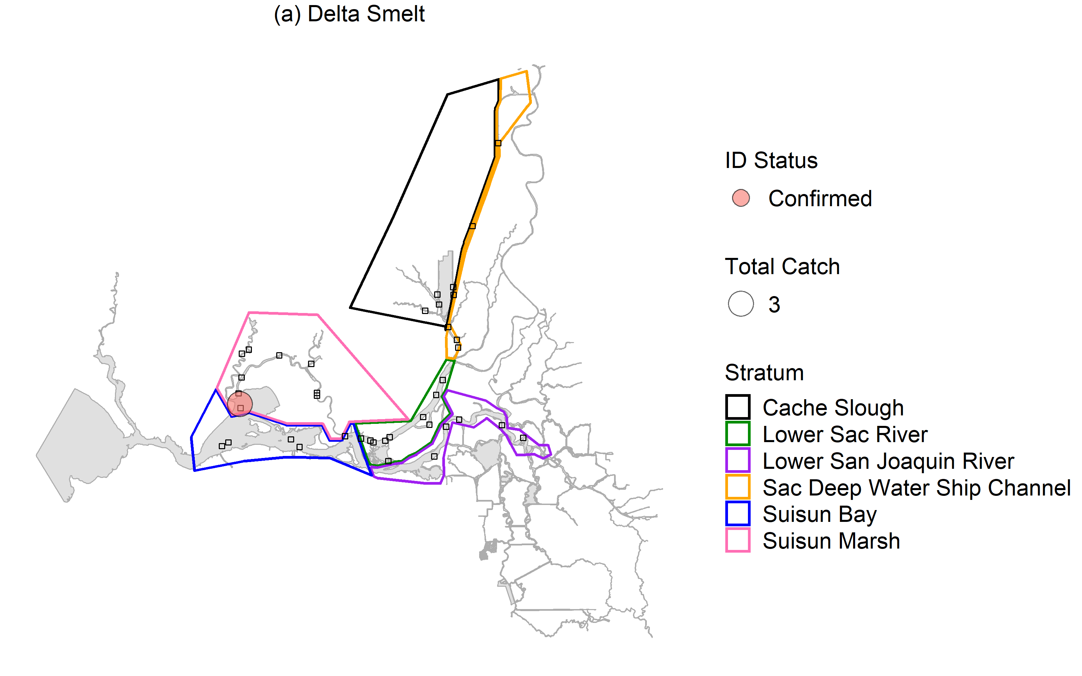

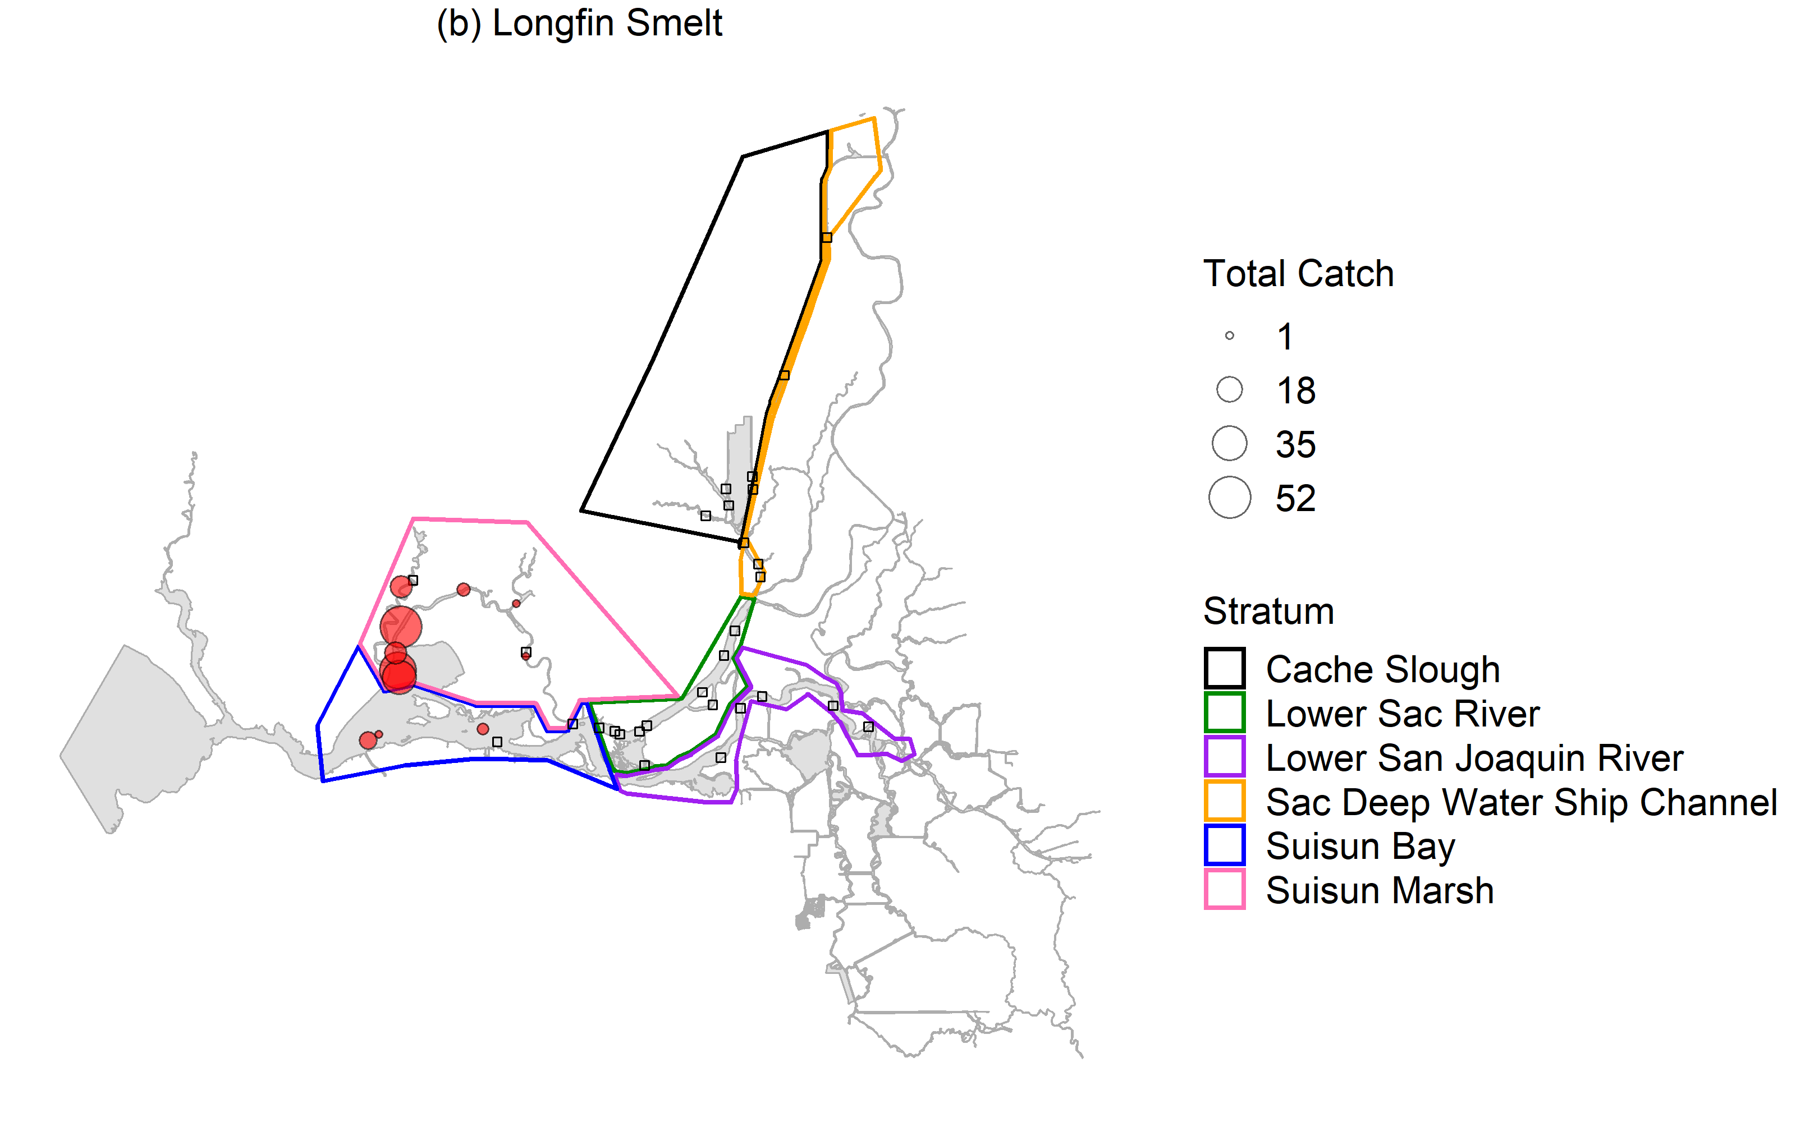

Figure 1. Delta Smelt (a) and Longfin Smelt (b) catch by station as of current processing levels for EDSM 2023 Phase 2 20mm trawls from survey week 41 (5/8–5/12/2023). Delta Smelt catch is differentiated between primary and confirmed ID status. Sites with no Delta Smelt or Longfin Smelt catch are indicated with squares.

**Chipps Island**

Table 5. Delta Smelt (DSM) and Longfin Smelt (LFS) catch in Chipps Island midwater trawls from 5/15, 5/18, and 5/19/23. These data are preliminary and subject to change. If the table is blank, there were no DSM or LFS detections.

Total number of tows sampled: 30

| **Date** | **Station Code** | **Species** | **Mark Type** | **Fork Length** | **Total Catch** | **Disposition** |
| --- | --- | --- | --- | --- | --- | --- |