Reclamation logo non-interactive

Final Environmental Assessment

###### 

###### **Sacramento Deep Water Ship Channel Nutrient Enrichment Project: Phase 2**



|  |
| --- |
| **Mission Statements**  The mission of the Department of the Interior is to protect and provide access to our Nation’s natural and cultural heritage and honor our trust responsibilities to Indian Tribes and our commitments to island communities.  The mission of the Bureau of Reclamation is to manage, develop, and protect water and related resources in an environmentally and economically sound manner in the interest of the American public. |

Table of Contents

Table of Contents iii

List of Tables iii

List of Appendices iii

List of Acronyms and Abbreviations iii

Section 1 Introduction 1

**1.1** **Background** 1

**1.2** **Purpose and Need for the Project** 7

Section 2 Alternatives Including the Proposed Action 8

**2.1** **No Action Alternative** 8

**2.2** **Proposed Action Alternative** 8

2.2.1 Monitoring Plan 11

Section 3 Affected Environment and Environmental Consequences 13

**3.1** **Biological Resources** 13

**3.1.1** **Affected Environment** 13

**3.1.2** **Environmental Consequences** 19

3.2 Hydrology and Water Quality 20

3.2.1 Affected Environment 20

3.2.2 Environmental Consequences 20

3.3 Recreation 22

3.3.1 Affected Environment 22

3.3.2 Environmental Consequences 22

3.4 Environmental Commitments 23

3.5 Cumulative Effects 23

Section 4 Consultation and Coordination 24

**4.0** **Public Review Period** 24

**4.1** **Federal Laws, Regulations, and Policies** 24

Section 5 References 25

**List of Tables**

**Table 1 – Special Status Species List** 15

**List of Appendices**

**List of Acronyms and Abbreviations**

µg/L microgram/Liter

µS/cm microsiemens/cm  
BMP Best Management Practices

CEQ Council on Environmental Quality

CFR Code of Federal Regulations

CNDDB California Natural Diversity Database

CNPS California Native Plant Society  
CRF California Red-legged Frog  
CV Central Valley

CVP Central Valley Project

CWA Clean Water Act

DIN Dissolved Inorganic Nitrate

DOC Dissolved Organic Carbon  
DPS Distinct Population Segments

EA Environmental Assessment

EFH Essential Fish Habitat

ESA Endangered Species Act  
GGS Giant Garter Snake

IEP Interagency Ecological Program  
IPaC Service Information for Planning and Conservation website

ITA Indian Trust Assets  
LAA May Affect, and Likely to Adversely Affect

MBTA Migratory Bird Treaty Act  
MGD million gallons per day  
M&I Municipal and Industrial  
NE No Effect

NEPA National Environmental Policy Act

NH4-N Ammonium-as nitrogen  
NHPA National Historic Preservation Act  
NLAA Not Likely to Adversely Affect

NL72 Navigation Light 72  
NL74 Navigation Light 74

NMFS National Marine Fisheries Service

NO3-NNitrate- as nitrogen  
NPDES National Pollutant Discharge Elimination System

NPPA Native Plant Protection Act

PO4-P Orthophosphate-as phosphorus

Quad Quadrangle

Reclamation Bureau of Reclamation

Service U.S. Fish and Wildlife Service

Si Silica

SHPO State Historic Preservation Officer

SSC Sacramento Deep Water Ship Channel

SWRCB State Water Resources Control Board

TSS Total Suspended Solids

TDN Total dissolved nitrogen

TDP Total dissolved phosphorus

TN Total nitrogen

TP Total phosphorus

USGS US Geological Survey

VOC Volatile Organic Compound

VSS Volatile Suspended Solids

WSP West Sacramento Port

1. **Introduction**

In conformance with the National Environmental Policy Act, 42 U.S.C. § 4431 et seq. (NEPA), as amended, the Bureau of Reclamation (Reclamation) has prepared this Environmental Assessment (EA) to evaluate and disclose potential environmental impacts associated with implementation of the Sacramento Deep Water Ship Channel Nutrient Enrichment Project (Proposed Action).

This EA describes the existing environmental resources in the project area, evaluates the impacts of the No Action and Proposed Action alternatives on the resources, and proposes measures to avoid, minimize, or mitigate any adverse impacts. This EA was prepared in accordance with NEPA, Council on Environmental Quality (CEQ) regulations (40 Code of Federal Regulations (CFR) 1500-1508), and Department of the Interior Regulations (43 CFR Part 46).

1. **Background**

Reclamation operates the Central Valley Project (CVP), a system of reservoirs, power plants, operable gates, pumping plants and canals that supply water for irrigation, municipal and industrial use and for wildlife refuges in the Central Valley. CVP operations are thought to contribute to the decline of delta smelt (*Hypomesus transpacificus*), an endemic fish listed as ‘threatened’ under the federal Endangered Species Act (ESA), by adversely affecting the extent and quality of its critical habitat. Under the Central Valley Project Improvement Act of 1992, Reclamation has the authority to fund activities that have the potential to reduce CVP impacts on smelt and their critical habitat and to undertake actions to improve Delta habitat conditions.

The background related to the proposed action is similar to the previous effort described in the Sacramento Deep Water Ship Channel: Nutrient Enrichment Project Environmental Assessment (EA) and Biological Assessment (BA), September 2018 (Phase 1), and is hereby incorporated by reference.

In October 2018, Reclamation partnered with the University of California-Davis (UCD) and the United States Geological Survey (USGS) to conduct a pilot, whole-system scale nitrogen enrichment experiment in the upper SSC (Loken et al 2019). The experiment was centered on Navigation Light 74 (NL 74) located in the ‘old’ water zone of the SSC. A 400 meter long stretch centered on NL 74 was enriched with nitrate by aerial application of calcium nitrate fertilizer using a crop duster. The goal was to add enough fertilizer to boost the concentration of inorganic nitrogen to the natural, pre-drawdown concentration of roughly 0.5 mg/L, thereby increasing the doubling rate of phytoplankton. In calculating how much fertilizer to add, however, it was assumed, based on the stable conductivity gradient, that the enriched plug would remain intact long enough to support measurably enhanced levels of primary production. This assumption turned out to be incorrect. Within 36 hours, tidal mixing completely dispersed the added fertilizer to the entire eight km-long reach encompassed by the monitoring plan (Figure 1). The resultant nitrate concentration was <0.05 mg/L and except for a possible uptick in net ecosystem productivity immediately after the application in the fertilized reach, the experiment had no statistically demonstrable effect on SSC plankton production (Loken et al 2019).

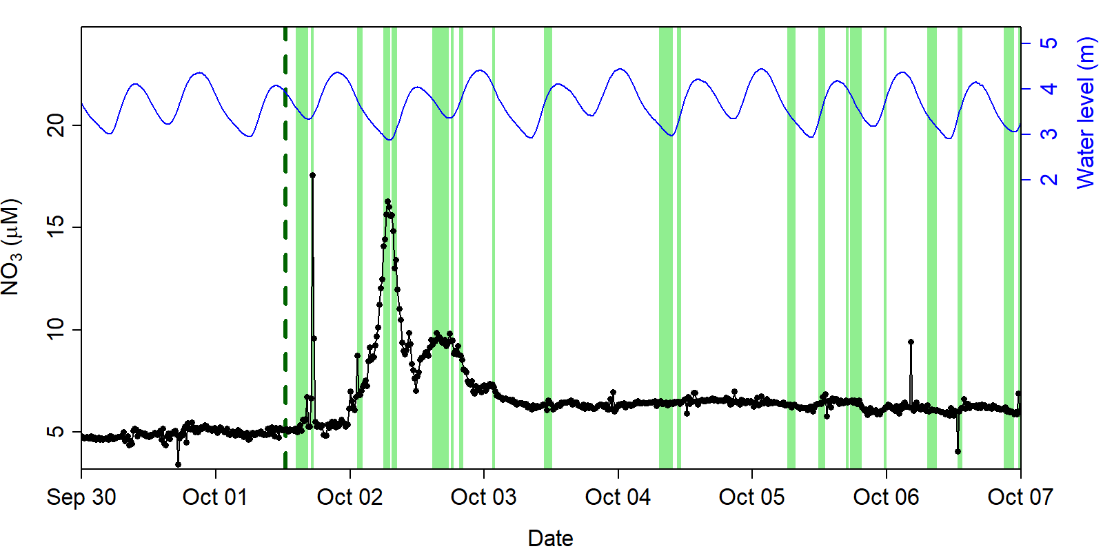

**Figure 1. Nitrate concentrations (black) and water level (blue) at Navigation Light 74 (NL74). The vertical line (Oct 1 ~13:00) represents the time the fertilizer was applied. Green vertical bands represent time intervals when it was expected that the fertilized segment would be located at NL74. During the first pass of the fertilized reach (Oct 1), only a few measurements of elevated nitrate were recorded. During the successive tidal cycles on Oct 2, there were two nitrate peaks coinciding with the times expected for the fertilizer reach to pass by the mooring. After Oct 3, successive pass of the fertilized segment did not align with elevated nitrate, suggesting it mixed longitudinally.**

**Purpose and Need for the Project**

The purpose of the Proposed Action is to determine if the addition of enough nitrogen to offset the effect of tidal dispersion can stimulate plankton (fish food organisms) production in the SCC. Determining if nitrogen fertilization can boost plankton production is an initial step in a broader effort to determine the potential ecological benefits of repairing the West Sacramento lock system sector gates that could then be operated to hydraulically reconnect the ship channel with the main stem Sacramento River. Functioning sector gates could be used to adaptively manage net flow of Sacramento River water down the ship channel to export ship channel plankton downstream, thereby stimulating plankton production in the north Delta.

The need for the action derives from the low production levels of phytoplankton biomass in the Bay-Delta ecosystem, contributing to a food-limited habitat for delta smelt.

1. **Alternatives Including the Proposed** **Action**

This EA considers two possible alternatives: the No Action Alternative and the Proposed Action. The No Action Alternative reflects future conditions without the Proposed Action and serves as a basis of comparison for determining potential impacts to the human environment that would result from implementation of the Proposed Action.

Identification of the reasonable range of alternatives for this EA was based upon consideration of the purpose and need. Additional alternatives were considered but eliminated due to them being substantially similar in design and impacts as the Proposed Action (40 C.F.R. § 1502.14(a)).

**2.1 No Action Alternative**

Under the No Action Alternative, Reclamation would not apply nitrogen into the SSC, nor would the broader effort of adaptively managing and exporting plankton to the north Delta occur. Regions of the Bay-Delta ecosystem and habitat for delta smelt would continue to be food-limited.

1. **Proposed Action Alternative**

In this second phase of the Project, Reclamation proposes to: (i) repeat the nitrogen enrichment experiment using multiple aerial applications under neap tide conditions over two four-day periods; and (ii) conduct two rhodamine dye experiments to quantify tidal dispersion under neap and spring tide conditions. The goal of the nitrogen enrichment experiment is to achieve high enough nitrate concentrations to stimulate a plankton bloom. The rhodamine dye results will be used to calibrate a hydrodynamic model that will be used to inform the design of future experiments and to evaluate alternative gate operation scenarios for managing water quality and food supply enhancement actions should the gates become operational.

## 2.2.1 Nitrogen enrichment experiments

As in the first nitrogen enrichment experiment conducted in 2018, the 2019 experiment will entail aerial applications of calcium nitrate fertilizer using a crop duster. As in the previous experiment, the experimental area will be centered at or near NL74, located in the upper SSC (Figure 5).

Unlike the 2018 experiment, which was conducted in early fall (October) without regard to tidal phase, the 2019 experiments will target summer neap tide conditions when temperature and light conditions will be optimal for phytoplankton growth and longitudinal mixing by tidal action will be minimal.

The Phase 2 action will consist of two, 4-day rounds of nitrogen fertilizer application for a total of eight application days. During fertilization weeks (weeks three and five), Reclamation will apply calcium nitrate daily for four consecutive days. On day one 200 kg NO3-N will be applied to a 400 meter length of the SSC that is centered at NL74. Between 0 and 200 kg NO3-N will be applied on the following three days. The goal is to maintain an average nitrate concentration of 0.5 mg NO3-N L-1 for four consecutive days. Depending on the actual rates of dispersion and NO3 loss, Reclamation will vary the amount of calcium nitrate applied each day. At most Reclamation will apply the same load on four days, leading to a weekly maximum load of 800 kg NO3-N. Based on results from experiment 1, this application schedule should maintain nitrate levels close to 0.5 mg NO3-N for four days, but concentrations will decline to <0.2 mg NO3-N within two days of the last application. Further, it is expected the NO3-N will be used by organisms, so Reclamation expects concentrations to return to low levels (<0.05 mg NO3-N L-1) within two weeks. In this fashion, Reclamation will continually load the system with a modest amount of nitrate rather than relying on it to resist dispersion. On each fertilization day, fertilizer will be reapplied to the same water mass. Each morning, the maximum NO3 concentration will be located where the application of fertilizer will be centered. Two nitrate addition weeks will be conducted, improving the ability to assess the nutrient effects and hedge the experiment in case of unforeseen environmental factors (e.g., ships). During the neap cycle prior to and following the nitrate applications (weeks 1 and 7), the system will be monitored in a similar fashion as the fertilized weeks. These data will be used as reference conditions that will be compared to the manipulation weeks.

The objective is to add enough nitrogen to increase nitrate concentration from its post drawn down value of roughly 0.05 mg/L to a pre-draw down value of 0.5 mg/L to stimulate primary and secondary production. NL74 is located within the “old” water zone and, therefore, experiences no net advection to the north Delta. Seasonally (summer), the DIN concentrations in the water column at NL74 are depleted to <0.05 mg N/L while PO4-P concentrations (data not shown) remain in a narrow range of 0.10 – 0.12 mg P/L (Figure 2). Chlorophyll-a concentrations vary seasonally between 3 to 10 µg/L (Figure 3).

**Figure 2. Variation in dissolved inorganic nitrogen at three locations in the upper Sacramento ship channel, 2012-2016.**

**Figure 3. Variation in chlorophyll concentration (phytoplankton standing stock) at three locations in the upper Sacramento ship channel, 2012-2016.**

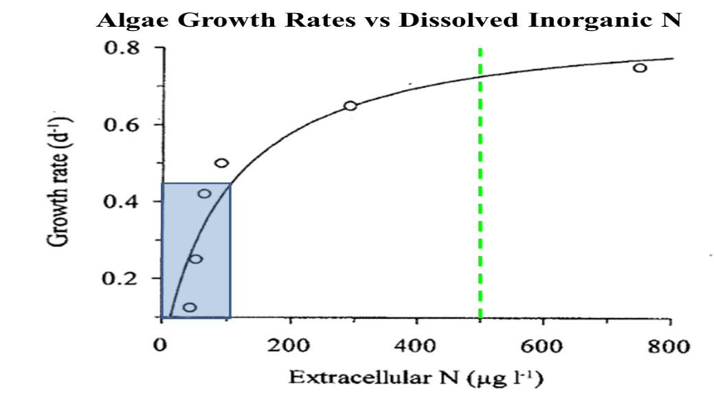

**Figure 4. Relationship between dissolved inorganic nitrogen concentration and doubling rate of phytoplankton (*Cyclotella*) under laboratory conditions.**

The experiment will add enough nitrogen to achieve a target DIN of 0.5 mg N/L. This DIN level is expected to increase the doubling rate of algae by a factor of roughly 2× (Figure 4), a level that should be easily detectable by field measurements. Moreover, increasing DIN to 0.5 mg N/L will increase the DIN:PO4-P molar ratio to ~15, which is close to the average N:P ratio of ~16 for algae (Jassby 2008). The N enrichment target of 0.5 mg/L is comparable to the maximum seasonal DIN level attained at NL 74 under natural conditions (Figure 2).

### 2.2.1.1 Rhodamine dye experiments

During the previous experiment in 2018, the fertilizer mixed more rapidly than expected. Within 36 hours of application, the 400 meter nitrate plug completely eroded and concentrations were near background concentrations throughout the study reach. This high level of dispersion was likely primarily driven by tides. On each ebb and flood tide, sheer stress along the channel margins and sediments results in slower flow velocities. Flows in the middle of the channel near the surface are faster than flows along the sediment-water interfaces. Variation in flow velocities, effectively leads to longitudinal mixing.

To evaluate dispersion, Reclamation will apply a conservative tracer and observe its dissolution along the study reach. Application of a conservative tracer is the most effective way to evaluate dispersion in this system as the tracer integrates all the factors involved with heterogeneous mixing. However, not all tides are equal and the rate of dispersion will vary with tidal amplitudes. Reclamation plans to release the conservative tracer during consecutive high and low tidal amplitude periods (spring and neap tides) to bookend the rates of dispersion. Combining these conservative tracer releases with high resolution hydrodynamic measurements, it will be possible to calibrate a 3-dimensional hydrodynamic model of the upper SSC that will improve understanding of both the hydrodynamics of the system and the effects dispersion has on nutrient dynamics, plankton production and other biogeochemical processes.

Re clamation will use rhodamine as a conservative tracer. Rhodamine is an approved substance by the National Sanitation Foundation (http://info.nsf.org/Certified/PwsChemicals/Listings.asp?ProductFunction=Tracer+Dye&) and has long been used as a hydrologic tracer in surface waters (reviewed by Runkel et al 2015). Rhodamine is easily detectable fluorometrically using common autonomous equipment compatible with the current sensor infrastructure. An additional benefit of rhodamine is that it photodegrades and absorbs to sediments effectively removing it from the system in the weeks to months following application (Rai and Tarhbun 1988, Runkel et al. 2015). Thus, rhodamine will not persist indefinitely in contrast to other ionic tracers (e.g., sodium, bromide, chloride). Further, the application of these salts would be impractical due to the size of the SSC and its elevated natural conductivity. While not completely conservative (Runkel et al. 2015), rhodamine is the most practical tracer to use in this study. Rhodamine has been used in numerous government and academic research projects (Runkel et al. 2015 and REFS within), and Reclamation will maintain rhodamine concentrations well below toxicity thresholds (Smart 1984; Field 1995). Rhodamine should follow the same mixing patterns as calcium nitrate, is detectable in real-time, and will degrade after the completion of the experiment. Reclamation expects rhodamine concentrations to return to near background levels three to five days after application depending on the tides and dispersive forces. Within five days of application, it is expected that rhodamine levels will become 1 µg L-1, which is near the minimum detection limit of the proposed equipment and well below the 1000 µg L-1 toxicity threshold (Field 1995).

Reclamation plans to elevate rhodamine concentrations to 20 µg L- in the same 400 meter study reach as the fertilizer application. Assuming similar dispersion as experiment 1, concentrations will diminish to 1 µg L- within two days. Reclamation does not expect to be able to measure rhodamine concentrations less than 0.5 µg L-1, and thus should be able to monitor its dispersion for two to three days following application.

Because the sensors used to measure chlorophyll concentration are also sensitive to rhodamine dye, the dye experiments must be conducted after the nitrogen addition experiment.

### 2.2.1.2 Experiment schedule

Reclamation proposes to conduct the first round of fertilizer applications during the week of July 22, 2019 and the second round during the subsequent neap tide during the week of August 5th (Table 1). Consequently, the rhodamine dye experiments would occur the week of August 26th, to target a spring tide condition (maximum tidal dispersion) and the week of September 2nd, to target a neap tide.

|  |  |  |  |  |  |  |  |  |  |  |  |  |  |
| --- | --- | --- | --- | --- | --- | --- | --- | --- | --- | --- | --- | --- | --- |
| **Table 1: Schedule for Phase 2 experiment, July-Aug 2019** | | | | | | | | | | | | | |
| **Week** | | **Moon** | **App** | **Sun** | **Mon** | | **Tues** | | **Wed** | **Thurs** | | **Fri** | **Sat** | |
|  |  | Neap |  |  |  | |  | |  |  | |  |  | |
| **0** | July 1 | Spring |  |  |  | | **Deploy** | |  | *Holiday* | |  |  | |
| **1** | July 8 | Neap |  |  | **Sample** | | **Sample** | | **Sample** | **Sample** | | **Sample** |  | |
| **2** | July 15 | Spring |  |  | **Sample** | |  | | **Sample** |  | |  |  | |
| **3** | July 22 | Neap | NO3 |  | **Sample** | | **Sample** | | **Sample** | **Sample** | | **Sample** |  | |
| **4** | July 29 | Spring |  |  | **Sample** | |  | | **Sample** |  | |  |  | |
| **5** | Aug 5 | Neap | NO3 |  | **Sample** | | **Sample** | | **Sample** | **Sample** | | **Sample** |  | |
| **6** | Aug 12 | Spring |  |  | **Sample** | |  | | **Sample** |  | |  |  | |
| **7** | Aug 19 | Neap |  |  | **Sample** | | **Sample** | | **Sample** | **Sample** | | **Sample** |  | |
| **8** | Aug 26 | Spring | Rhod |  | **Sample** | |  | | **Sample** |  | |  |  | |
| **9** | Sep 2 | Neap | Rhod |  | *Holiday* | | **Sample** | |  |  | |  |  | |
| **10** |  | Spring |  |  |  | | **Retrieve** | |  |  | |  |  | |
| Rhodamine addition | | | Nitrate addition | | |  | |  | | |  | | |

### 2.2.1.3 Monitoring Plan

In the 2018 experiment, electrical conductivity (EC) was used to reference the fertilized segment and the adjacent reference locations. Although there was a consistent evaporation-driven EC gradient throughout the SSC, using EC to locate specific water masses at a fine spatial resolution proved challenging. On some days, clear vertical gradients in EC were present, suggesting unequal flow velocities with depth. Additionally, when the boat was positioned near shore during monitoring, meaningful differences in EC compared to the channel center were occasionally detected. Together these observations contradicted the initial working hypothesis that water moves upstream/downstream as a relatively intact plug. Fine-scale heterogeneity in EC indicated variation in flow velocities in both the vertical and horizontal dimensions. Unequal flow velocities cause higher rates of advective mixing. The EC gradient is useful at larger spatial or temporal scales, but it is not ideal for tracking individual water parcels at the resolution of the first fertilization experiment. In experiment 2, Reclamation will locate the fertilized area using an onboard SUNA that continuously measures nitrate concentration.

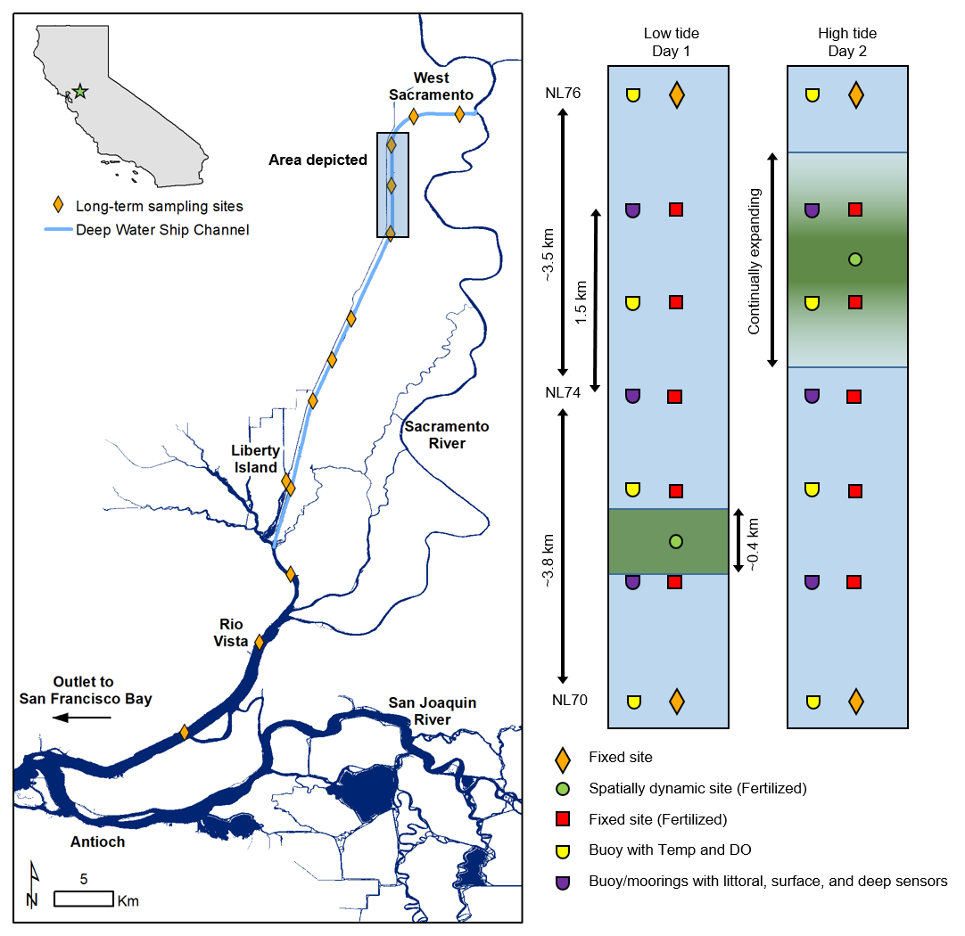

**Figure 5. Location of experiment. The fertilized segment (green) and sampling sites. One spatially dynamic station (green circle) will be referenced using the maximum concentration of nitrate or rhodamine. Note that the location of the fertilized plug will move north/south and expand over time. Fixed sampling sites (red squares and orange diamonds) span the theoretical range of the fertilized plug including 3 long-term sampling sites (NL70, NL74, and NL74).**

### 2.2.1.4 Sampling schedule

To determine if the fertilizer influences chemical and biological properties of the SSC, the monitoring plan includes sampling before, during, and after fertilization in both the manipulated and control reaches (see Table 2). However, dispersion eliminates true reference conditions, and even the most distant sites may be slightly manipulated. It will be necessary to evaluate the mean and variability of water properties for each of these circumstances, but reliance will be placed on comparisons through time (i.e., before, during, and after).

|  |  |  |  |
| --- | --- | --- | --- |
|  | **Before Fertilization** (week 2) | **During Fertilization** (weeks 4 and 6) | **After Fertilization** (week 8) |
| **Manipulated**  (centered at NL74) | 5 sites  5 dates | 5-6 sites  10 dates | 5 sites  5 dates |
| **Reference**  (NL70 and NL76) | 2 sites  5 dates | 2 sites  10 dates | 2 sites  5 dates |

**Table 2. Sampling Schedule as described in the monitoring plan**

For the purposes of this experiment, Reclamation will treat each neap tide cycle (roughly 14 days) independently. During fertilization weeks (weeks three and five), calcium nitrate will be applied daily for four consecutive days. On day one, application of 200 kg of NO3-N to a 400 meter length of the SSC that is centered at NL74 will occur. Application between 0 and 200 kg of NO3-N will occur on the following three days. The goal is to maintain a mean nitrate concentration of 0.5 mg NO3-N L-1 for four consecutive days. Depending on the actual rates of dispersion and NO3 loss, the amount of calcium nitrate applied each day will vary. At most application will be of the same load on four days, leading to a weekly maximum load of 800 kg NO3-N. Based on results from experiment 1, this application schedule should maintain nitrate levels close to 0.5 mg NO3-N/L for four days, but concentrations will reduce to below 0.2 mg NO3-N within two days of the last application. Further, it is expected the NO3-N will be used by organisms, so concentrations are expected to return to low levels (<0.05 mg NO3-N L-1) within two weeks. In this fashion the system will be episodically loaded with a modest amount of nitrate rather than relying on it to resist dispersion. On each fertilization day, Reclamation intends to reapply fertilizer to the same water mass. Each morning, Reclamation will locate the maximum NO3 concentration where the application of fertilizer will be centered.

Two nitrate addition weeks will be conducted, thereby improving the ability to assess the nutrient effects and hedge the experiment in case of unforeseen environmental factors (e.g., ships). During the neap cycle prior to and following the nitrate applications (weeks one and seven), Reclamation will monitor the system in a similar fashion as the fertilized weeks. These data will be used as reference conditions that will be compared to the manipulation weeks.

In addition to sampling intensively during the neap tides, two days will also be sampled during the spring tides (weeks two, four, six, eight). These will allow for monitoring of the recovery of the system and assess changes in ecological properties that respond at longer timescales (e.g., zooplankton). It is expected the system will mix rapidly during these weeks returning to baseline before the subsequent neap tie weeks. However, residual effects of the fertilizer application during the previous neap tide may persist into the subsequent neap time.

This schedule will result in 30 sampling events over 8 weeks.

### 2.2.1.5 Deployed equipment

Reclamation will deploy continuous sensors at multiple geographic locations and depths.

First, dissolved oxygen and temperature sensors on mini-buoys will be deployed at seven location. Each mini-buoy array will have two PME ‘minidot’ dissolved oxygen sensors at two depths (within 1 m of surface and 1 m off the bottom). These mini-buoys will be placed at the same locations as fixed sampling sites.

To understand the physical movement of water in the DWSC, Reclamation will deploy an acoustic Doppler at NL73 and CTDs (conductivity, temperature, dissolved oxygen) at three geographic locations. These sensor packages will be spaced longitudinally. The center site will be NL74––the center of the manipulated reach. The other two sites are located 1.5 km upstream and downstream of NL74 (Figure 6). These sites are approximately 75% of the tidal excursion length during neap tides at this location. At each of these three sites, CTDs will be deployed at multiple depths along the channel margin. One CTD will be positioned near shore and maintain a depth of 1 to 2 m. The other two CTDs will be positioned offshore on a common mooring line. The mooring will be anchored in the deeper part of the channel (> 6 m) but not in its center. Unfortunately, equipment cannot be placed in the center of the channel due to ship traffic. The mooring will have CTDs near the bottom (~8 m), at the surface (1 m), and 1 to 5 additional depths. This center array needs to be rugged enough to withstand the wake of large freight ships and will possibly have a safety chain anchored on shore.

In addition to CTDs, Reclamation will deploy a side-looking acoustic Doppler (ADCP). The ADCP will be anchored to the piling of channel marker 73, but extended laterally along the bottom so it can monitor water flows in the main channel.

Reclamation will also install 3 buoys/moorings equipped with YSI EXO2s and Satlantic SUNA nitrate sensors. These sensor packages will be placed on the shoulder of the channel (~3 m depth) at each of the three continuous monitoring sites. The center site (NL74) will be a buoy with real-time communication. The upper and lower sites will be subsurface moorings and log data internally.

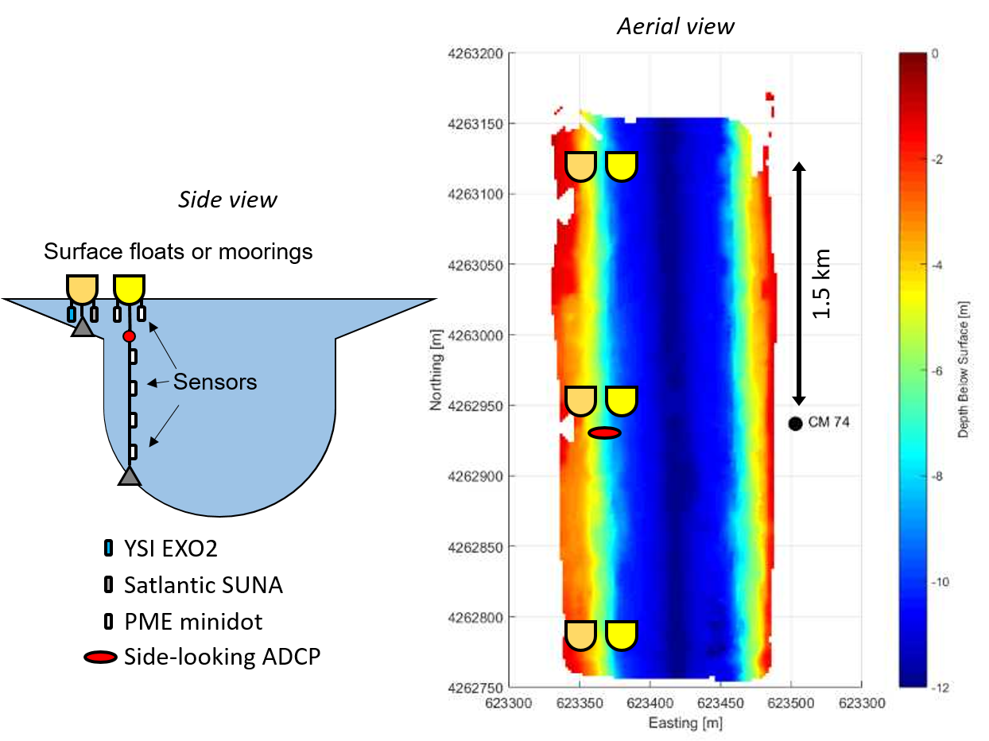

**Figure 6. Deployed equipment at 3 sites centered at NL74. A side-looking acoustic Doppler (red oval) will be installed on the channel marker 73. Three littoral buoys/moorings (orange) will be placed on the shoulder of the channel spaced 1.5 km apart. Three deeper buoys will contain dissolved oxygen, conductivity sensors at multiple depths. These instruments will be anchored along the steeper section of the channel but be well outside the center of the channel to avoid ship traffic. Rhodamine sensors will be integrated into the bench moorings during the rhodamine releases.**

Upstream (38.5197, -121.5846)

Channel marker 73 (38.5062, -121.5846)

Downstream (38.4927, -121.5845)

#### 2.2.1.5.1 Deployed equipment locations

Sideward-looking ADCP – (USGS hydrodynamics)

1 deployed at NL73 piling

Extended toward the deep channel via conduct/pipe

Conductivity, temperature, dissolved oxygen spar buoys (USGS – hydrodynamics & UC-Davis)

3 total buoys, deployed at three sites

Sites: NL74, 1.5 km upstream, and 1.5 km downstream

Location: On channel slope (~6 m depth) where anchoring is feasible.

Per line: 3 DO (PME), 4 conductivity (HOBO), 6 temperature (HOBO)

EXO2/SUNA moorings/buoy (USGS – hydrodynamics)

3 internally logging systems (2 moorings, 1 buoy)

Sites: NL74 (buoy), 1.5 km upstream, and 1.5 km downstream

EXO2 – fully loaded (Chla, BGA, Turbidity, pH, fDOM, DO, Temp, Cond)

SUNA – optical NO3 sensor

Installed on ledge (~3 m). As far out into the channel as feasible, but package will be above the steep drop-off

Rhodamine sensors – (UC-Davis)

3 total, one at each site.

Option 1: Turner Cyclops with PME datalogger

Deployable anywhere, self-contained logger

Option 2: Turner cyclops configured to BGC moorings/buoys.

Wired to datalogger

Sensor totals:

PME minidot dissolved oxygen 9

HOBO conductivity 12

HOBO temp 9

Rhodamine 3

EXO2 3

SUNA 3

### 2.2.1.6 Sampling procedure

*Week 0:*

*Deploy sensor mooring and buoys*

*Install mooring in Lake Washington and secure boat in West Sacramento*

*Week 1: Reference week (neap tide)*

*Mon: Southbound map, sample sites, northbound map.*

*Tues: Southbound map, sample sites, northbound map.*

*Wed: Southbound map, sample sites, northbound map.*

*Thur: Southbound map, sample sites, northbound map.*

*Fri: Southbound map, sample sites, northbound map*

*Week 2: Reference week (spring tide)*

*Mon: Southbound map, sample sites, northbound map.*

*Wed: Southbound map, sample sites, northbound map*

*Week 3: Nitrate release 1 (neap tide)*

*Mon: Southbound map, apply calcium nitrate, map application area, sample sites, northbound map.*

*Tues: Southbound map, apply calcium nitrate, map application area, sample sites, northbound map.*

*Wed: Southbound map, apply calcium nitrate, map application area, sample sites, northbound map.*

*Thurs: Southbound map, apply calcium nitrate, map application area, sample sites, northbound map.*

*Fri: Southbound map, sample sites, northbound map*

*Week 4: Post-application sampling (spring tide)*

*Mon: Southbound map, sample sites, northbound map.*

*Wed: Southbound map, sample sites, northbound map*

*Week 5: Nitrate release 2 (neap tide)*

*Mon: Southbound map, apply calcium nitrate, map application area, sample sites, northbound map.*

*Tues: Southbound map, apply calcium nitrate, map application area, sample sites, northbound map.*

*Wed: Southbound map, apply calcium nitrate, map application area, sample sites, northbound map.*

*Thurs: Southbound map, apply calcium nitrate, map application area, sample sites, northbound map.*

*Fri: Southbound map, sample sites, northbound map*

*Week 6: Post-application sampling (spring tide)*

*Mon: Southbound map, sample sites, northbound map.*

*Wed: Southbound map, sample sites, northbound map*

*Week 7: Reference week (neap tide)*

*Mon: Southbound map, sample sites, northbound map.*

*Tues: Southbound map, sample sites, northbound map.*

*Wed: Southbound map, sample sites, northbound map*

*Thur: Southbound map, sample sites, northbound map.*

*Fri: Southbound map, sample sites, northbound map*

*Week 8: Rhodamine release 1 (spring tide)*

*Mon: Southbound map, release 13 gallons of rhodamine, map application area, sample sites, northbound map.*

*Wed: Southbound map, map application area, sample sites, northbound map.*

*Week 9: Rhodamine release 2 (neap tide)*

*Mon: Southbound map, release 13 gallons of rhodamine, map application area, sample sites, northbound map.*

*Wed: Southbound map, map application area, sample sites, northbound map.*

*Week 10: Wrap up*

*Retrieve equipment and moorings. Return boats*

1. **Affected Environment and Environmental Consequences**

This section describes the affected environment and evaluates the environmental consequences that may occur with implementation of the Proposed Action and the No Action Alternative. Potential impacts on several environmental resources were examined and found to be minimal or nonexistent. These resources include:

Indian Trust Assets (ITAs): ITAs are legal interests in assets that are held in trust by the U.S. for federally recognized Indian tribes or individuals. There are no Indian reservations, Rancherias or allotments in the project area. The nearest ITA is the Wilton Rancheria, about 18 miles away.

Indian Sacred Sites: Sacred sites are defined in Executive Order 13007 (May 24, 1996) as “any specific, discrete, narrowly delineated location on Federal land that is identified by an Indian tribe, or Indian individual determined to be an appropriately authoritative representative of an Indian religion, as sacred by virtue of its established religious significance to, or ceremonial use by, and Indian religion; provided that the tribe or appropriately authoritative representative of an Indian religion has informed the agency of the existence of such a site.” There are no identified Indian Sacred Sites within the Proposed Action area; therefore this project would not inhibit use or access to any Indian Sacred Sites.

Cultural Resources: Reclamation has determined that the Proposed Action is type of undertaking that does not have the potential to cause effects on historic properties, should such properties be present, pursuant to 36 CFR § 800.3(a)(1). As such, Reclamation has no further obligations under 54 U.S.C. § 306108, commonly known as Section 106 of the National Historic Preservation Act (NHPA).

Environmental Justice: Executive Order 12898 requires each Federal agency to identify and address disproportionately high and adverse human health or environmental impacts, including social and economic effects of its program, policies, and activities on minority populations and low-income populations. The Proposed Action would not result in adverse human health or environmental impacts to minority or low-income populations.

* 1. **Biological Resources**
     1. **Affected Environment**

The project area is centered at NL74 (38.5062 N, 121.5836 W) in the upper SSC, located West of Sacramento City. The SSC includes both natural habitat and man-made navigation features, beginning with the Sacramento River near Suisun Bay. The SSC accounts for approximately 13% of the Sacramento River’s overall area where the two overlap. The SSC diverges from the Sacramento River into the man-made channel approximately 2 miles north of Rio Vista. In total, the SSC comprises an approximately 17-mile section of the Sacramento River and a 29-mile navigation channel, of which 25 miles are man-made (USACE 2011).

Tidal wetlands, tidal mudflats, and riparian habitat are present along portions of levees and the banks of SSC. Land adjacent to the banks of the SSC as it passes through the Delta is used primarily for agricultural purposes with pockets of residential, commercial, and industrial development. Within the man-made portion of the SSC, warm water temperatures (in summer, generally 10 degrees Fahrenheit [°F] warmer than in the Sacramento River portion), higher salinities, lack of riparian vegetation, and the presence of predators combine to create conditions that generally are unfavorable to rearing and out-migrating juvenile salmonids (NMFS 2006).

Typical wildlife species associated with the riparian and floodplain communities include mammals such as striped skunk, raccoon, and gray fox. Riparian bird species include red-shouldered hawk, wood duck, great blue heron, black crowned night heron. Amphibians and reptiles include Pacific tree frog, Pacific gopher snake, garter snake, and western pond turtle. Special status species that associate with riparian and floodplain habitats include federally listed western yellow-billed cuckoo and valley elderberry longhorn beetle (Reclamation, 2016).

**Special Status Species**

Special-status species addressed in this section include plants and animals that are legally protected or are otherwise considered sensitive by Federal, State, or local resource conservation agencies and organizations. These include species that are State listed and/or Federally listed as rare, threatened, or endangered; those considered as candidates or proposed for listing as threatened or endangered; and plants considered by the California Native Plant Society (CNPS) to be rare, threatened, or endangered.

**California Native Plant Protection Act**

The Native Plant Protection Act (NPPA) of 1977 protects rare and endangered plants in California and prohibits take of endangered or rare native plants. Based on a review of California Natural Diversity Database (CNDDB) and CNPS database searches for rare and endangered plant species was conducted for the surrounding U.S. Geological Survey (USGS) Quads (2015), the federally threatened Colusa Grass and federally endangered Solano Grass returned occurrences. Under the California Rare Plant Rank they are listed as 1B (Plants Rare, Threatened, or Endangered in California or Elsewhere). CNPS further designates the level of endangerment with a Threat Rank, with .1 meaning a plant is seriously threatened, a rank of .2 means fairly threatened, and a rank of .3 means not very threatened in California. The following is a list of rare and endangered plants with recorded occurrences surrounding Quads:

* Solano Grass (*Tructoria mucronata*) 1B.1 Federally Endangered
* Colusa Grass (*Neostapfia colusana*) 1B.1 Federally Threatened

Due to the scale of the Proposed Action, any impacts to existing vegetation will be negligible and unlikely to occur within the project area.

**Migratory Bird Treaty Act**

A list of bird species with recorded occurrences within the surrounding quads was also obtained from the CNDDB (2015). The list was compared to the Service’s list of protected species under the Migratory Bird Treaty Act (MBTA) of 1918 (2015a). There are no protected migratory bird species with recorded occurrences in the Proposed Action project area and are, therefore, not discussed further.

**Threatened or Endangered Species**

The U.S. Fish and Wildlife Service (Service) and National Marine Fisheries Service (NMFS) have jurisdiction over federally listed threatened and endangered species. An endangered species is defined as “…any species which is in danger of extinction throughout all or a significant portion of its range.” A threatened species is defined as “…any species that is likely to become an endangered species within the foreseeable future throughout all or a significant portion of its range” (16 USC Section 1532). Section 9 of the Endangered Species Act of 1973 (ESA) makes it illegal to “take” (defined as to “harass, harm, pursue, hunt, shoot, wound, kill, trap, capture, or collect or attempt to engage in such conduct”) endangered and threatened species (16 USC 1538).

A special-status species list was generated from the Service Information for Planning and Conservation (IPaC) website for the surrounding area on June 21, 2019 (USFWS 2017). The following Table 3 includes those federally listed species with recorded occurrences within the surrounding USGS 7.5-minute Quads based on the CNDDB (2015). The table also includes the species’ status, determination of impacts from the Proposed Action, and a summary of the rationale supporting the determination.

|  |  |  |  |  |
| --- | --- | --- | --- | --- |
| **Table 2 – Special Status Species List** | | | | |
| **Common Name** | **Scientific Name** | **Status1** | **Effect2** | **Summary of Effects Determination3** |
| **Plants** |  |  |  |  |
| Colusa Grass | *Neostapfia colusana* | FT | NE | Occurences4 and Critical Habitat outside of the Action Area |
| Solano Grass | *Tuctoria mucronata* | FE | NE | Occurences4 and Critical Habitat outside of the Action Area |
| **Invertebrate**s |  |  |  |  |
| Delta Green Ground Beetle | *Elaphrus viridis* | FT | NE | Occurences4 and Critical Habitat outside of the Action Area |
| San Bruno Elfin Butterfly | *Callophrys mossil bayensis* | FE | NE |  |
| Valley Elderberry Longhorn Beetle | *Desmocerus californicus dimorphus* | FT | NE | Occurences4 and Critical Habitat outside of the Action Area |
| Conservancy Fairy Shrimp | *Branchinecta conservation* | FE | NE | Occurences4 and Critical Habitat outside of the Action Area |
| Vernal Pool Fairy Shrimp | *Branchinecta lynchi* | FT | NE | Occurences4 and Critical Habitat outside of the Action Area |
| Vernal Pool Tadpole Shrimp | *Lepidurus packardi* | FE | NE | Occurences4 and Critical Habitat outside of the Action Area |
| **Birds** | | | | |
| California Clapper Rail | *Rallus longirostris obsoletus* | FE | NE |  |
| Lest Bell’s Vireo | *Vireo bellii pusillus* | FE | NE | Occurences4 and Critical Habitat outside of the Action Area |
| Yellow-billed Cuckoo | *Coccyzus americanus* | FT | NE | Occurences4 and Critical Habitat outside of the Action Area |
| **Amphibians** |  |  |  |  |
| California Red-legged Frog | *Rana draytonii* | FT | NE | Occurences4 and Critical Habitat outside of the Action Area |
| California Tiger Salamander | *Ambystoma californiense* | FT | NE | Occurences4 and Critical Habitat outside of the Action Area |
| **Fish** |  |  |  |  |
| Delta Smelt | *Hypomesus transpacificus* | FT | NLAA |  |
| **Reptiles** | | | | |
| Giant Garter Snake | *Thamnophis gigas* | FT | NE | The giant garter snake inhabits marshes, sloughs, ponds, small lakes, low-gradient streams, and other waterways and agricultural wetlands, such as irrigation and drainage canals and rice fields. Unlikely to occur due to a lack of suitable habitat. |

1 Status: Federal Listing (**FE**: Endangered; **FT**: Threatened; **X**: Critical Habitat)

State Listing (**SE**: Endangered; **ST**: Threatened; **SC**: Candidate)

**MBTA**: Migratory Bird Treaty Act

2 Effects determination

**NE**: No Effect to federally listed species anticipated from the Proposed Action.

**NLAA**: Not Likely to Adversely Affect with Environmental Protection Measures

**LAA**: May Affect, and Likely to Adversely Affect

3 Summary of rationale supporting determination

4 California Natural Diversity Database 2014 recorded occurrences in the surrounding 9 Quads.

#### Vernal Pool Species

Vernal pools are ephemeral wetlands that fill during the rainy season and disappear during the dry season. During the time water is present they provide unique habitat for species like vernal pool fairy shrimp, vernal pool tadpole shrimp, and Colusa grass. Revised critical habitat for vernal pool crustaceans was designated on August 11, 2005 (70 FR 46923). There is no Critical Habitat for vernal pool species within the Proposed Action area.

#### Giant Garter Snake (*Thamnophis gigas*)

Giant garter snakes (GGS) require habitat with adequate water during their active season and emergent herbaceous wetland vegetation (USFWS 2006a). GGS also require higher elevation upland habitat. Rice production areas, irrigated agriculture, and channels and canals provide the majority of GGS habitat in the Central Valley. GGS typically breed in March and April with young born late July through early September (Hansen and Hansen 1990).

#### Delta Smelt (*Hypomesus transpacificus*) Delta Smelt were listed as threatened under the ESA on March 5, 1993 (58 FR 12854). Critical habitat for Delta Smelt includes all water and submerged lands below ordinary high water and the entire water column bounded by and contained in Suisun Bay (including the contiguous Grizzly and Honker bays); the length of Goodyear, Suisun, Cutoff, First Mallard (Spring Branch), and Montezuma sloughs; and the existing contiguous waters contained in the legal Delta (as defined in Section 12220 of the California Water Code) (USFWS 1994a). Through the Proposed Action, an increase in food resources (i.e. phytoplankton and zooplankton) would be expected to have a beneficial effect on the entire Delta system, as well as for endangered native species such as Delta Smelt. As mentioned previously, a target level of DIN of 0.5mg N/L would not be expected to have any detrimental aquatic ecosystem effects, such as eutrophication and hypoxia, and, therefore, would not have a detrimental effect on Delta Smelt because a DIN of 0.5 mg/L is the concentration that occurs naturally before nitrogen is drawn down to below detection by phytoplankton uptake. In addition, the use of rhodamine dye is not anticipated to have detrimental aquatic ecosystem effects on the SSC. As mentioned previously, rhodamine photodegrades and absorbs to sediments, effectively removing it from the system in the weeks to months following application. In addition, rhodamine concentrations will be maintained well below toxicity thresholds. Rhodamine dye experiments have been successfully conducted in the Delta to estimate tidal dispersion (Lucas et al. 2006).

#### California Central Valley Steelhead Distinct Population Segments (DPS) (*Oncorhynchus mykiss*)

California Central Valley (CV) Steelhead were listed as threatened under the ESA on January 5, 2006 (71 FR 834) and include all naturally spawned populations of steelhead in the Sacramento and San Joaquin rivers and their tributaries, excluding steelhead from San Francisco and San Pablo bays and their tributaries and two artificial propagation programs: the Coleman National Fish Hatchery and Feather River Fish Hatchery steelhead hatchery programs. The DPS excludes steelhead spawned and reared at Nimbus Fish Hatchery. Critical habitat was designated for CV steelhead on September 2, 2005 and includes the Sacramento delta watershed (70 FR 52488). As described for Delta Smelt, CV Steelhead will not be impacted by the Proposed Action. This is in part due to the proposed target level of DIN of 0.5mg N/L, which is not expected to have any detrimental aquatic ecosystem effects and will likely have a beneficial effect of increasing food resources for native fish. The use of rhodamine is also not anticipated to have a negative effect on native fish species since concentrations will be maintained well below toxicity thresholds and the tracer dye will not remain in the SSC ecosystem. In addition, because there is no hydrological connection between SSC and the Sacramento River, steelhead do not use the man-made portion of the SSC for migration or spawning. While it is possible that steelhead use the upper portion of the water column within the man-made portion of the SSC as habitat for rearing, it is unlikely due to the absence of CV steelheads during fish community surveys in SSC conducted in 2008 (SWCA 2009).

#### Critical Habitat

The federal ESA requires that the Service and NMFS designate critical habitat for species listed as federally endangered or threatened. “Critical habitat” is defined in ESA as: (1) specific areas within the geographical area occupied by the species at the time of listing, if they contain physical or biological features essential to a species’ conservation, and those features may require special management considerations or protection; and (2) specific areas outside the geographical area occupied by the species if the agency determines that the area itself is essential for conservation (16 USC 1531 et seq).

Critical habitat has been designated for the following species located within the project area:

* Delta Smelt

##### Physical and Biological Features of Critical Habitat

The Physical and Biological Features (PBFs), formerly known as the primary constituent elements (PCEs), of Delta Smelt are essential to the conservation of the specie’s life stages. On December 19, 1994, USFWS released the designated critical habitat for Delta Smelt (59 CFR 652.56). The specific PBFs included in that designation were: (1) physical habitat; (2) water; (3) river flow; and (4) salinity concentrations required to maintained Delta Smelt habitat for spawning, larval, and juvenile transport, rearing, and adult migration.

#### Essential Fish Habitat

The Magnuson-Stevens Fishery Conservation and Management Act, as amended by the Sustainable Fisheries Act (Public Law 104 to 297), mandates all federal agencies consult with NMFS on any activities or proposed activities authorized, funded, or conducted by that agency that may adversely impact essential fish habitat (EFH) of commercially managed marine and anadromous fish species (Section 305(b)(2). These regulations require that federal action agencies provide NMFS with a written assessment of the effects of their action on EFH (50 CFR Section 600.920). EFH includes specifically identified waters and substrate necessary for fish spawning, breeding, feeding, or growing to maturity. Important components of EFH for spawning, rearing, and migration include suitable substrate composition; water quality (e.g., dissolved oxygen, nutrients, temperature); water quantity, depth and velocity; channel gradient and stability; food; cover and habitat complexity (e.g., large woody debris, pools, channel complexity, aquatic vegetation); space; access and passage; and floodplain and habitat connectivity (Pacific Fishery Management Council 2003). EFH also includes all habitats necessary for the production of commercially valuable aquatic species, to support a long-term sustainable fishery, and contribute to a healthy ecosystem (16 USC 1802[10]).   
  
The SSC is not designated by NMFS to contain EFH for any listed species of fish.

#### Fish and Wildlife Coordination Act

The Fish and Wildlife Coordination Act, as amended in 1964, was enacted to protect fish and wildlife when Federal actions result in the control or modification of a natural stream or body of water. The statute requires Federal agencies to take into consideration the effect that water-related projects would have on fish and wildlife resources. Consultation and coordination with the Service and State fish and game agencies are required to address ways to prevent loss of and damage to fish and wildlife resources and to further develop and improve these resources.

* + 1. **Environmental Consequences**

***No Action Alternative***

Under the No Action Alternative, Reclamation would not apply nitrogen into the SSC, nor would the broader effort of adaptively managing and exporting plankton to the north Delta occur. Regions of the Bay-Delta ecosystem and habitat for delta smelt would continue to be food-limited.

***Proposed Action***

**Rare and Endangered Plants**

Colusa Grass and Solano Grass generally occurs in vernal pools. Within the Proposed Action area, there is no critical habitat for vernal pool species. The Proposed Action would have no effect on rare and endangered plants.

**California Tiger Salamander (*Ambystoma californiense*)**California tiger salamanders are typically found in annual grasslands, grass understory of valley foothill woodland, and uncommonly along streams. Adults breed and lay eggs in vernal pools and other temporary ponds. There are no vernal pools at the project site. The Proposed Action would have no effect on California Tiger Salamander.

**California Red-Legged Frog (*Rana aurora draytonii*)**

Red-legged frogs (CRF) require variety of habitat types including aquatic, riparian and upland areas. Adults often utilize dense, shrubby or emergent vegetation closely associated with deep-water pools with fringes of cattails and dense stands of overhanging vegetation such as willows.  
  
In addition to there being no Critical Habitat in SSC, the Proposed Action would also occur outside of the CRF breeding season. The Proposed Action would have no effect on the California Red-Legged Frog.

**Vernal Pools**There is no vernal pool habitat within the project area. Vernal pools are generally not present within the active floodplain. The Proposed Action would have no effect on vernal pools.  
  
**Fisheries**

Given that a DIN of 0.5 mg/L is the concentration that occurs naturally before nitrogen is drawn down to below detection by phytoplankton uptake, a proposed target level of DIN of 0.5 mg N/L is not expected to have detrimental aquatic ecosystem effects on the SSC, and, therefore, would not have any negative effect on native fish species. In addition, the fertilizer to be used for this experiment comes in the form of 1 mm diameter granules that will be deposited by crop duster from an elevation of ~10 m. Each granule weighs about 4 mg. In quiescent water, the granules sink at an average speed of ~0.1 m/s and are expected to be fully dissolved within the top 1 m of the water column. The kinetic energy of a 4 mg granule moving at this velocity is ~2 x 10-8 J, which would be barely perceptible and thus not likely to harm any Delta smelt present near the surface. In addition, the use of rhodamine dye is not anticipated to have detrimental aquatic ecosystem effects on the SSC. As mentioned previously, rhodamine photodegrades and absorbs to sediments, effectively removing it from the system in the weeks to months following application. Rhodamine concentrations will be maintained well below toxicity thresholds. Rhodamine dye experiments have also been successfully conducted in the Delta to estimate tidal dispersion (Lucas et al. 2006).

The California Department of Fish and Wildlife has been sampling four stations in the SSC as part of its Summer Townet (STN) and Fall Mid-Water Trawl (FMWT) surveys since 2009 (Figure 13). Although Delta Smelt are frequently observed at STN station #797, which is within the SSC’s turbidity maximum zone, and at station #719, which exchanges water with the Cache Slough Complex, the experiment would occur far upstream near station #796. Since 2011, the STN has captured 10 fish at that location, two in 2011 and 8 in 2012 (Table 3).

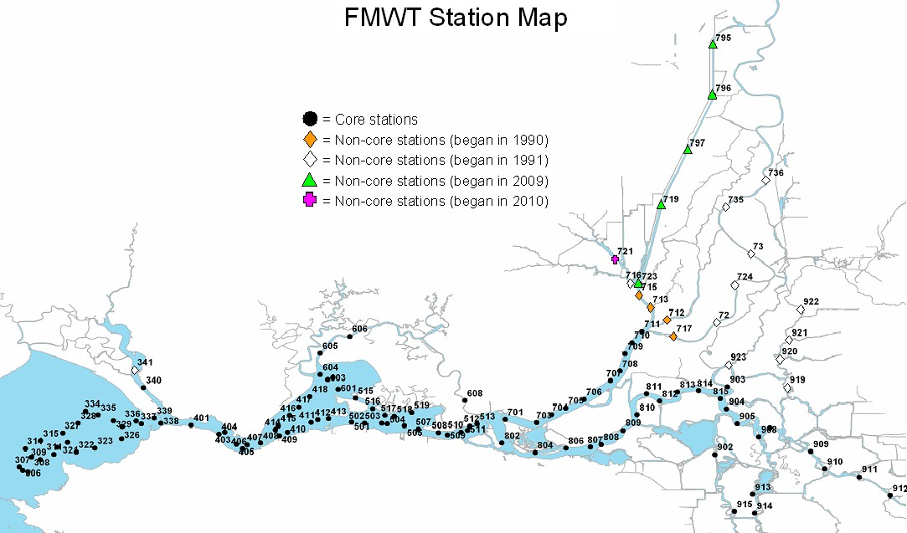

**Figure 13. Location of California Department of Fish and Wildlife Fall Mid-Water Trawl stations.**

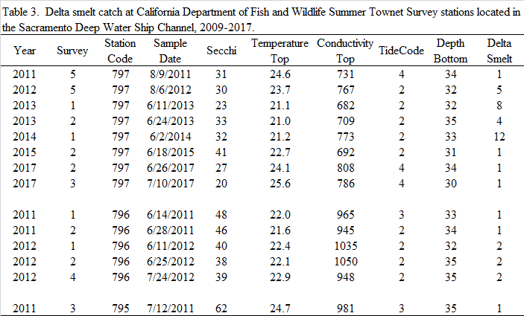

During the July-September period, when the experiment is slated to occur, 14 Delta Smelt have historically been captured at stations 795 and 796, the two closest to where the nutrient addition experiment will be conducted (Table 3).

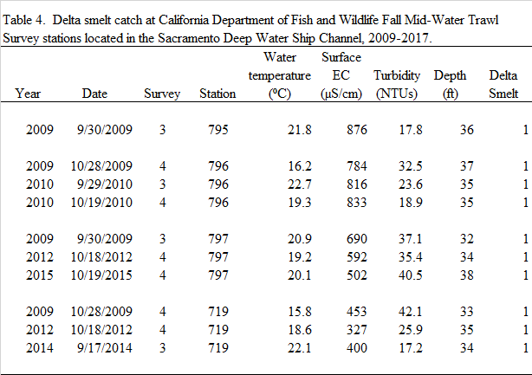

In addition to the long-term routine monitoring programs conducted by the California Department of Fish and Wildlife, the U.S. Fish and Wildlife Service has conducted sampling in the SSC since 2017 under its Enhanced Delta Smelt Monitoring (EDSM) program. The EDSM program samples both the upper and lower SSC. The upper reach includes the project area near NL74, whereas the lower reach (between navigation lights 62 and 68) includes the area where turbidity tends to be relatively high. During the period from December 2017 through March 2019, a total of seven Delta Smelt have been captured in the upper SSC. By contrast, during the same period, 279 Delta Smelt have been captured in the lower reach (Table 5).

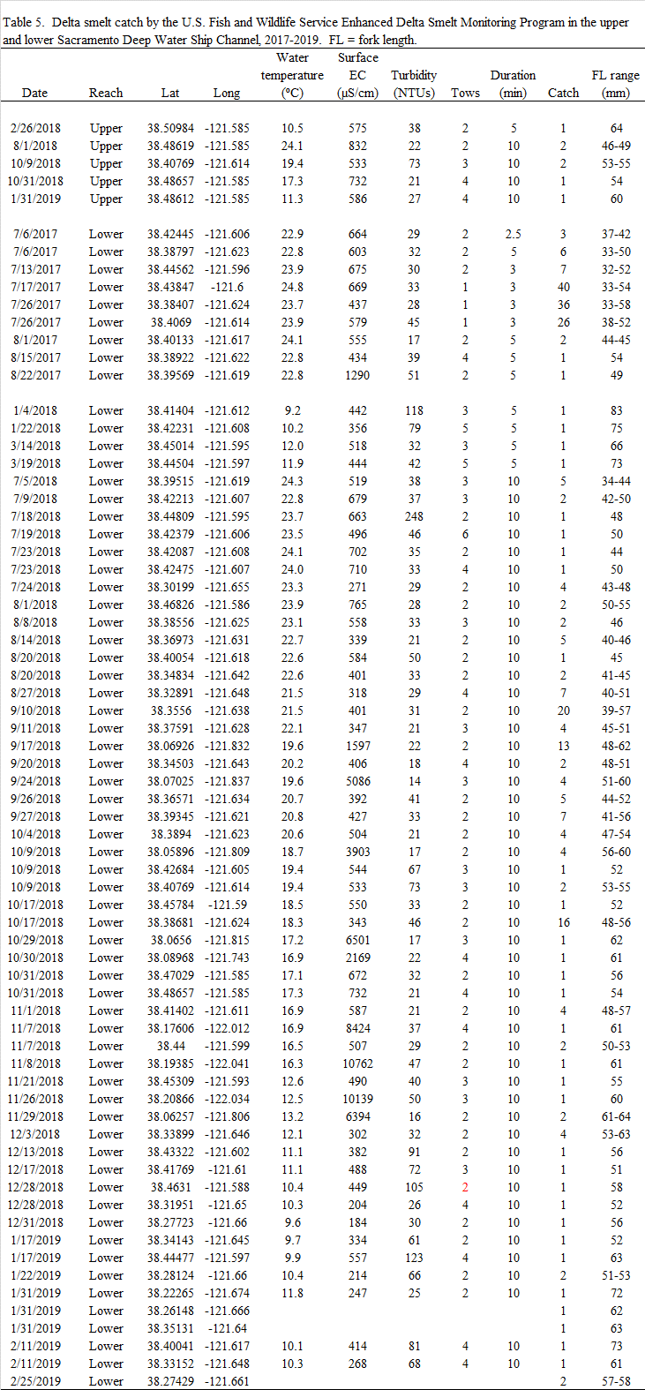

Collectively, the fish survey data indicate that Delta Smelt that inhabit the SSC are concentrated primarily in the lower reach of relatively high turbidity (median = 33 NTU) and moderate EC (median = 533 µS/cm). The experiment is thus not likely to adversely affect Delta Smelt. On the contrary, by potentially stimulating production of zooplankton, the experiment could in theory benefit any Delta Smelt within the study reach.

## Hydrology and Water Quality

### 3.2.1 Affected Environment

**Hydrology**  
Under the Propose Action, Reclamation would not be altering the hydrology of flows of SSC or any surrounding bodies of water.

**Water Quality**

The lock area in the uppermost section of the SSC receives a small amount of flow from the Sacramento River due to leakage through the sector gates (which are currently locked in a closed position). The lower SSC exchanges water tidally with Cache Slough and the lower Sacramento River. The main sources of water from the Sacramento River are rain and snowmelt that collect upstream in reservoirs and are released in response to water needs or flood control. The quality of surface water within the downstream portions of Sacramento River is also influenced by other human activities including; historical mining, agricultural, and municipal and industrial (M&I) activities. Water quality issues within the primary project area include the presence of mercury, pesticides, trace metals, turbidity, and toxicity from unknown origin (CALFED 2000a).

### 3.2.2 Environmental Consequences

***No Action Alternative***

Under the No Action Alternative, Reclamation would not apply nitrogen into the SSC, nor would the broader effort of adaptively managing and exporting plankton to the north Delta occur. Therefore, no impacts on hydrology or water quality would occur.

***Proposed Action***

**Water Quality**

The Proposed Action would be completed in accordance with permit conditions and Best Management Practices (BMP) to protect water quality. These practices would prevent fuels, hazardous materials, and other pollutants from entering the ship channel.  
  
Excessive concentrations of nitrate can cause excessive growth of algae and other plants, leading to accelerated eutrophication, and occasional loss of dissolved oxygen. To avoid these detrimental effects, the experiment is targeting a DIN of 0.5 mg N/L. Previous studies of nutrient:chlorophyll stoichiometry in the north Delta indicate that 0.5 mg N/L could at most produce a maximum chlorophyll concentration of 50 µg/L, but only if all the nitrogen were immediately incorporated into algal biomass (assuming no grazing, no denitrification, no algal sedimentation). The results of the first experiment indicate that such ideal conditions do not apply in the study SSC and therefore that the actual chlorophyll yield will be considerably less than 50 µg/L.

The fertilizer to be used for this experiment contains 1% ammonium nitrogen (NH4-N). It has been hypothesized that ammonium favors the growth of *Microcystis*, a potentially harmful cyanobacterium that can release microcystin, a neurotoxin, into the water column. *Microcystis* is observed in the Delta,but has never been observed in the SSC upstream of the tidal exchange zone with Cache Slough. Under natural conditions, NH4-N in the study reach since 2012 has ranged between below detection to roughly 0.07 µg/L. The addition of the fertilizer would increase NH4-N by 0.004 µg/L, an insignificant change.

The aerial application of nitrogen will be conducted by crop-duster. The crop-duster will provide certification that the equipment used will be pesticide/herbicide-free.

Reclamation will also be using rhodamine as a conservative tracer. Rhodamine is an approved substance by the National Sanitation Foundation (http://info.nsf.org/Certified/PwsChemicals/Listings.asp?ProductFunction=Tracer+Dye&) and has long been used as a hydrologic tracer in surface waters (reviewed by Runkel et al 2015). Rhodamine experiments have been successfully conducted in the Delta to estimate tidal dispersion (Lucas et al. 2006). Rhodamine photodegrades and absorbs to sediments, effectively removing it from the system in the weeks to months following application. In addition, rhodamine concentrations will be maintained well below toxicity thresholds, and the tracer dye is not anticipated to have detrimental aquatic ecosystem effects on the SSC.

**National Pollutant Discharge Elimination System (NPDES)**

Section 402 of the Clean Water Act (CWA) specifically required Environmental Protection Agency (EPA) to develop and implement the NPDES program. In California, EPA authorizes the State Water Resources Control Board (SWRCB) to oversee the NPDES program.

Under the Limited Threat General Order, the Central Valley Regional Water Quality Control Board has issued Reclamation an NPDES permit to conduct nutrient enrichment experiments in the SSC. The permit order number is R5-2016-0076-036.

The Limited Threat General Order applies to Reclamation as the proposed action involves:

* Clean or relatively pollutant-free wastewaters that pose little or no threat to water quality
  + Discharge of less than 0.25 million gallons per day (MGD) or less than 4 months in duration or
  + Discharges greater than or equal to 0.25 MGD and greater than or equal to 4 months in duration
* Wastewater that may contain toxic organic constituents, volatile organic compounds (VOC), petroleum fuel pollution constituents, pesticides, inorganic constituents, chlorine, and other chemical constituents for which treatment technologies are well-established to eliminate constituents that pose a threat to water quality and that require treatment prior to discharge (CRWQB).

The following BMPS are included to minimize adverse impacts to water quality:

* All equipment working within the ship channel would be inspected daily for fuel, lubrication, and coolant leaks; and for leak potentials (e.g. cracked hoses, loose filling caps, stripped drain plugs); and all equipment must be free of fuel, lubrication, and coolant leaks.
* Vehicles or equipment would be washed/cleaned only at approved off-site areas.

## 3.3 Recreation

### 3.3.1 Affected Environment

Recreational activities occur throughout the SSC, and predominantly include fishing and boating opportunities.

### 3.3.2 Environmental Consequences

***No Action Alternative***

Under the No Action Alternative, Reclamation would not apply nitrogen into the SSC, nor would the broader effort of adaptively managing and exporting plankton to the north Delta occur. Therefore, no impacts to recreation would occur.

***Proposed Action***

Impacts to recreational fishing opportunities on the SSC would not occur. As described previously, the proposed target level of DIN 0.5 mg N/L, or the Rhodamine dye, is not expected to have any detrimental aquatic ecosystem effects and, therefore, would not affect local fish populations or impede fishing opportunities.

Additionally, impacts to boating recreational activities are not expected to occur. Use of a crop duster and the 40ft research vessel are not expected to impact boating traffic in the SSC. Use of the YSI water quality sondes and collection of grab samples are also not expected to have an impact. Therefore, the Proposed Action would not impact recreational activities in the SSC.

## 3.4 Environmental Commitments

Environmental commitments are measures or practices adopted to reduce or avoid adverse effects that could result from project implementation. These are also known as protective measures and are in accordance with relevant permits. The following section describes the best management practices, environmental commitments, and mitigation measures that would be implemented under the Proposed Action:

**Protection Measure #1 – Water Quality**

* The Proposed Action will occur in late-July. This will restore nitrogen to levels that occur naturally earlier in the season before drawdown by phytoplankton growth.
* The form of nitrogen in the fertilizer to be used for this experiment is 99% nitrate and 1% ammonium nitrogen. The addition of this trace amount of NH4-N is not likely to significantly alter the stoichiometry of the water to favor Microcystis or other potentially harmful algae.

**Protective Measure #2 – Cultural Resources**

* In the unlikely event that human remains are uncovered, the project would cease immediately and Reclamation cultural resource staff would provide direction on how to proceed.
* If human remains are discovered on lands under the jurisdiction of Reclamation, they would be treated in accordance to the provisions of the Native American Graves Protection and Repatriation Act of 1990 (25 U. S. C 3001).
* If human remains are discovered on lands owned by any other non-federal entity, they would be treated in accordance to the provisions in the California Health and Safety Code (HSC 7050.5).

## Cumulative Effects

The cumulative effects of implementation of reasonably foreseeable projects and the alternatives as compared to conditions under the No Action Alternative and the Proposed Action are discussed below. Cumulative effects are impacts on the environment that result from the incremental impacts of an alternative when added to other past, present, and reasonably foreseeable future actions of Federal, state, or local agencies or individual entities or persons (40 CFR 1508.7). Such impacts can result from individually minor, but collectively significant, actions taking place over time (40 CFR 1508.8). Cumulative effects include the effects of future State, tribal, local or private actions that are reasonably certain to occur in the project area.

Due to the relatively short timeframe and low impact of the Proposed Action, there would not be any significant cumulative effects.

1. **Consultation and Coordination**

Several Federal laws, permits, licenses and policy requirements have directed or guided the NEPA analysis and decision making process included in this EA.

* 1. **Public Review Period**

This EA will be available for public comment for five days and additional analysis will be prepared if substantive comments identify impacts that were not previously analyzed or considered.

* 1. **Federal Laws, Regulations, and Policies**

**National Historic Preservation Act (54 USC § 300101 et seq.)**

54 U.S.C. § 304108, commonly known as Section 106 of the NHPA, requires that Federal agencies take into consideration the effects of their undertakings on historic properties. Historic properties are cultural resources that are included in, or eligible for inclusion in, the National Register. The 36 CFR Part 800 regulations implement Section 106 of the NHPA and outline the procedures necessary for compliance with the NHPA. Compliance with the Section 106 process follows a series of steps that are designed to identify if significant cultural resources are present in the proposed action project area and to what level they would be affected by the proposed Federal undertaking.

The proposed project action would have no impact on historical or cultural resources, therefore Reclamation will not consult with the State Historic Preservation Officer (SHPO).

**Section 7 of the Endangered Species Act (16 USC §** **1531 et seq.)**

Section 7 of the Endangered Species Act requires Federal agencies to ensure that discretionary federal actions do not jeopardize the continued existence of threatened or endangered species or result in the destruction or adverse modification of the critical habitat of these species. Reclamation sent letters to the Service and NMFS in July 2019 seeking concurrence that the proposed action was not likely to adversely affect Delta Smelt, salmonids, or green sturgeon.

### National Pollutant Discharge Elimination System

The NPDES permit program controls water pollution by regulating point sources that discharge pollutants into waters of the United States. The Central Valley Regional Water Quality Control Board has issued Reclamation an NPDES permit to conduct nutrient enrichment experiments in the SSC. The permit order number is R5-2016-0076-036.

1. **References**

Baxter, R. L, et al. 2015. An Updated Conceptual Model of Delta Smelt Biology; Our Evolving Understanding of Estuarine Fish. Interagency Ecological Program, Management, Analysis, and Synthesis Team.

CNPS, Rare Plant Program. 2015. Inventory of Rare and Endangered Plants v8-02. California Native Plant Society, Sacramento, California. Website http://www.rareplants.cnps.org Accessed 04 February 2015.

CNDDB [California Natural Diversity Database]. 2018. California Department of Fish and Wildlife’s Natural Diversity Database, RareFind Version 5. Accessed April, 2018

CRWQB [California Regional Water Quality Control Board, Central Valley Region] 2016. Order R5-2016-0076-01/NPDES Permit No. CAG995002.

DTSC [Department of Toxic Substances Control], EnviroStor. 2015. Hazardous Waste and Substances List. Website http://www.envirostor.dtsc.ca.gov. [accessed March 3, 2015]

Feyrer, F., et al. 2004. Fish Assemblages of Perennial Floodplain Ponds of the Sacramento River, California (USA), With Implications for the Conservation of Native Fishes. Fisheries Management and Ecology 11:335-344.

Field, M., Wilhelm, R., Quinlan, J., & Aley, T. 1995. An Assessment of the Potential Adverse Properties of Fluorescent Tracer Dyes Used for Groundwater Tracing. Environmental Monitoring and Assessment, 38, 75–96.

Frantzich, J and T. Sommer. 2015 Yolo Bypass as a Fall Web Subsidy for the Lower Estuary. Interagency Ecological Program Newsletter 28(1): 3-13

Jassby A. 2008. Phytoplankton in the Upper San Francisco Estuary: Recent Biomass Trends, Their Causes and Their Trophic Significance. San Francisco Estuary and Watershed Science 6.

Kimmerer, W. J. 2002. Effects of Freshwater Flow on Abundance of Estuarine Organisms: Physical Effects on Trophic Linkages? Marine Ecology Progress Series 243: 39-55.

Lehman, P.W., et al. 2013. Long-Term Trends and Casual Factors Associated with Microcystis Abundance and Toxicity in San Francisco Estuary and Implications for Climate Change Impacts. Hydrobiologia 718(1): 141-158.

Loken, L., R.A. Dahlgren and S. Sadro. 2019. Sacramento Deep Water Ship Channel Nutrient Enrichment Project: Summary of Year One Results. Report to Bureau of Reclamation, April 23, 2019.

Lucas, L.V., D.M. dereno, J.R. Burau, T.S. Schraga, C.B. Lopez, M.T. Stacey, K.V. Parchevsky, and V.P. Parchevsky. 2006. Intradaily variability of water quality in a shallow tidal lagoon: mechanisms and implications. Estuaries and coasts 29(5): 711-730.

Mueller-Solger, A.B., et al. 2002. Nutritional Quality of Food Resources for Zooplankton (*Daphina*) in a Tidal Freshwater System (Sacramento-San Joaquin Delta). Limnology and Oceanography 47:1468-1476.

NMFS, 2006. Sacramento Deep Water Ship Channel Maintenance Dredging and Bank Protection Project Biological Opinion 3006/00041. August 29, 2006

Rai, D. Y., & Rathbun, R. E. 1988. Photolysis of Rhodamine-WT Dye. Chemosphere, 17(3), 559–573.

Runkel, R. L. 2015. On the use of rhodamine WT for the characterization of stream hydrodynamics and transient storage. Water Resources Research, 51(8), 6125–6142.

Bureau of Reclamation [Reclamation]. 2016. Upper Sacramento River Anadromous Fish Habitat Restoration Program.

Smart, P. L. 1984. A Review of the Toxicity of Twelve Fluorescent Dyes Used for Water Tracing. NSS Bulletin, 46, 21–33.

Sommer, T. and F. Mejia. 2013. A Place to Call Home: A Synthesis of Delta Smelt Habitat in the Upper Sand Francisco Estuary. San Francisco Estuary and Watershed Science. [online serial] 11(2).

Sommer, T. R., et al. Floodplain Rearing of Juvenile Chinook Salmon: Evidence of Enhanced Growth and Survival. Canadian Journal of Fisheries and Aquatic Sciences 58:325-333.

SWCA, 2009. Stockton and Sacramento Deepwater Ship Channel Maintenance Dredging Project 2008 Fish Community and Entrainment Monitoring Report. Prepared for US Army Corps of Engineers Sacramento District. Prepared by SWCA Environmental Consultants, Portland, Oregon. April 2009.

USACE [U.S. Army Corps of Engineers]. 2011. Draft SEIS/SEIR Sacramento River Deep Water Shipping Channel.

USFWS. 1994a. Endangered and Threatened Wildlife and Plants; Critical Habitat Determination for the Delta Smelt. Federal Register 59: 65256-65278

USFWS [U.S. Fish and Wildlife Service]. 1998. Draft Recovery Plan for the Least Bell’s Vireo (*Vireo bellii pusillus*). Portland, Oregon. May 1998.

USFWS. 1999. Conservation Guidelines for the Valley Elderberry Longhorn Beetle. Sacramento, California. July 1999.

USFWS. 2002. Recovery Plan for the California Red-legged Frog (*Rana aurora draytonii*). September 12, 2002.

USFWS. 2005a. Recovery Plan for Vernal Pool Ecosystems of California and Southern Oregon. Portland, Oregon. 606 pages.

USFWS. 2005b. Revised Guidance on Site Assessments and Field Surveys for the California Red-legged Frog. August 2005

USFWS. 2006. Valley Elderberry Longhorn Beetle (*Desmocerus californicus dimorphus*) 5-Year Review: Summary and Evaluation. September 2006.

USFWS. 2007. National Bald Eagle Management Guidelines. May 2007.

USFWS. 2015a. Fish and Wildlife Service. Birds Protected by the Migratory Bird Treaty Act. http://www.fws.gov/migratorybirds/. Accessed: 2018

USFWS. 2015b. Sacramento Fish and Wildlife Office. Endangered Species List. http://www.fws.gov/sacramento Accessed: 2018

Van Nieuwenhuyse, E. E. 2007. Response of Summer Chlorophyll Concentration to Reduced Total Phosphorus Concentration in the Rhine River (Netherlands) and the Sacramento-San Joaquin Delta (California, USA). Canadian Journal of Fisheries and Aquatic Sciences 64: 1529-1542.

Van Nieuwenhuyse, E.E. et al. 2011. Nutrient Enrichment Experiments in the Delta-Mendota Canal, Central Valley Project, California. Bureau of Reclamation, Mid-Pacific Region, Sacramento, California. 54 p.