Estimating spatial structure in scalar fields and in fish abundance from time series measurements

JR Burau
Draft 1 – Rough working notes
July 27, 2009

Objective: Estimate along-channel spatial variation in fish abundance and scalar distributions (such as temperature, EC, turbidity, Chl-a) within a tidal excursion of a fixed site (Eulerian) sampling location based on the time series collected at this location.

This approach is attractive in strongly tidally forced environments because water parcels move long distances twice a day, movements that can be used to infer spatial structures. For example, the tides move water parcels up to 9 miles in the western delta during max flood or max ebb conditions during spring tides (figure 1). The basic idea behind this approach is to sample at a fixed site letting the tides bring the water , and what is in it (scalars such as salinity (computed from electrical conductivity and temperature), turbidity, and organisms (zooplankton, small fish)) to us. Knowledge of the velocity at this fixed site can then be used (with some simplifying assumptions) to estimate where the water parcels (and the things in the water) that passed our sampling location (1) where at the previous slack water, or, (2) where the water parcels will be at the next slack water. Hence the name slack water plots. This method seeks to minimize (make sense of) the incredibly dynamic motions made by scalar fields and pelagic organisms that occur four times a day within strongly tidally forced environments, such as the delta, by generating a series of spatial snapshots made at each slack water period (~ 4 times a day), a period when things are minimally moving. We note that in a progressive wave system like the delta, slack water does not occur everywhere in the delta at the same time, so spatial distributions inferred from widely spaced fixed site sampling locations represent a common point in the tide cycle, not a common point in time. For example, spatial distributions taken at high-slack water represent the farthest intrusion of ocean-derived constituents for that 24-hour day, it does not represent the spatial distribution at a specific time (in other words you’d never be able to take a picture of these distributions (DeGeorge: it might be fun to output model results for every node in the model when u=0 at each node and see what it looks like – we could then string together all of the plots that represent high slack water and those that represent low-slack water – this may be a very useful way of visualizing salinity intrusion into the delta (stringing together high slack images) or the reverse, fresh water intrusion into the bay (stringing together low water slack images). These images could be very useful in the context of salinity compliance since, if the high slack images were strung together, once could see high salinity approaching Jersey point, or Emmaton, and it would also show the spring neap modulation in the salt field, etc.).

To estimate spatial variability from fixed-site time series measurements we make a series of assumptions that we believe reasonably hold for periods of a half tidal cycle, the period for which these assumptions are made (e.g. six hours or less). These assumptions basically involve the (1) assumption of pure advection for both scalar fields and fish distributions and (2) that we can locally correct Eulerian measures to mimic the inherently Lagrangian nature of the movements of scalar fields and fish distributions past fixed site sampling locations. We point out that spatial distributions inferred from this approach are estimates that depend to a large degree at how well our assumptions are met, and like all measurements , contain a limited, and perhaps biased view of what is actually occurring in the real world. Nonetheless, the hope is that time series of these spatial maps, computed using a consistent methodology (e.g. we will be comparing apples to apples over time), will be useful in interpreting the co-evolution of fish distributions and scalar fields at timescales longer than the tidal day. These methods may be particularly useful during periods where the local spatial gradients in both the scalar fields and, potentially fish distributions, are large, such as occurs during the transition from summer to winter conditions precipated by the “first flush”. Principle among our assumptions are (1) there is minimal behavior between the most recent slack water and when fish are caught in a trawl and (2) there is relatively insignificant lateral and along-channel dispersion (and, if appropriate sources or sinks) of scalar fields, at least when compared to advection, during each ~6 hour flood or ebb tide. To minimize the influence of our assumptions, we propose to specifically select sampling locations where our assumptions are likely to be the most valid, such as: in the center of the channel, in relatively straight reaches that have minimal bathymetric variability within a tidal excursion of the sampling location and locations that are not along the tidal excursion trajectory of water that enters from other side channels (see figure 1 for the proposed initial sampling locations). We begin by discussing how we propose to correct Eulerian collected velocity information for the changes in phase and amplitude that occur along the axis of the estuary, the so-called Euler/Lagrange tranformation, then discuss algorithm implemtation and some suggested graphical products.

Computation of Euler-Lagrange transformations associated with tidal excursion trajectories

Simple Eulerian to Lagrangian Transformation

First we assume that a simple temporally invariant function exists that we could use to “correct” the Eulerian measured along-channel current speed, , for wave propagation and along-channel dissipation, to estimate the Lagrangian current speed, , at some along-channel distance from the Eulerian sampling location.

where

For each set of data (e.g. half tidal cycle – complete flood, or ebb tide) one can estimate where the water will end up at the next slack water, or, where the water was at the previous slack water. At this point is unclear which of these realizations will be most useful, so we propose to compute both. Additionally, and importantly, one could compare scalar field estimates between flood/ebb sets as a measure of how well our assumptions are being met, principally, how well our assumption of pure advection is holding up. For example, our along-channel estimates of scalar distributions of “where the water went” on one tide could be compared with estimates of “where the water came from” on the next tide. Deviations in spatial structure between these subsequent measurements would be indication of how well the assumption of advection was being met. For example, if the assumption of pure advection holds true we would expect small deviations between subsequent measurements, with a slow (multiple tidal cycle) evolution of the scalar fields over time, particularly in the late fall when the scalar fields, such as salt, turbidity and others, have reached a quasi-dynamic equilibrium. If there are widely different along channel spatial distributions inferred between subsequent measurements, then either the scalar field (or fish distributions) are changing rapidly (within a tidal cycle) or other things are happening such as fish behavior, or lateral mixing, etc. and our assumption of pure advection is suspect. So, at least to first order, this methodology is self evaluative, particularly with regard to its representation of salinity, a conservative tracer. With regard to the spatial distributions of fish inferred from this method, if the inferred distributions vary widely between subsequent measurements, then the fish are either very patchy, or they are not acting very much like passive particles, or both. Ideally, using this methodology, we would like to “see” significant patches of fish multiple times at our sampling locations as the net fish migrations through the estuary are perturbed by the tides.

The function will be determined based on numerical model experiments using the RMA model at the locations shown in figure (2, 3) where will be determined from plots of the ratio of 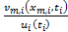 vs as is shown conceptually in figure 4. Again, we propose to develop separate distinct tidal dissipation/wave propagation relations for upstream and downstream of the fixed site monitoring locations because the bathymetry varies significantly up and downstream of the proposed sampling locations, especially on the San Joaquin. And, thus, we expect the upstream and downstream relations could differ. As a first cut, we propose to fit to the form of a relation based on the analytical work of Officer (19xx) who developed a wave equation formulation from the linearized shallow water equations (but some other form may work equally well):
(2)

It is also quite possible, given the straight, relatively deep and channelized regions of the delta where we propose the initial sampling, that , which would be a happy outcome. In other words, we may find, based on the numerical modeling experiments, that there is very little difference between Eulerian and Lagrangian velocities at these locations (which could be achieved by a balance between tidal reflections (local bathymetric resonance) and energy dissipation), especially the unnaturally spatially invariant bathymetry throughout the tidal excursion associated with the Sacramento River sampling location (this reach of the river is virtually completely manmade, dredged as part of the central valley flood protection system). Of the sampling we suggest, the upstream trajectory associated with the Jersey Point sampling location will challenge the assumptions of this approach to the greatest extent owing to the relatively complex bathymetry in this region (figure 1) (e.g. (1) a couple of bends in which secondary circulation will create lateral mixing and (2) lateral shear created by variable bathymetry that could be used by organisms to substantially alter there trajectories over what would be predicted by pure advection). Nonetheless, we will explore the form of , and, as a fist cut will estimate the () using a least-squares fit from data obtained from numerical model simulations to correct Eulerian measures for along channel energy dissipation and wave propagation, if needed.

Numerical model experiments – figuring out what looks like?

Basically, we propose to output time series (u,v, ec, temp, turbidity) from the model at the Eulerian sampling location and at a series of fixed locations, indicated by the “X’s” shown on figure 2,3, within an upstream and downstream tidal excursion of the Eulerian sampling location. With this time series data from the model we will be able to compare the velocity at a fixed sampling location, , with the velocities measured at distances , as is shown conceptually in figure 4.

Calculation of distance travelled along a tidal excursion trajectory

To compute the distance traveled along a tidal excursion trajectory over the time interval to t, we have, in analytical form,

(3)

where is the Lagrangian current speed following a particle path (e.g. streakline) and X(t) is the location of the particle in some arbitrary coordinate system, t is time.

In our case we are interested in the distance a parcel of water travels from a given slack water, say at , to all of the points along the tidal excursion trajectory up until the next slack water, , where P is the tidal period (about 12 hours in the Delta). To be useful, we need to use velocity data and thus discrete mathematics to estimate where successive particles would be in a coordinate system referenced to our Eulerian fixed-site sampling location, xxx, for times t after slack water, , up to the next slack water, , or,

(4)

Or, using Eulerian measures and an estimate of the along-channel distance from an Eulerian sampling location, , we have

(5)

Proof of concept – Assume , or

As a proof of concept, let , or , which suggests Eulerian velocity measurements, both upstream and downstream of the measurement location, well represent the Lagrangian velocities at tidal excursion distances (e.g. no need for “m”, which allows for upstream/downstream tidal propagation differences), we have,

(6)

Or, for a fixed interval, ,

(7)

So, basically, to determine the distance traveled to a series of particles released at intervals, beginning at slack water (as is shown in figure 5) (Ist) until the next slack water, (Ien), one computes a running average of the measured velocity, , outputting the sum times at each i, so for example for Ist =0 we have

And so on….up to the next slack water (or t~P/2, ien~P/2).

This computation is shown graphically in panel D of figure 5 and whose end result, the for each measured velocity, is shown in panel C. Once we have computed the distance for each ½ tide cycle (an ebb in the case of figure 5), one can plot spatial distributions of scalar concentrations (salinity, temperature, turbidity) as is shown in figure 6, of for trawl data using “circle plots” as is shown in figure 7.

Now, we could also use the same ebb time series in figure 5 to compute where a particle was at the previous slack water by letting summing “backwards” (from the end of the ebb to the beginning of the ebb by letting, ,

This process is shown graphically in figure 8 (again, using the same data as in figure 5, but by reversing the running summation to calculate the positions, ). Similar to estimating where water parcels went we can now estimate where they came from. By combining time series data of positions from panel D (figure 8) with scalar concentration time series in panel C (figure 8) scalar distributions are estimated as is shown in figure 9. For trawl data, data from panel A (figure 8) is combined with position data from C with the end result in figure 10.

Note the representations shown in figures (6,7) and (9,10) are produced from the exact same data set – figure (6,7) show where scalars concentrations and fish distributions, respectively, would be a the next slack water, whereas figure (9,10) show where scalars and fish distributions were at the previous slack water – notice how different our conclusions would be depending on which slack water we look at. Comparing data at a common point in the tide (e.g. slack water) may be more useful in understanding ecosystem response than a common point in time.

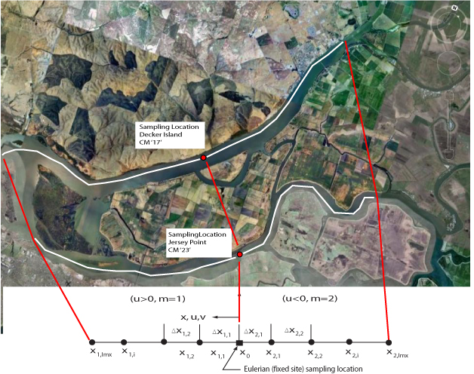
Figure 1. Sampling locations and curvalinear mapping from a tidal excursion trajectory (white lines above) in the real world onto a standard 1D cartesian grid (below). Note that Sacramento River sampling station is located on the northern side of the channel in the ship channel a region that hopefully better represents the exchange between the confluence and Liberty Island (e.g. as far from the influence of water from Threemile Slough as is possible. The San Joaquin River location is located roughly mid-channel, hopefully, on a streakline that avoids exchanges of water from both False River and Three Mile Slough (although we expect dispersive exchanges of these waters into the San Joaquin over time.

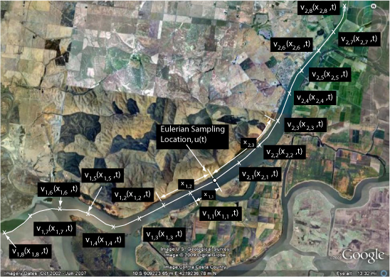
Figure 2. Numerical model sampling strategy for the Decker Island Sampling location. The X’s indicate locations where time series data (u,v, ec, temp, turbidity) will be output from the model. The X’s are spaced approximately every mile - the maximum tidal excursion along this reach is roughly 8 miles long. Data required: accurate along-channel distances to each sampling location in the model and time series of u,v, ec, temp, turbidity at each “X” for at least month (e.g. at least 2 spring/neap cycles) during low flow and high flow conditions (I don’t expect the net flows to affect the result very much; however, we should make the comparison). The X’s should be placed within the channel thalweg (e.g. in this case the ship channel) in deep water away from the banks and variations in bathymetry along the path a particle would take if released from the Eulerian sampling location (e.g. away from Decker Island and the junction of Threemile Slough with the Sacramento River).

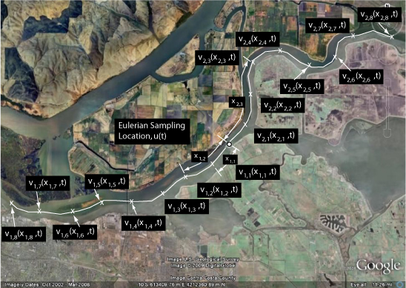
Figure 3. Numerical model sampling strategy for the Jersey Point sampling location. The X’s indicate locations where time series data (u,v, ec, temp, turbidity) will be output from the model. The X’s are spaced approximately every mile - the maximum tidal excursion along this reach is roughly 8 miles long. Data required: accurate along-channel distances to each sampling location and time series of u,v, ec, temp, turbidity at each “X” for at least month (e.g. at least 2 spring/neap cycles) during low flow and high flow conditions (I don’t expect the net flows to affect the result very much; however, we should make the comparison). The X’s should be placed within the channel thalweg in deep water away from the banks and siginficant variations in bathymetry (e.g. sand bars, islands) along the path a particle would take if released from the Eulerian sampling location.

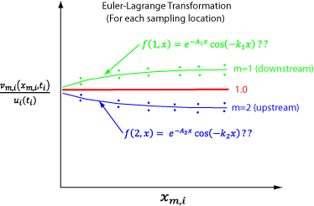

Figure 4. Conceptual plot of vs which will be used to develop the Euler-Lagrange transformation, , from numerical model results by comparing velocities taken at distance along a tidal excursion trajectory, , with the velocities taken at a fixed sampling location, .

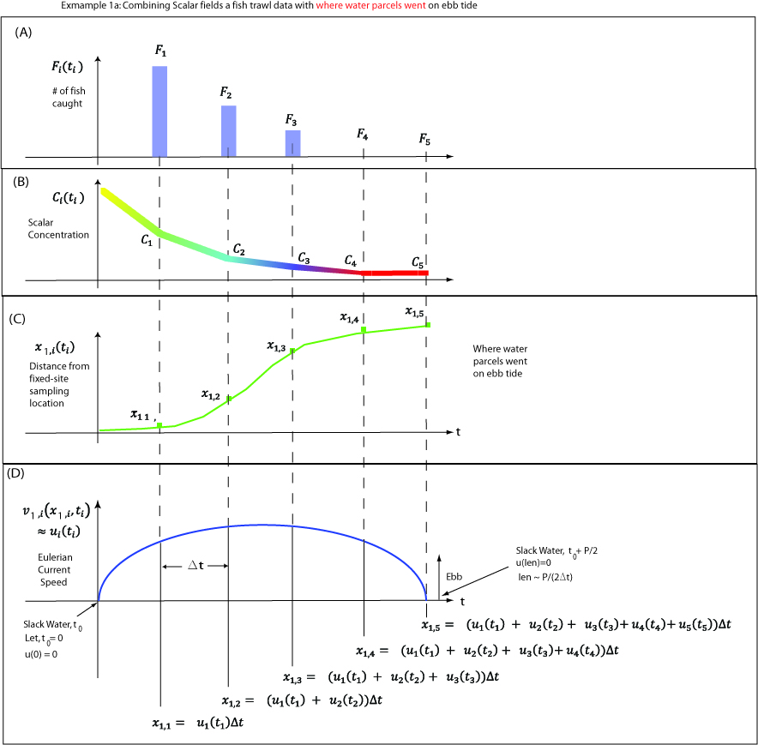

Figure 5. Conceptual example time series data set for an ebb tide: (A) number of fish caught, (B) scalar concentration (for example temperature, salinity, turbidity), (C) distance from a fixed site sampling location inferred from (D) time series of velocity data collected at a fixed site.
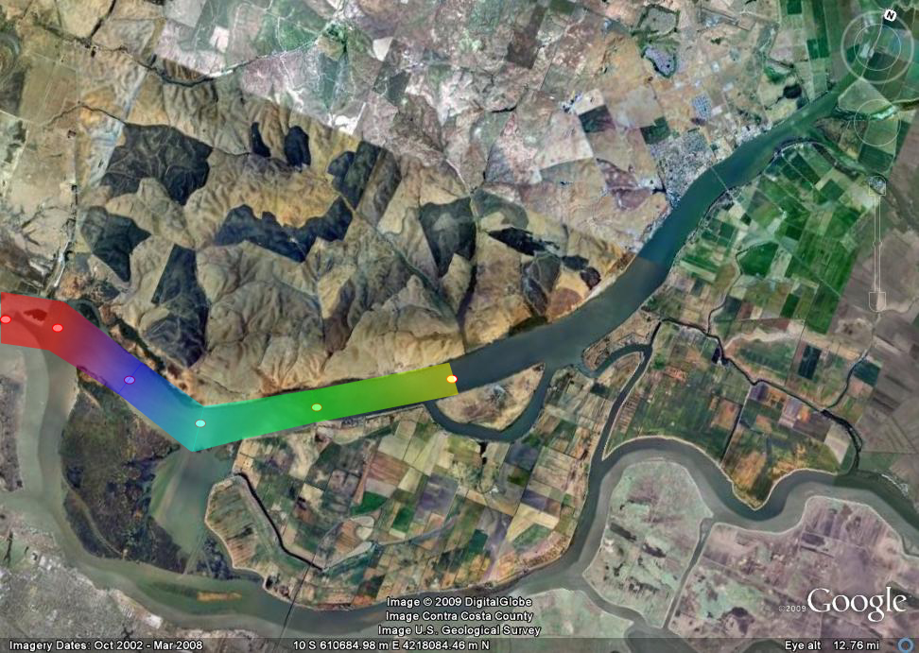
Figure 6. Color contours of scalar concentration distributions where positions from fixed site sampling locations are inferred from Eulerian velocity measurements at position “0” (panel C in figure 5) and concentrations are from time series also collected at “0” and shown in panel B in figure 5. Plot of where water parcels containing a given concentration went on an ebb tide on the next slack water.

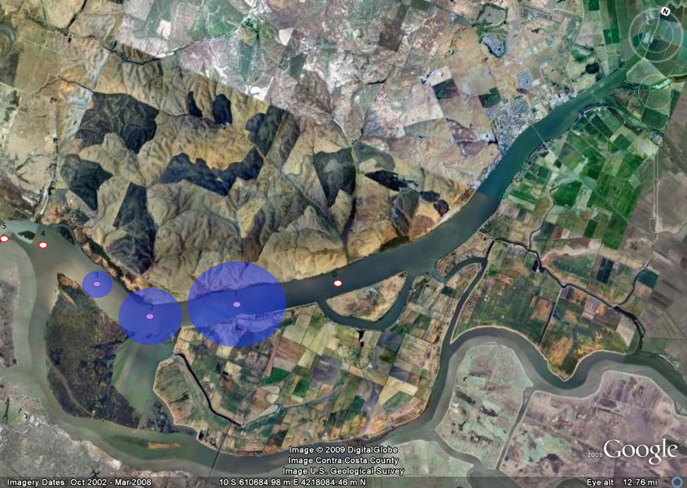
Figure 7. “Circle plots” of trawl catch where positions from fixed site sampling locations are inferred from Eulerian velocity measurements at position “0” (panel C in figure 5) and the trawl catches are from time series also collected at “0” and shown in panel A in figure 5. Plot of where water parcels containing fish at “0” went to on the next slack water on an ebb tide.

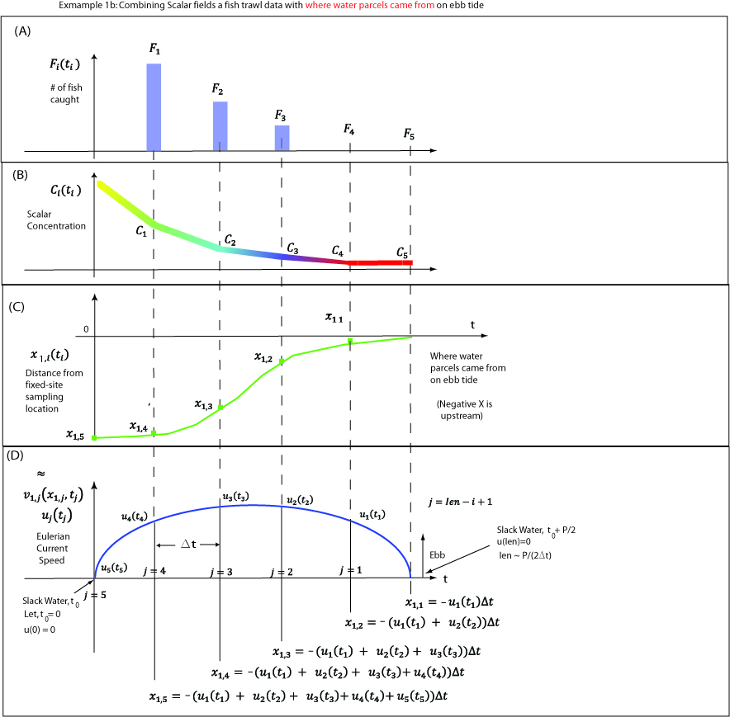
Figure 8. Conceptual example time series data set for an ebb tide: (A) number of fish caught, (B) scalar concentration (for example temperature, salinity, turbidity), (C) distance from a fixed site sampling location inferred from (D) time series of velocity data collected at a fixed site.

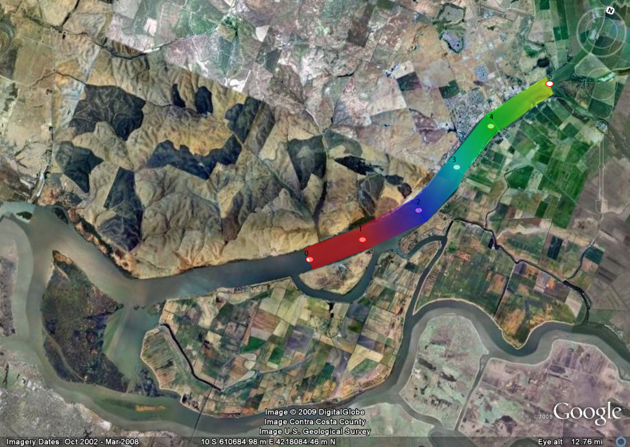
Figure 9. Color contours of scalar concentration distributions where positions from fixed site sampling locations are inferred from Eulerian velocity measurements at position “0” (panel C in figure 8) and concentrations are from time series also collected at “0” and shown in panel B in figure 8. Plot of where water parcels containing a given concentration were at slack water before the ebb tide shown on figure panel D on figure 8.

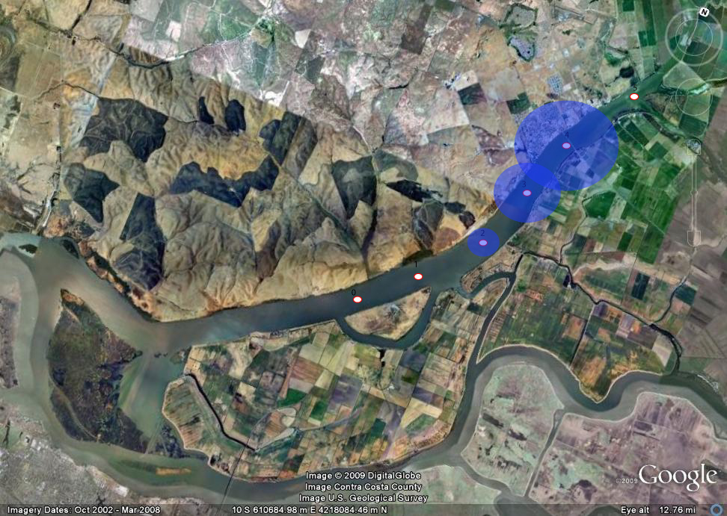
Figure 10. “Circle plots” of trawl catch where positions from fixed site sampling locations are inferred from Eulerian velocity measurements at position “0” (panel C in figure 8) and the trawl catches are from time series also collected at “0” and shown in panel A in figure 8. Plot of where water parcels containing fish collected at “0” came from on the ebb tide shown in panel D on figure 8.

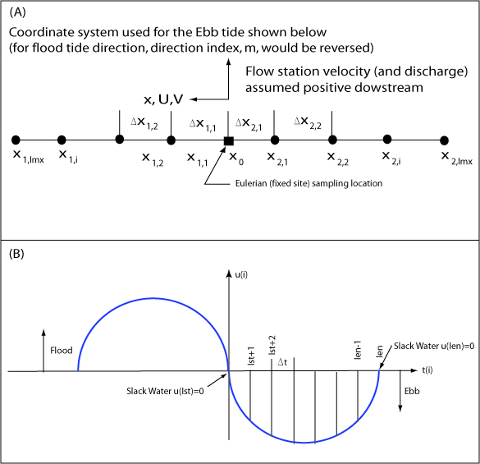

Figure xx. (A) One dimensional coordinate system, (B) complete tidal cycle (~12 hours) showing temporal discretization.

