Preliminary results
Jon Burau and Bill Bennett
V.1
January 28, 2009

We are nearing out take limit (170 out of 200) and request a continuation of sampling until about 1:00 am on January 29th, acknowledging that we may go slightly over the take outlined by DFG, but based on yesterday’s data collection efforts, we expect the catches to fall off precipitously as we proceed into the ebb. We have been catching delta smelt on the flood tides (which are quite weak given the high river flows)(Figures 1 and 2). Based on the data collected yesterday we feel the smelt are still primarily in the western delta. Thus, as we progress from flood to ebb we expect the catches to fall off precipitously to decline as we saw yesterday.

Figures
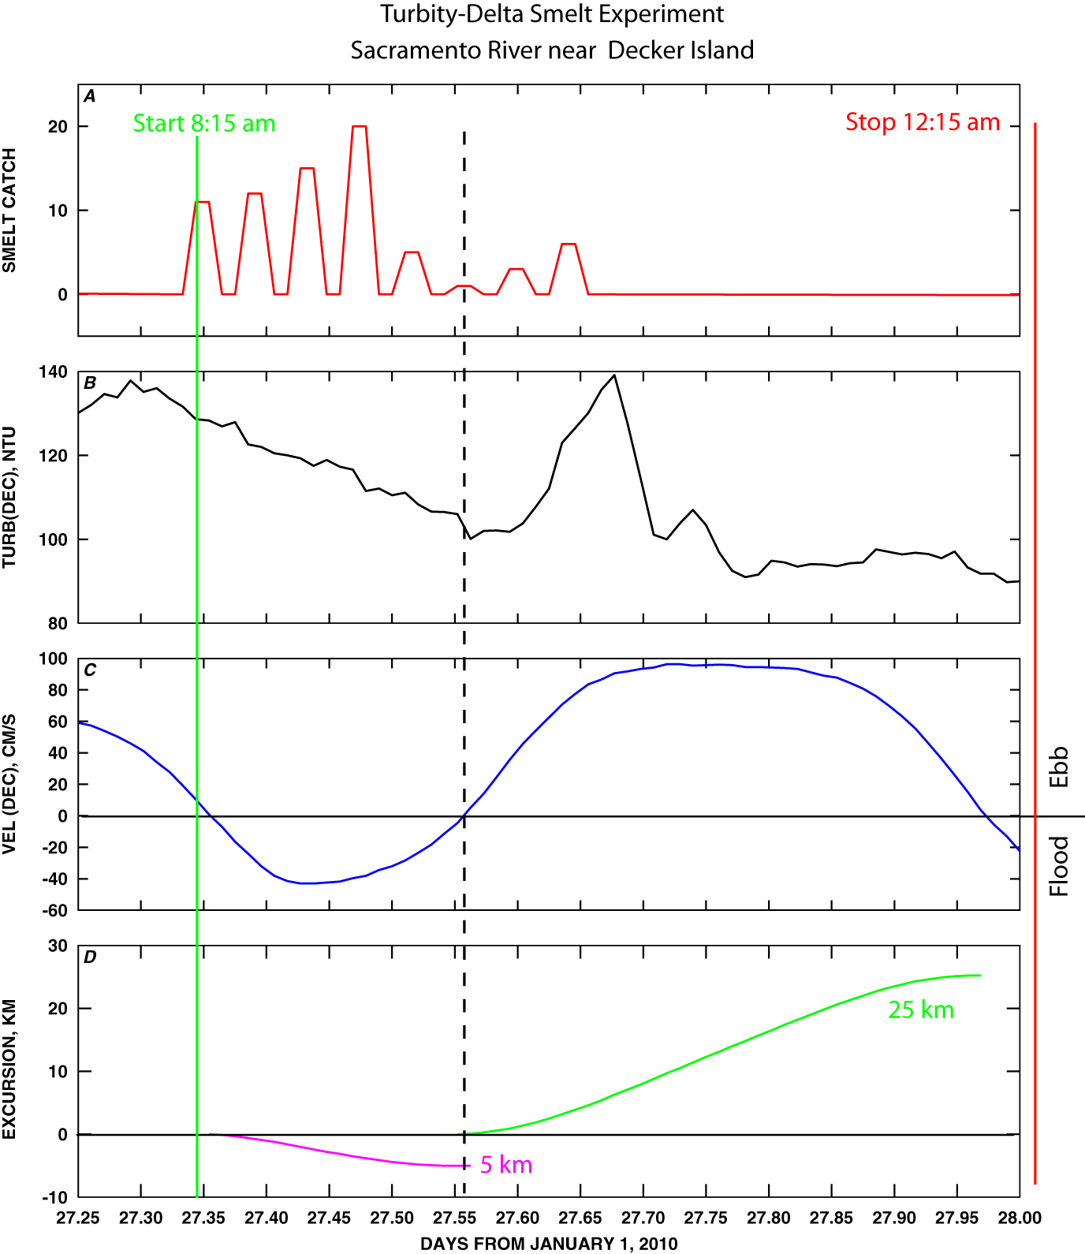

Figure 1 – Time series of: (a) delta smelt trawl catch, (b) turbidity, (c) water velocity, (d) tidal excursion for data collected in the Sacramento River near Decker Island.

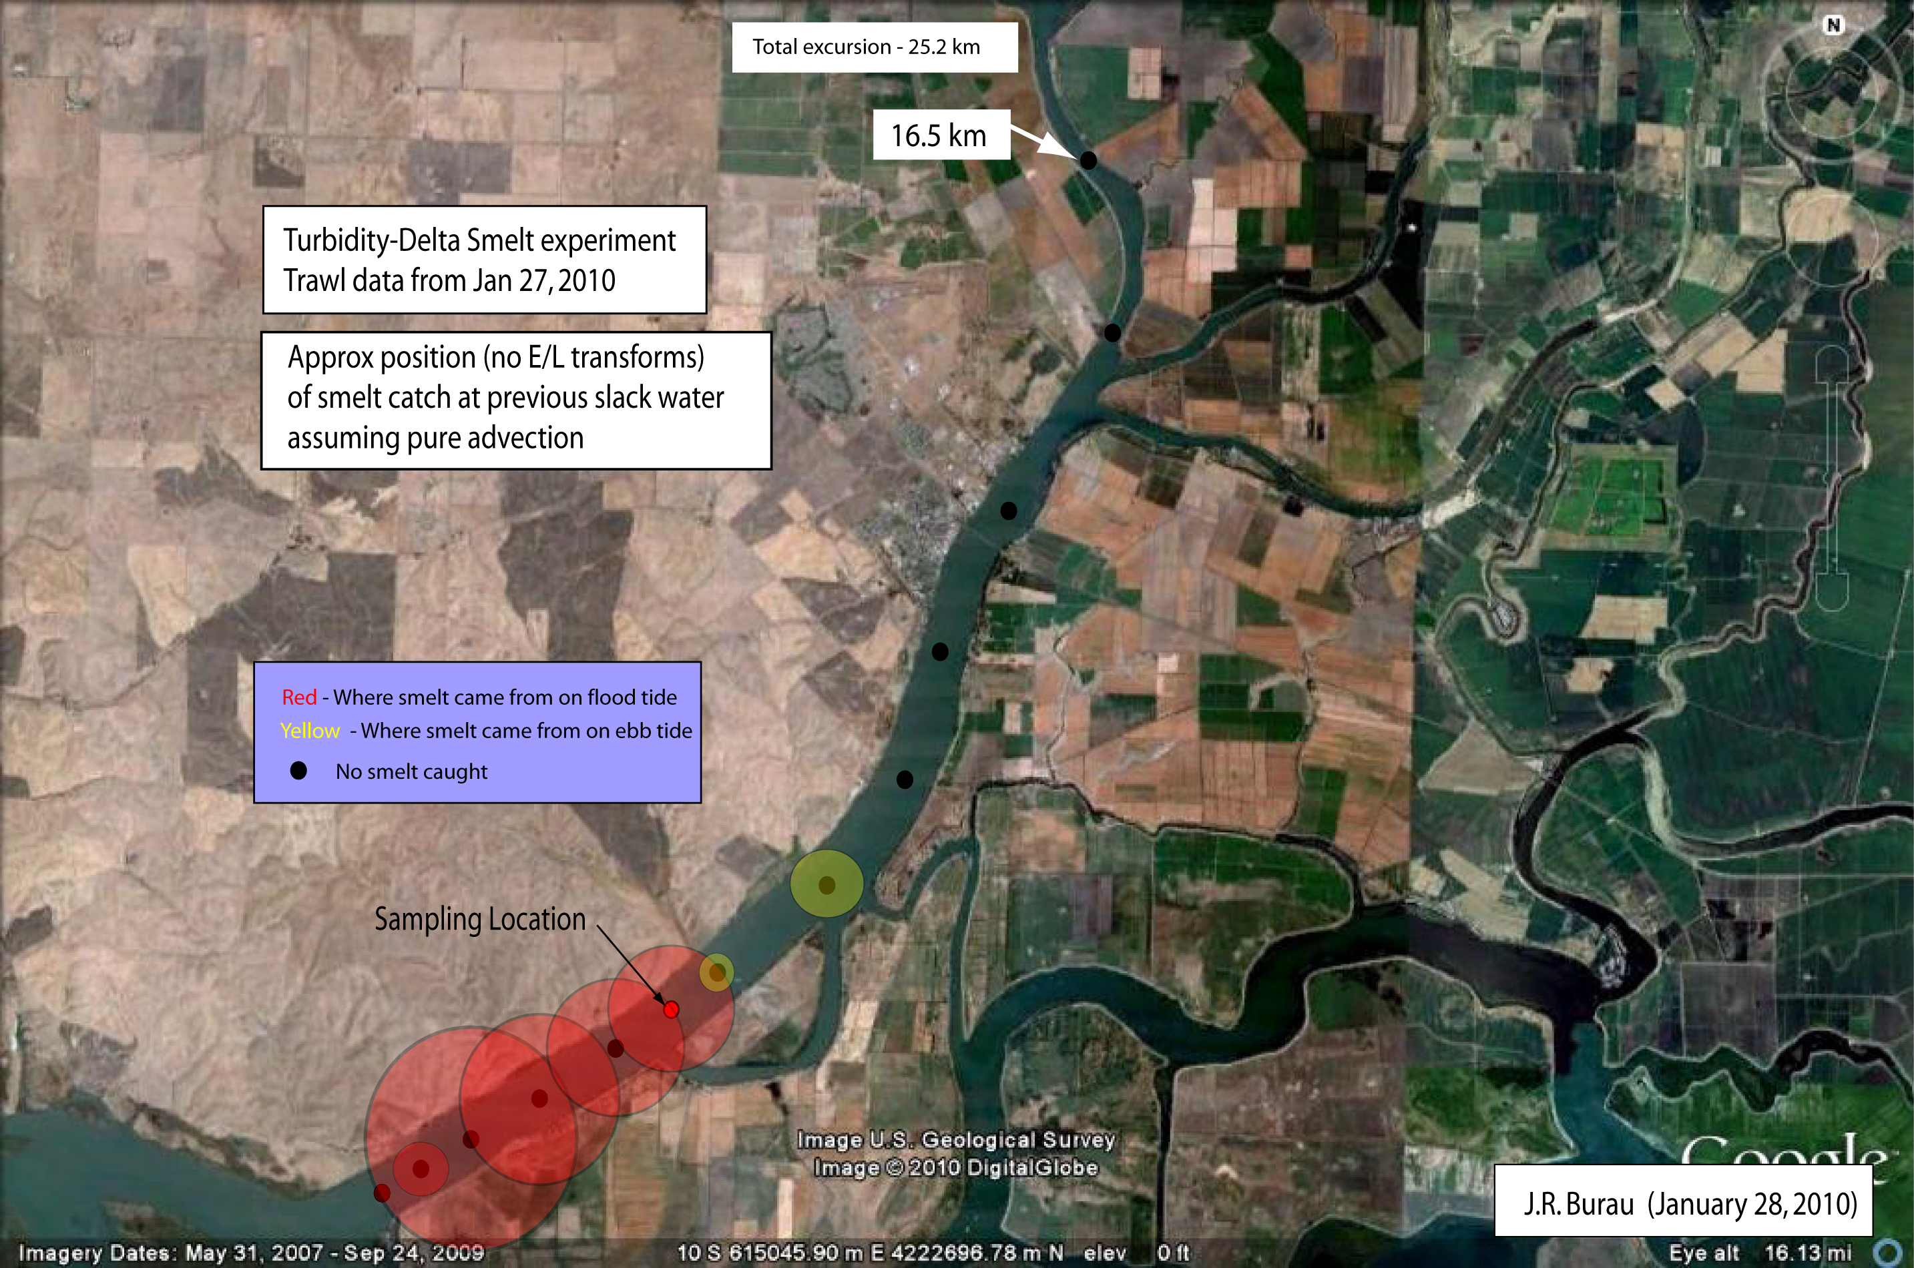

Figure 2 – Plot of locations of trawl catch on the previous slack water – red “bubbles” indicate where smelt were after a flood tide and yellow “bubbles” indicate where smelt were on the previous slack before ebb (assuming pure advection and no Euler-Lagrange transformations)

