### Turbidity Status 1-25-2010

### V.2

### J.R. Burau

**Discussion of Delta-wide distributions**

The first flush continues to move through the system. The discharges at Freeport and at Vernalis have peaked (figures 1 and 2) and remain steady at 55k cfs, the Freemont weir was topped for a couple of days with peak flows of 9k cfs (not shown). Turbidities at Freeport peaked @ 363 NTU on Jan 23 (figure 3) and are declining and at Vernalis peaked at 573 NTU on Jan 21 (figure 4), turbidities at both sites are declining.

Turbidities from the Sacramento River reached Mallard Island January 23 (figure 5) creating a continuous turbidity bridge between Suisun Bay and the north delta. The Southern Delta remains relatively “clear” at stations OBI (figure 6) and MDM (figure 7) as does the southern Mokelumne (not shown), while turbidities in the central delta remain high from a previous wind event (figure 8). Turbidity from the San Joaquin has reached Clifton Court (figure 9).

The USGS plans to field verify a number of the turbidity monitoring stations with grab samples today, especially the “clear water” regions that have been hypothesized as migratory barriers to delta smelt.

**Preemptive reductions in exports and the role of Franks Tract**

On January 25the the turbidity gradient switched from being higher in Franks Tract due to wind wave re-suspension to being higher on the San Joaquin due to Sacramento River derived sediments arriving from the western delta (and possibly Threemile) (Figure 10). Dispersive transports of turbidity into Franks Tract will likely increase dramatically over the next few days creating a large pool of turbidity (some of which may be re-suspended by wind waves) that could be transported towards the pumps. Franks Tract is a large reservoir, relative to the channel capacities of Old and Middle River, and thus once the Turbidities are elevated in Franks Tract (which may occur over the next couple days) it may be difficult to control them with restrictions on Old and Middle River flows, potentially causing prolonged significant reductions in exports. Also, we would point out that if smelt are associated with this influx of turbidity into Franks Tract, they will be difficult to remove from the central delta by changes in exports alone and the transport times from Franks Tract to the pumps is short. The notion that filling Franks Tract with suspended sediment, now, may reduce exports overall from the delta, suggests the possibility of reducing exports now to save water later. These data are very preliminary and this concept is in its infancy, however, this is something we should address in the analysis of these data and in future modeling studies. I would point out that the regulatory averaged stations (Prisoner’s Point, Holland Tract, and Victoria Canal) are too far to the east to pick up transport of turbidity into Franks Tract from the west – if the processes suggested above are occurring, these three stations may not be the best to use to control pumping. In other words, once turbidity is high at the regulatory stations it may be too late.

Finally, although it is too early to tell but it looks like the net flow into Franks Tract through False River may have really increased, bringing turbid water (and perhaps delta smelt) into Franks Tract. We will know better tomorrow.

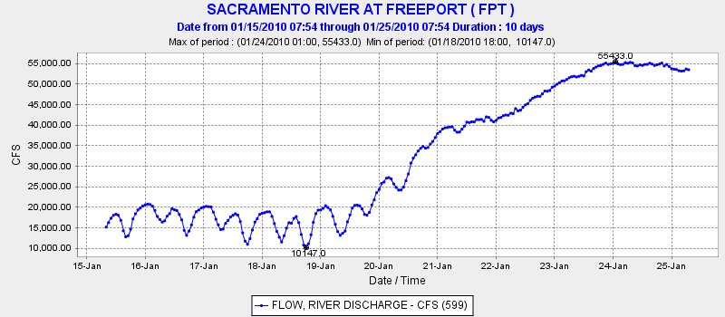

Figure 1 – Discharge in Sacramento River @ Freeport

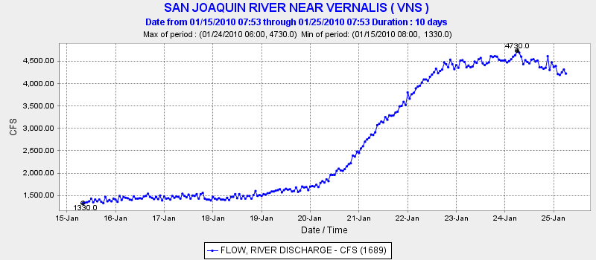

Figure 2 – Discharge in San Joaquin River@ Vernalis

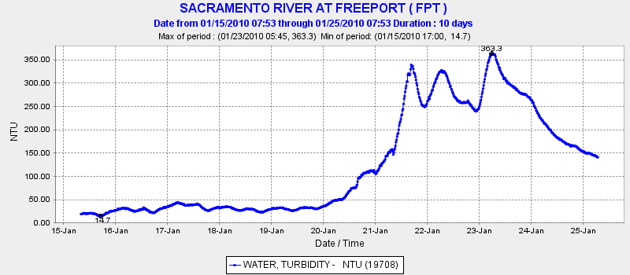

Figure 3 – Turbidity @ Freeport

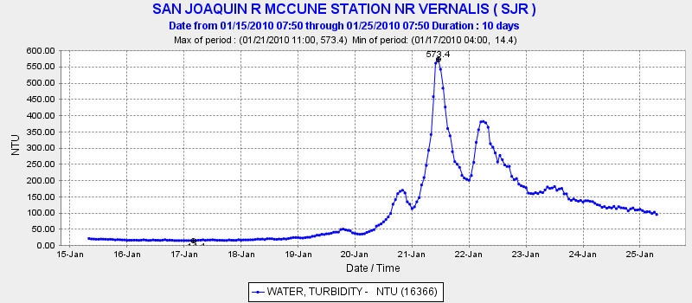

Figure 4 – Turbidity @ Vernalis

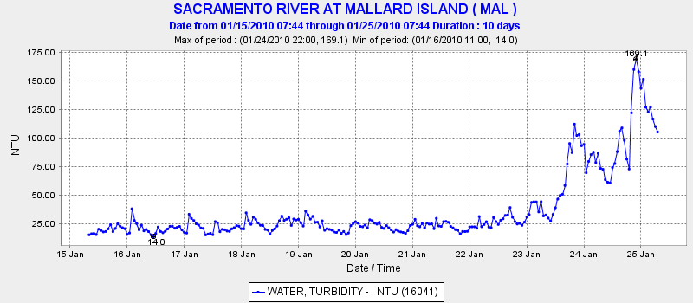

Figure 5 – Turbidity at Mallard I.

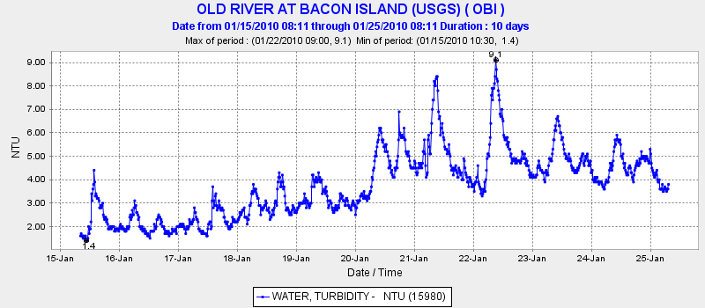

Figure 6 – Turbidity at Old River

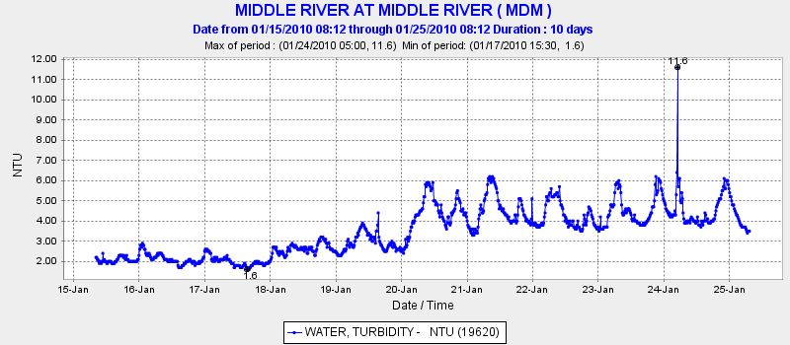

Figure 7 – Turbidity at Middle River

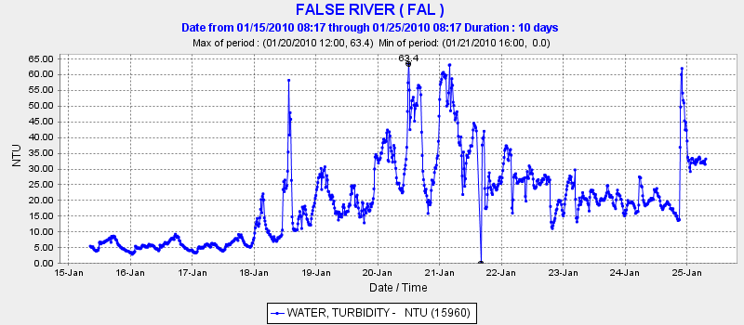

Figure 8 – Turbidity in False River

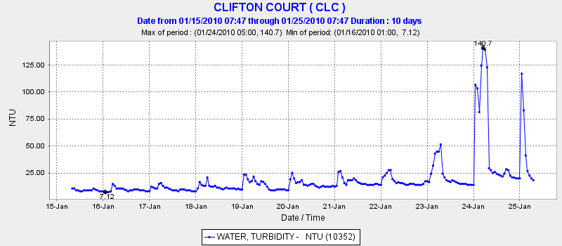

Figure 9 – Turbidity at Clifton Court Forebay.

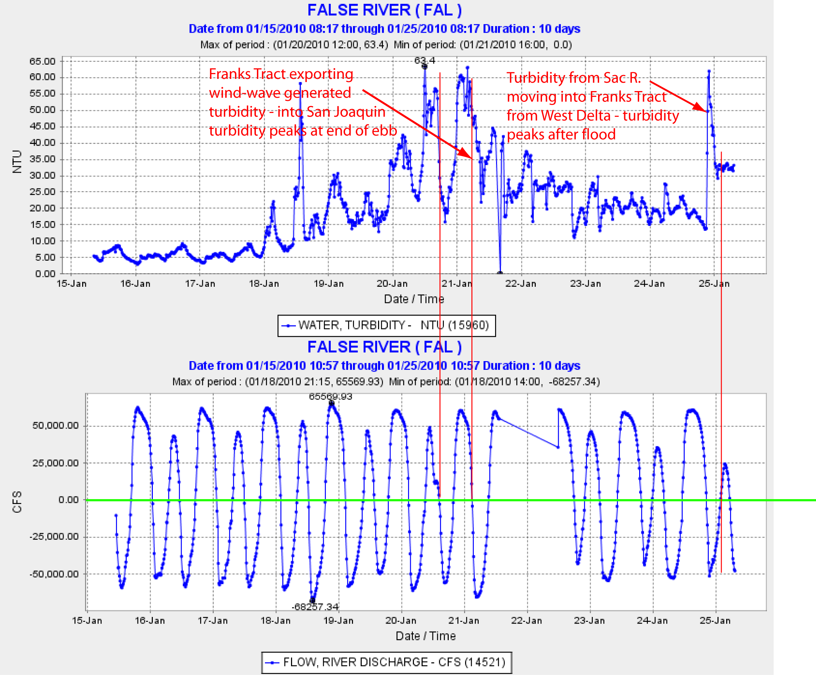

Figure 10 – Discharge (bottom) and turbidities (top) in False River. Turbidities were higher in Franks Tract than the San Joaquin during the period prior to Jan 25, when the pulse of Sacramento River arrived at False River. At which time the San Joaquin looks like it is beginning to pump turbidity into Franks Tract.