**2012-2015 Hydrology Summaries**

***Introduction***

The California State Water Resources Control Board (SWRCB) establishes water quality objectives and monitoring plans to protect the variety of beneficial uses of the water within the upper San Francisco Estuary (Estuary). The SWRCB ensures that these objectives are met, in part, by inclusion of water quality monitoring requirements into water rights decisions issued to the California Department of Water Resources (DWR) and the United States Bureau of Reclamation (USBR) as conditions for operating the California State Water Project (SWP) and the Federal Central Valley Project (CVP), respectively. These requirements include minimum outflows, limits to water diversions by the SWP and CVP, and maximum allowable salinity levels. In addition, DWR and USBR are required to conduct a comprehensive monitoring program to determine compliance with the water quality objectives and report the findings to the SWRCB.

***Hydrologic Conditions***

Hydrologic conditions are typically discussed using water years (October through September). Water years 2012, 2013, 2014 and 2015 are the primary focus of this hydrology summary. Water years are classified for the Sacramento Valley using the Sacramento Valley 40-30-30 Water Year Hydrological Classification Index¹ ².Water years are classified for the San Joaquin Valley using the San Joaquin Valley 60-20-20 Water Year Hydrological Classification Index ³ ⁴.

Water years 2012 to 2015 were quite different hydrologically from the wet year in 2011. Figures 1 and 2 demonstrate how water years 2012 through 2015 compare to 2011, and show water years dating as far back as 1906. Water Years 2006 and 2011 were classified as wet years in both the Sacramento and the San Joaquin Valleys. Water years 2014 and 2015 were classified as critically dry and were the driest 2 consecutive years that the Sacramento Valley has experienced in the past 109 years (Figure 1). Hydrologic conditions in the San Joaquin Valley were even drier than in the Sacramento Valley. In the San Joaquin Valley, water years 2013, 2014 and 2015 were all classified as critically dry. Water years 2012 through 2015 were all dry or critically dry in both the Sacramento and San Joaquin Valleys. Water years 2006 and 2011 were the only wet years in the past 10 years

In addition to water year classifications, other indicators, such as unimpaired runoff and net daily outflow are used to compare hydrologic conditions from year to year. Unimpaired Runoff is an annual estimate of how much water would be entering the Sacramento-San Joaquin Estuary if there were no reservoirs to capture runoff and no diversions to reduce runoff. The unimpaired runoff estimates, shown in Figure 3, for years 2012 to 2015 indicate that flows into the Estuary would have been some of the lowest on record.

Net daily outflow data shows how much water exits the Estuary into the Pacific Ocean. Net daily outflows include releases from reservoirs, local inflow, and withdrawals from the tributaries to the Estuary. Figure 4 shows that outflows were extremely low during Water Years 2012 to 2015, compared to prior years.

¹ The Sacramento Valley 40-30-30 Water Year Hydrological Index is equal to 0.4X current April to July unimpaired runoff + 0.3X current October to March unimpaired runoff + 0.3X previous year’s index (if the previous year’s index exceeds 10.0, then 10.0 is used).

² Sacramento River unimpaired runoff is the sum of Sacramento River at Bend Bridge, Feather River flow to Lake Oroville, Yuba River flow at Smartville and American River flow to Folsom Lake (SWRCB, 1999).

³ The San Joaquin 60-20-20 Water Year Hydrological Classification Index is equal to 0.6X current April to July unimpaired runoff = 0.2X current October to March unimpaired runoff + 0.2X previous year’s index (if the previous year’s index exceeds 4.5, then 4.5 is used).

⁴ San Joaquin River unimpaired runoff is the sum of Stanislaus River inflow to New Melones, Tuolumne River inflow to New Don Pedro Reservoir, Merced River inflow to Lake McClure, and San Joaquin River inflow to Millerton Lake.

Figure1. Water Year Hydrologic Classifications for the Sacramento Valley

from 1906 to 2015.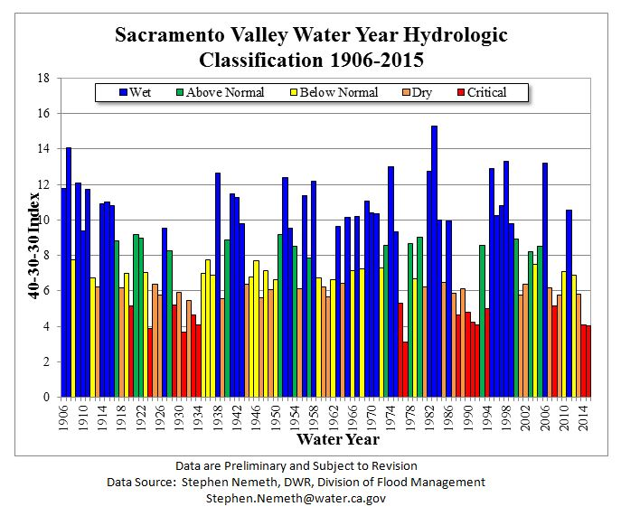 <http://cdec.water.ca.gov/cgi-progs/iodir/wsihist>

Figure2. Water Year Hydrologic Classifications for the San Joaquin Valley from 1906 to 2015.

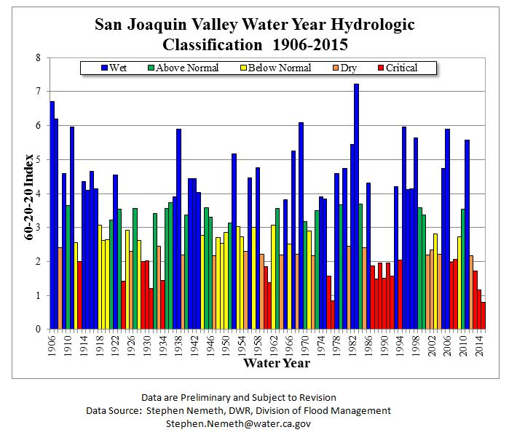

<http://cdec.water.ca.gov/cgi-progs/iodir/wsihist>

Figure 3. Unimpaired Runoff for the Sacramento and the San Joaquin Valley from 1906 to 2015.

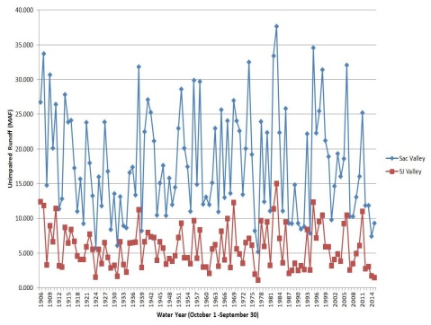

<http://cdec.water.ca.gov/cgi-progs/iodir/wsihist>

Figure 4. Net Daily Outflow

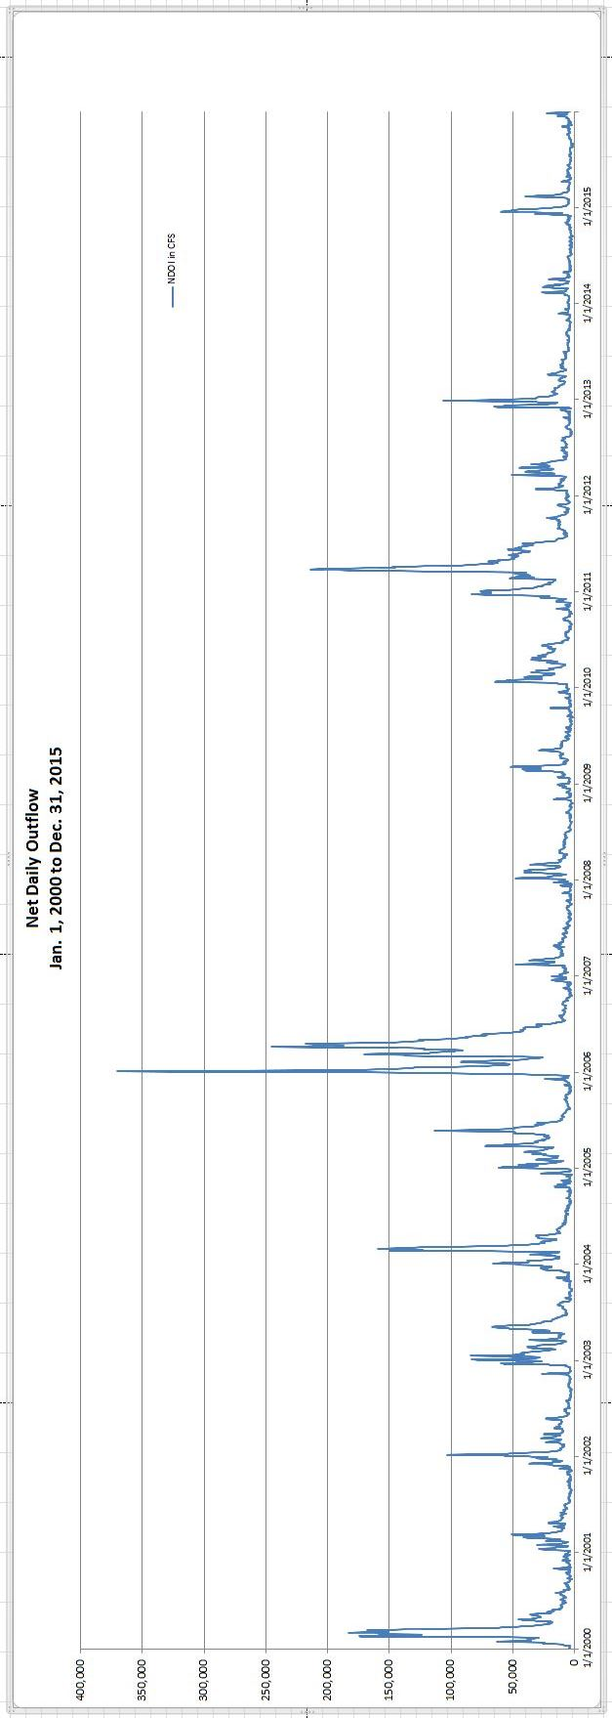

Fig.4.2 2000 through 2009