Environmental Monitoring Program Site Development

Data

* All Environmental Monitoring Program related data was updated through the most recent data (as is posted online).
* Benthic data was converted from a table of catch values to a matrix table format. The benthic data was sent to 34 North in year blocks and needed to be merged, adding 0’s where necessary to complete the matrix and have one file for the period of record.
* Link genus and species columns in the data for Zooplankton, Phytoplankton, and Benthic organisms. This linkage allows the user to view data as “genus species”

Data Filters

* Develop unique filters for each set of biological data.
  + Zooplankton filter by Phylum, Family and Genus Species. In addition, Zooplankton data is also filtered by gear type (CB Net, Pump and Mysid Net)
  + Phytoplankton filter by Class, Taxon, and Common Name (Phyto Group)
  + Benthic filter by Phylum, Order, and Genus Species

Explore Data

* Develop use cases and limits on exploring the environmental data sets (for example limit number of species to be graphed on one graph)
* Custom color assignment for most common species and parameters. Colors were assigned from a list of top species.

Site Content

* Upload the text for the Who, What, and Reporting tabs. Text needed to be converted and styled for Web View.
* Images
  + Upload images with detailed metadata to the Portal. Images and metadata were provided by the EMP staff. In some instances, additional metadata (taxonomic hierarchy) was needed for the species viewer
  + Create and design a new image viewer to be able to view images and metadata simultaneously.
* Custom Help Pages, develop pages to help general users navigate the site. Also, develop pages to direct the data managers to edit and update content.
* The contextual information for the Who, What and Reporting tabs of each data type has been made into an individual wiki to allow for ease of access for editing and updating information

|  |  |
| --- | --- |
| **Tab Name** | **Wiki URL** |
| What is Hydrology? | http://emp.baydeltalive.com/wiki/11392 |
| How is Hydrology Monitored? | http://emp.baydeltalive.com/wiki/11393 |
| Reporting of Hydrologic Conditions in the San Francisco Estuary | http://emp.baydeltalive.com/wiki/11760 |
| What is Water Quality? | http://emp.baydeltalive.com/wiki/11390 |
| How is Water Quality Monitored? | http://emp.baydeltalive.com/wiki/11391 |
| Environmental Monitoring Program Reporting Requirements for Discrete Water Quality Monitoring | http://emp.baydeltalive.com/wiki/11998 |
| What are Zooplankton? | http://emp.baydeltalive.com/wiki/11365 |
| How are Zooplankton Monitored? | http://emp.baydeltalive.com/wiki/11366 |
| Environmental Monitoring Program Reporting Requirements for Zooplankton | http://emp.baydeltalive.com/wiki/11367 |
| What are Benthic Organisms? | http://emp.baydeltalive.com/wiki/11368 |
| How are Benthic Organisms Monitored? | http://emp.baydeltalive.com/wiki/11369 |
| Environmental Monitoring Program Reporting Requirements for Benthic Organisms | http://emp.baydeltalive.com/wiki/11370 |
| What are Phytoplankton? | http://emp.baydeltalive.com/wiki/11371 |
| How is Phytoplankton Monitored? | http://emp.baydeltalive.com/wiki/11372 |
| Environmental Monitoring Program Reporting requirements for Phytoplankton | http://emp.baydeltalive.com/wiki/11386 |
| What are Estuary Fish and Why are they Important? | http://emp.baydeltalive.com/wiki/11551 |
| How are Fish Monitored? | http://emp.baydeltalive.com/wiki/11558 |
| Reporting of Fish Status and Trends in the San Francisco Estuary | http://emp.baydeltalive.com/wiki/11564 |

Reporting Tab Custom Graphs

* Custom filters for building the reporting tab graphs (i.e. Grouping all samples <5% of total as Other for Phytoplankton Reporting Graphs)
* Custom Captions for Reporting Tab Graphs
* Build custom graphs for each program based on samples provided by EMP
  + Benthic: 10 graphs
  + Zooplankton: 4 graphs, 1 table
  + Phytoplankton: 13 graphs
  + Water Quality: 18 graphs

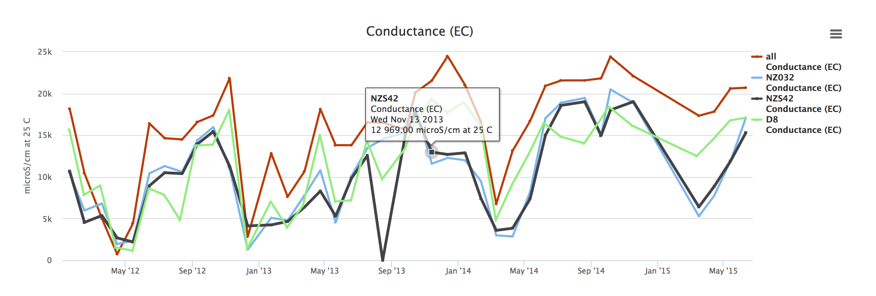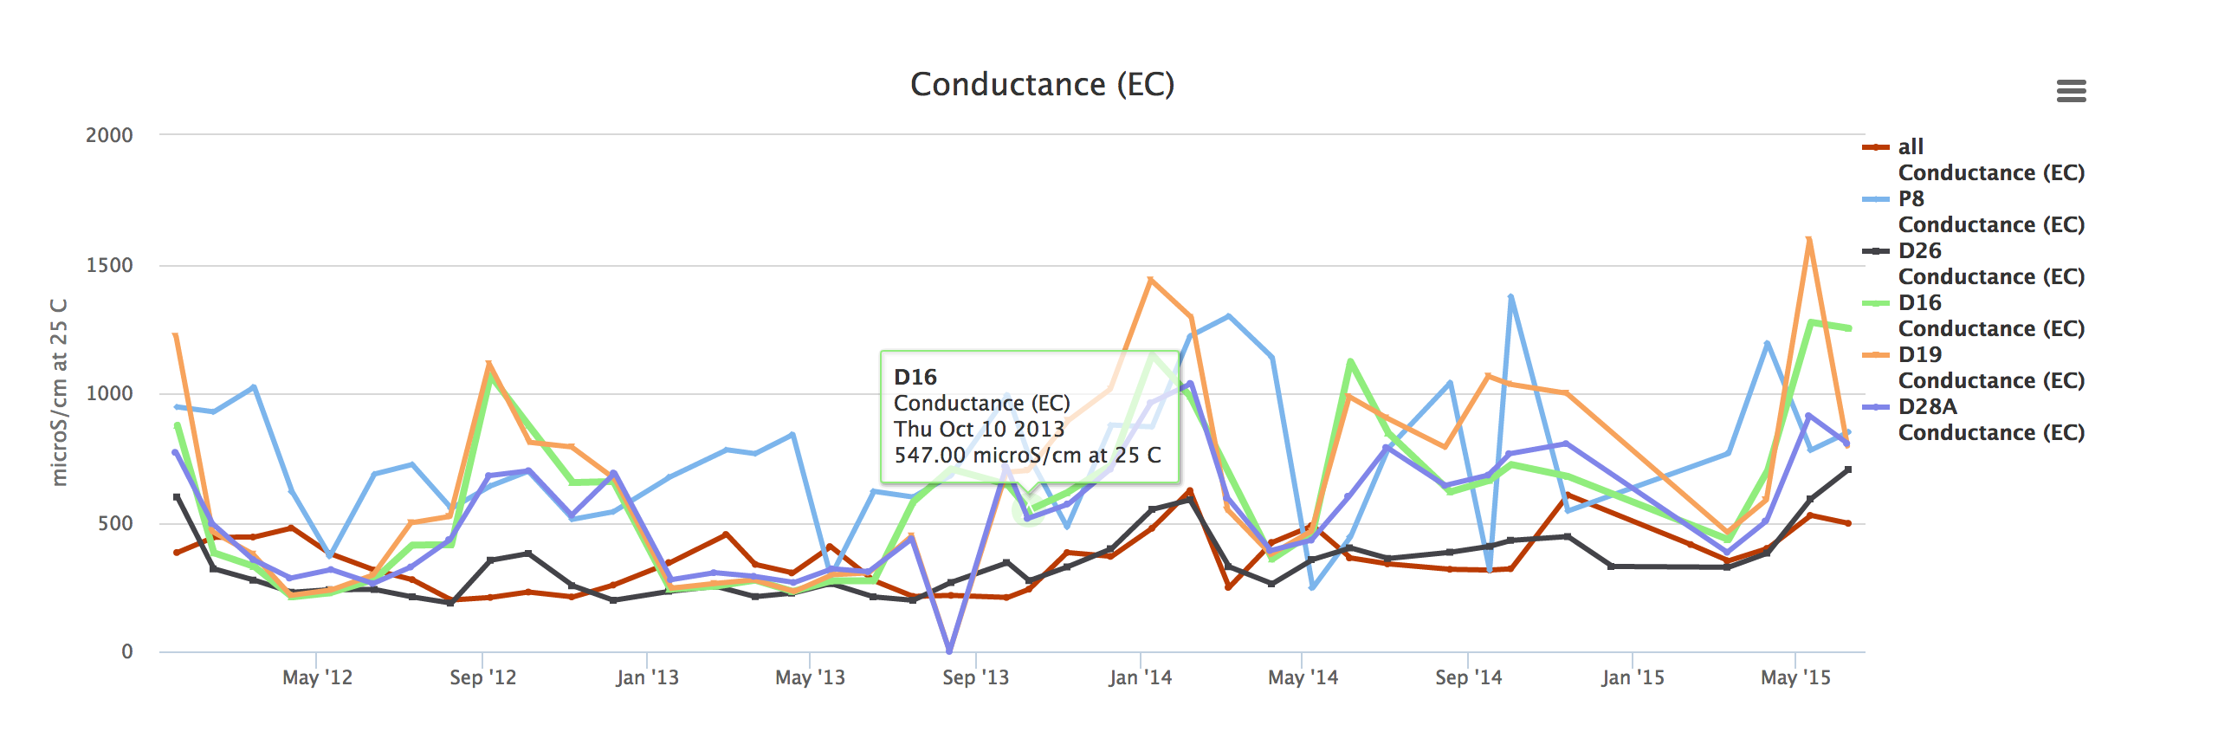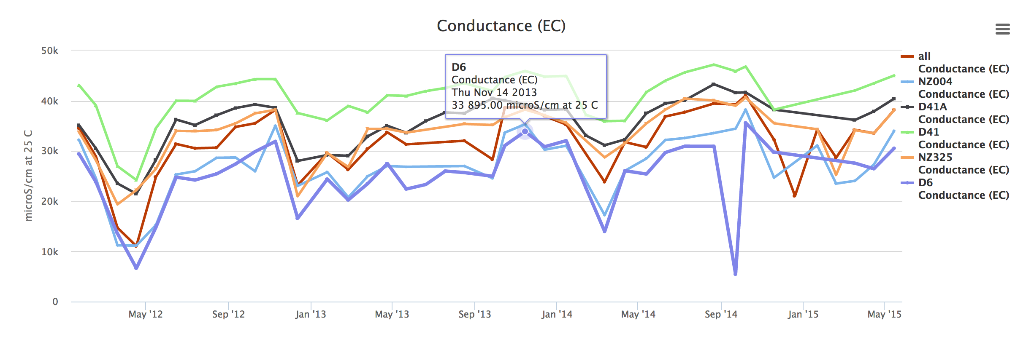

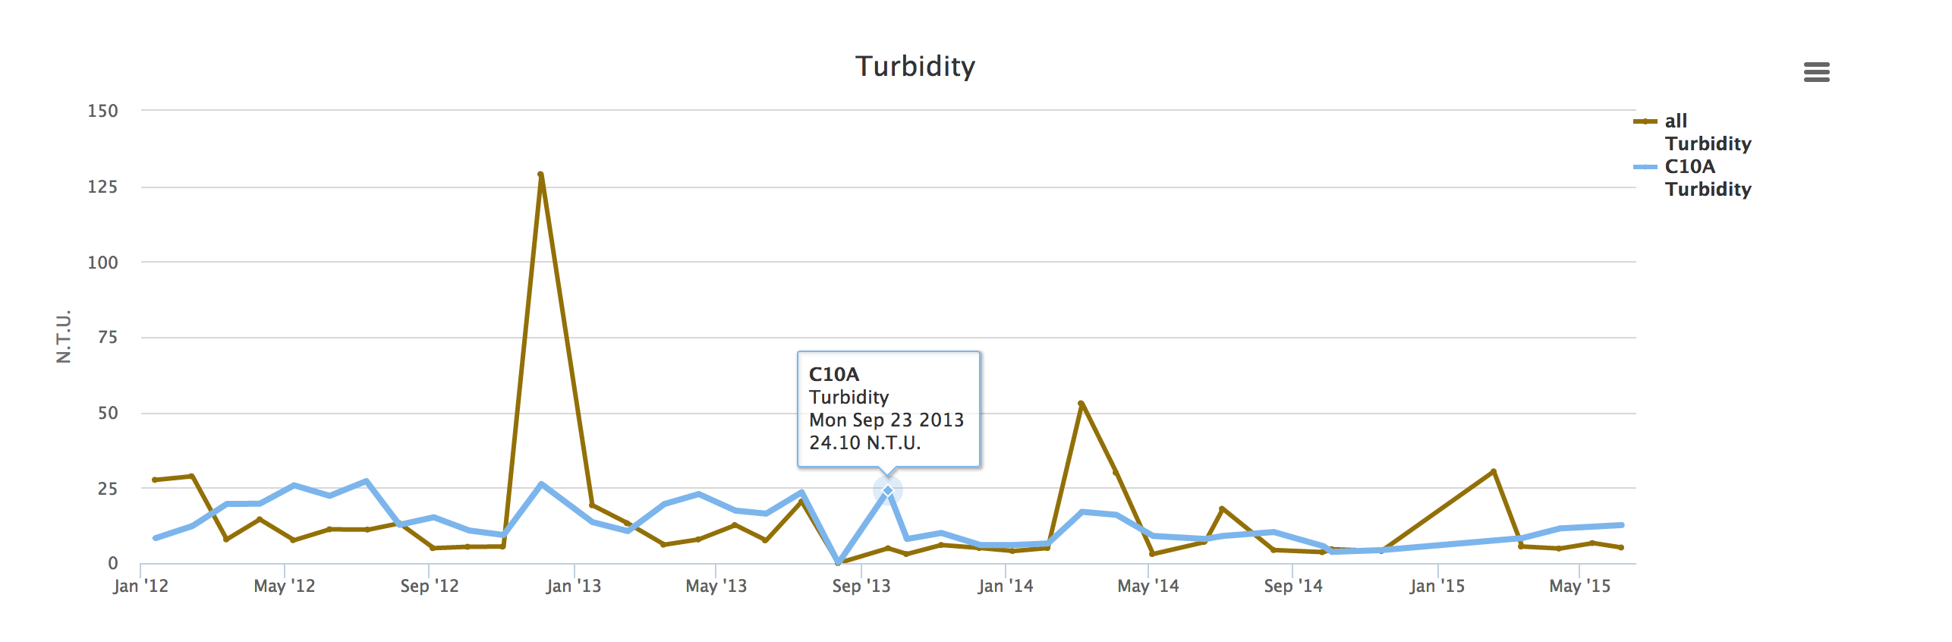

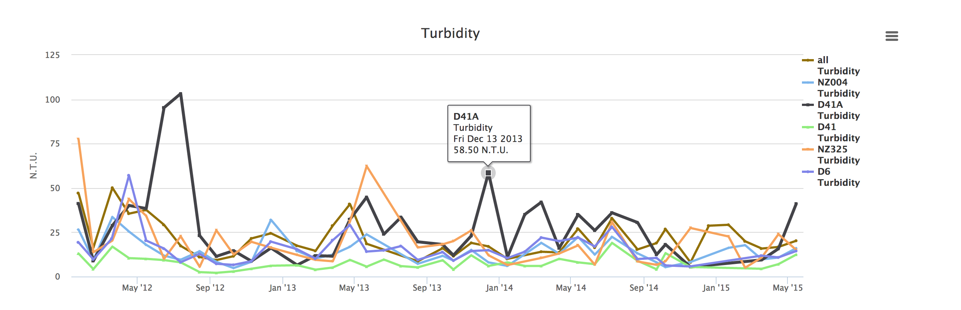

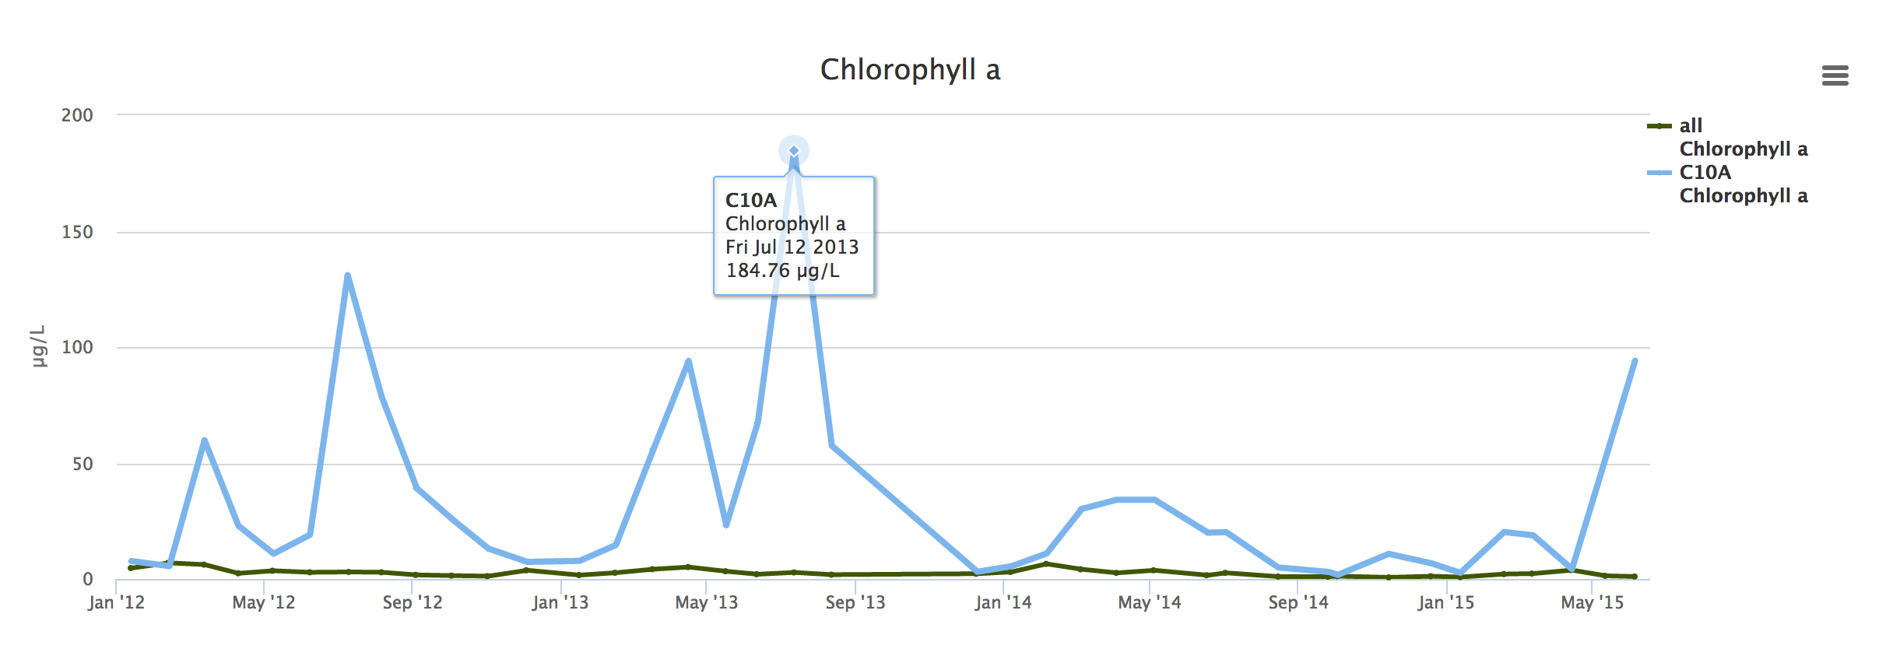

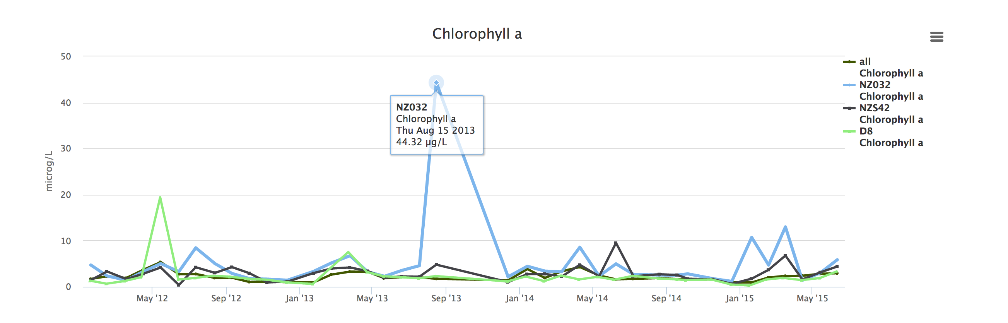

* + Hydrology: 4 graphs

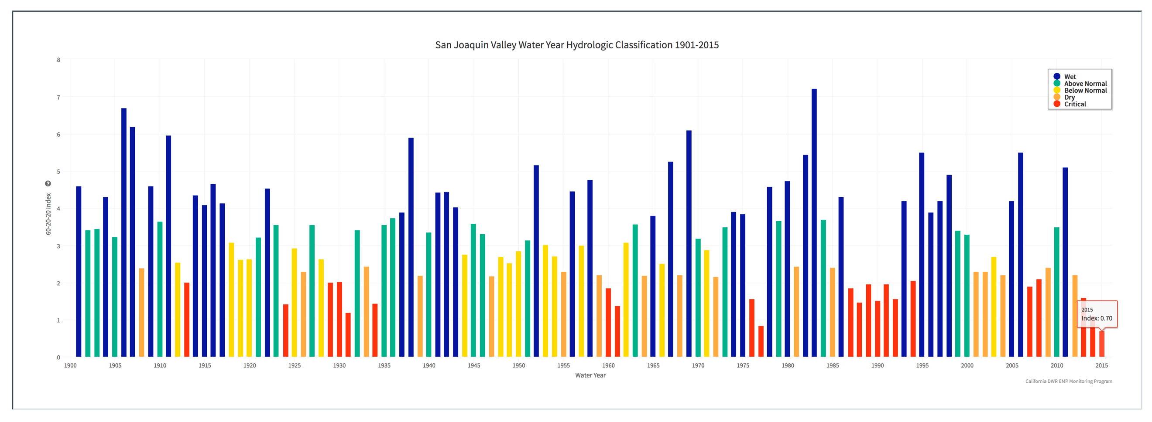

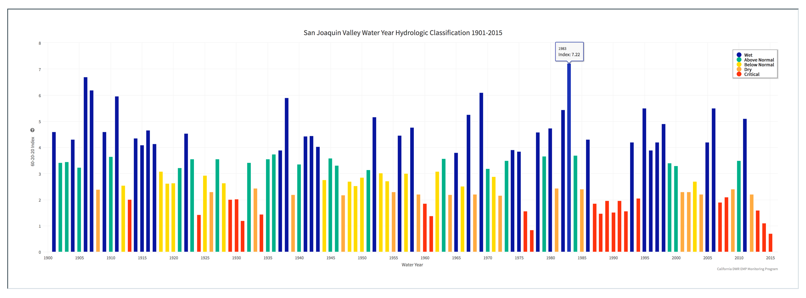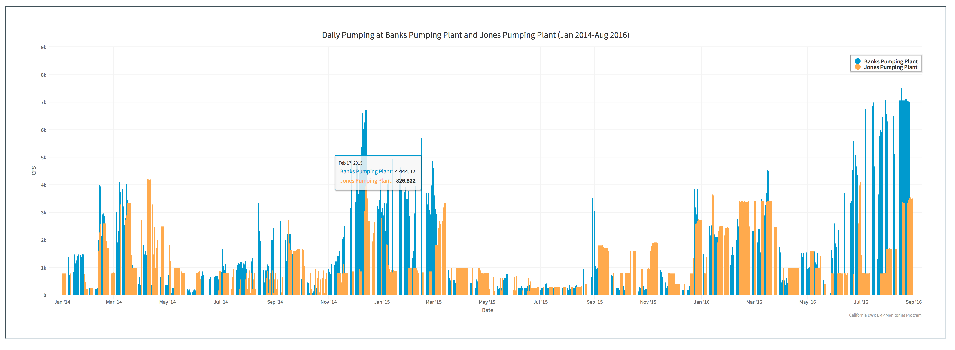

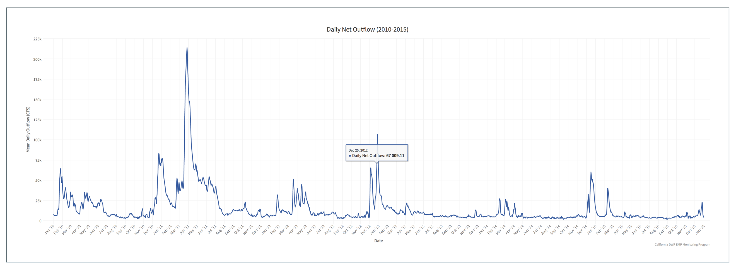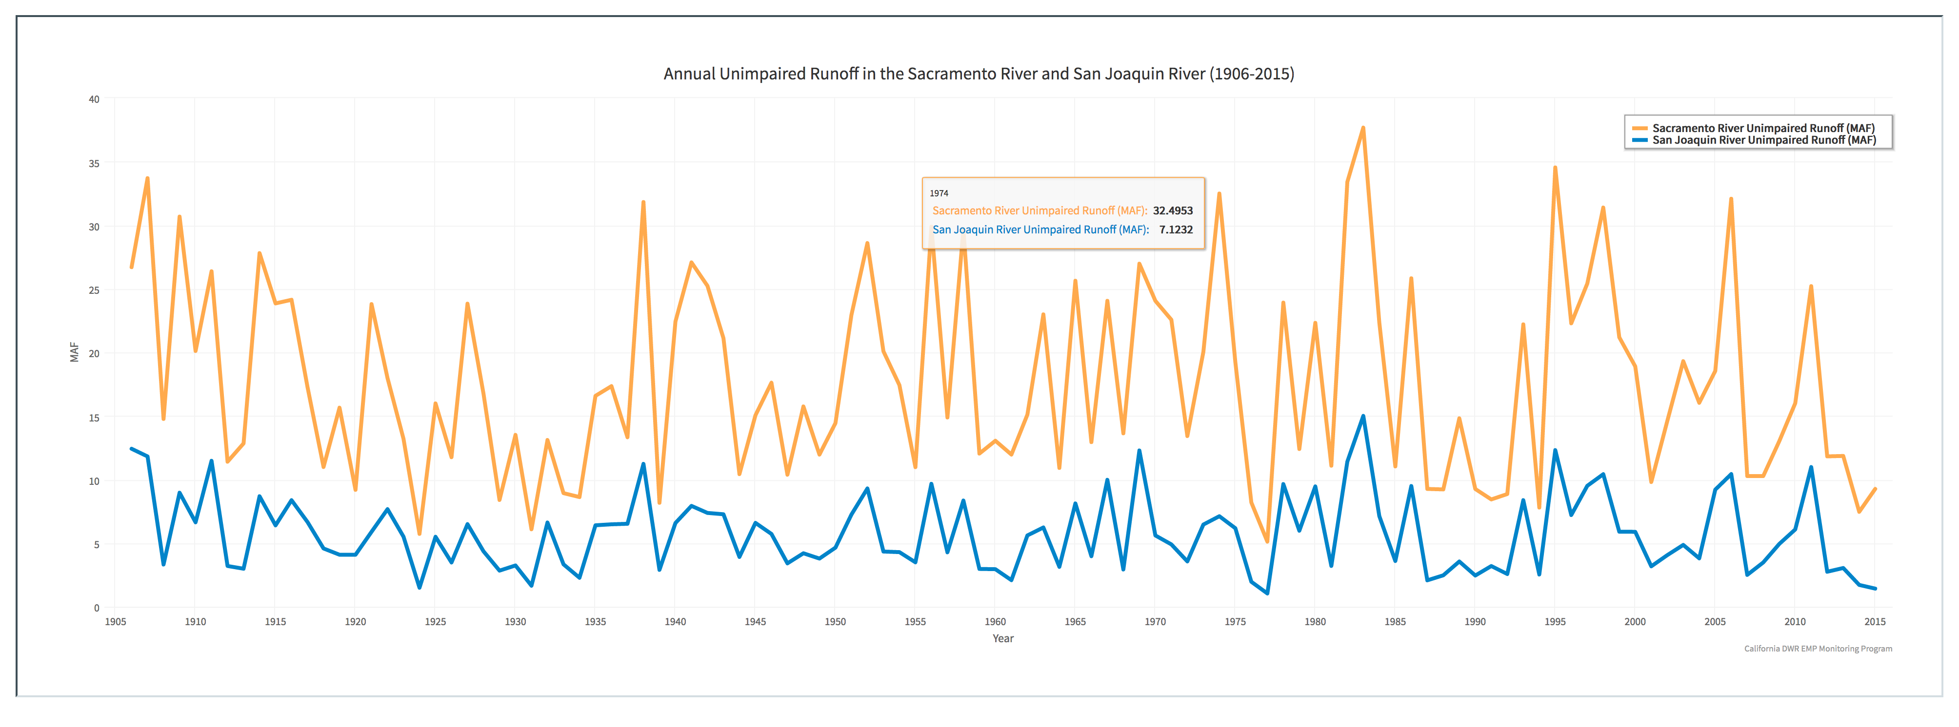

Custom GIS

* All layers created for the EMP exist in 2 forms (Web Feature Service, WFS, and Web Mapping Service, WMS)
* The Unique station identifier has been included in the GIS as well as metadata (other samples collected at that location, start and end date of data collection, station name, station ID, and station latitude and longitude)

Layer List

|  |  |  |
| --- | --- | --- |
| Layer Name | Layer URL | Thumbnail |
| EMP Stations by Data Type (Active) |  | Screen%20Shot%202016-12-13%20at%2011.20.26%20AM.png |
| EMP Stations by Data Type and Historic vs. Active |  | Screen%20Shot%202016-12-13%20at%2011.21.06%20AM.png |
| EMP Stations by Historic vs Active |  | Screen%20Shot%202016-12-13%20at%2011.21.46%20AM.png |
| EMP Active Zooplankton Monitoring Stations |  | Screen%20Shot%202016-12-13%20at%2011.23.10%20AM.png |
| EMP Active Discrete Water Quality Monitoring Stations |  | Screen%20Shot%202016-12-13%20at%2011.23.33%20AM.png |
| EMP Active Phytoplankton Monitoring Stations |  | Screen%20Shot%202016-12-13%20at%2011.24.37%20AM.png |
| EMP Active Benthic Monitoring Stations |  | Screen%20Shot%202016-12-13%20at%2011.25.35%20AM.png |
| EMP Zooplankton Monitoring Locations (Active and Historic) |  | Screen%20Shot%202016-12-13%20at%2011.26.04%20AM.png |
| EMP Discrete Water Quality Monitoring Locations (Active and Historic) |  | Screen%20Shot%202016-12-13%20at%2011.35.00%20AM.png |
| EMP Phytoplankton Monitoring Locations (Active and Historic) |  | Screen%20Shot%202016-12-13%20at%2011.35.58%20AM.png |
| EMP Benthic Monitoring Locations (Active and Historic) |  | Screen%20Shot%202016-12-13%20at%2011.19.31%20AM.png |
| EMP Discrete Water Quality Stations |  | Screen%20Shot%202016-12-13%20at%2011.35.31%20AM.png |
| EMP Real Time Water Quality Monitoring Locations |  | Screen%20Shot%202016-12-13%20at%2011.23.57%20AM.png |
| X2 Key Locations |  | Screen%20Shot%202016-12-13%20at%2011.37.38%20AM.png |
| CDEC Stations Delta Area |  | Screen%20Shot%202016-12-13%20at%2011.36.57%20AM.png |

Maps

* Create saved maps of monitoring (current and historic) locations for the Environmental Monitoring Program.

|  |  |
| --- | --- |
| Saved Map Name | Map URL |
| Delta Region California Data Exchange Center Monitoring Locations | http://emp.baydeltalive.com/maps/12032 |
| Environmental Monitoring Program Current Benthic Monitoring locations | http://emp.baydeltalive.com/maps/11774 |
| Environmental Monitoring Program Current Zooplankton Monitoring Locations | http://emp.baydeltalive.com/maps/11778 |
| Environmental Monitoring Program Current Phytoplankton Monitoring Locations | http://emp.baydeltalive.com/maps/11772 |
| Environmental Monitoring Program Current Discrete Water Quality Monitoring Locations | http://emp.baydeltalive.com/maps/11776 |
| Environmental Monitoring Program Discrete Water Quality Monitoring Current and Historic Monitoring Locations | http://emp.baydeltalive.com/maps/11756 |
| Environmental Monitoring Program Zooplankton Current and Historic Monitoring Locations | http://emp.baydeltalive.com/maps/11640 |
| Environmental Monitoring Program Phytoplankton Current and Historic Monitoring Locations | http://emp.baydeltalive.com/maps/11636 |
| Environmental Monitoring Program Benthic Monitoring Stations Current and Historic | http://emp.baydeltalive.com/maps/11639 |
|  |  |
|  |  |
|  |  |
|  |  |
|  |  |