Attachment 3
Soil Survey Information
Attachment 3
Complete Soils Survey Information for Series Encountered in Study Areas

Map Unit Description: Rd—RINDGE MUCK
Contra Costa County, California Version date: 7/22/2008 1:16:22 PM
Map Unit Setting
Elevation: 10 to 20 feet
Mean annual precipitation: 12 to 16 inches
Mean annual air temperature: 59 degrees F
Frost-free period: 250 to 310 days
Map Unit Composition
Rindge and similar soils: 85 percent
Minor components: 9 percent
Setting
Landform: Marshes
Landform position (three-dimensional): Talf
Down-slope shape: Linear
Across-slope shape: Linear
Parent material: Organic material
Properties and qualities
Slope: 0 to 2 percent
Depth to restrictive feature: More than 80 inches
Drainage class: Very poorly drained
Capacity of the most limiting layer to transmit water (Ksat): High to
very high (5.95 to 19.98 in/hr)
Depth to water table: About 12 to 48 inches
Frequency of flooding: Rare
Frequency of ponding: None
Available water capacity: Very high (about 16.8 inches)
Interpretive groups
Land capability classification (irrigated): 3w
Land capability (nonirrigated): 4w
Typical profile
0 to 60 inches: Muck
Minor Components
Webile
Percent of map unit: 5 percent
Landform: Marshes
Kingile
Percent of map unit: 4 percent
Landform: Deltas
Landform position (three-dimensional): Rise
Map Unit Description: 230—Ryde clay loam, partially drained, 0 to 2 percent slopes
Map Unit Setting
Elevation: -20 to 0 feet
Mean annual precipitation: 14 inches
Mean annual air temperature: 61 degrees F
Frost-free period: 270 days
Map Unit Composition
Ryde and similar soils: 85 percent
Minor components: 15 percent
Setting
Landform: Flood plains, deltas
Landform position (two-dimensional): Toeslope
Landform position (three-dimensional): Tread
Down-slope shape: Linear
Across-slope shape: Linear
Parent material: Herbaceous organic material derived from reeds and
tules, and alluvium derived from mixed rick sources
Properties and qualities
Slope: 0 to 2 percent
Depth to restrictive feature: More than 80 inches
Drainage class: Very poorly drained
Capacity of the most limiting layer to transmit water (Ksat): Moderately
high (0.20 to 0.57 in/hr)
Depth to water table: About 36 to 48 inches
Frequency of flooding: Rare
Frequency of ponding: None
Maximum salinity: Nonsaline (0.0 to 2.0 mmhos/cm)
Available water capacity: Very high (about 12.8 inches)
Interpretive groups
Land capability classification (irrigated): 3w
Land capability (nonirrigated): 4w
Typical profile
0 to 24 inches: Clay loam
24 to 63 inches: Stratified muck to silty clay loam
Minor Components
Guard
Percent of map unit: 3 percent
Landform: Rims
Egbert
Percent of map unit: 2 percent
Landform: Flood plains
Itano
Percent of map unit: 2 percent
Landform: Flood plains
Kingile
Percent of map unit: 2 percent
Landform: Deltas
Peltier
Percent of map unit: 2 percent
Landform: Flood plains
Rindge
Percent of map unit: 2 percent
Landform: Deltas
Scribner
Percent of map unit: 2 percent
Landform: Flood plains

Map Unit Description: Se—SHIMA MUCK
Map Unit Setting
Elevation: 0 feet
Mean annual precipitation: 12 to 14 inches
Mean annual air temperature: 61 degrees F
Frost-free period: 260 to 310 days
Map Unit Composition
Shima and similar soils: 85 percent
Setting
Landform: Marshes
Landform position (three-dimensional): Talf
Down-slope shape: Linear
Across-slope shape: Linear
Parent material: Organic material
Properties and qualities
Slope: 0 to 1 percent
Depth to restrictive feature: More than 80 inches
Drainage class: Very poorly drained
Capacity of the most limiting layer to transmit water (Ksat): Moderately
low to moderately high (0.06 to 0.20 in/hr)
Depth to water table: About 24 to 48 inches
Frequency of flooding: Rare
Frequency of ponding: None
Maximum salinity: Nonsaline to very slightly saline (0.0 to 4.0
mmhos/cm)
Available water capacity: Moderate (about 7.8 inches)
Interpretive groups
Land capability classification (irrigated): 3w
Land capability (nonirrigated): 4w
Typical profile
0 to 21 inches: Muck
21 to 25 inches: Silty clay
25 to 60 inches: Sand
Map Unit Description: Wa—WEBILE MUCK
Map Unit Setting
Elevation: 10 to 20 feet
Mean annual precipitation: 12 to 14 inches
Mean annual air temperature: 61 degrees F
Frost-free period: 260 to 330 days
Map Unit Composition
Webile and similar soils: 85 percent
Minor components: 14 percent
Setting
Landform: Marshes, channels
Landform position (three-dimensional): Talf, dip
Down-slope shape: Linear
Across-slope shape: Linear, concave
Parent material: Organic material and alluvium derived from igneous and
sedimentary rock
Properties and qualities
Slope: 0 to 1 percent
Depth to restrictive feature: More than 80 inches
Drainage class: Very poorly drained
Capacity of the most limiting layer to transmit water (Ksat): Moderately
low to moderately high (0.06 to 0.20 in/hr)
Depth to water table: About 36 to 60 inches
Frequency of flooding: Rare
Frequency of ponding: None
Maximum salinity: Nonsaline (0.0 to 2.0 mmhos/cm)
Available water capacity: Very high (about 15.4 inches)
Interpretive groups
Land capability classification (irrigated): 3w
Land capability (nonirrigated): 4w
Typical profile
0 to 43 inches: Muck
43 to 60 inches: Silty clay
Minor Components
Kingile
Percent of map unit: 10 percent
Landform: Marshes
Egbert
Percent of map unit: 4 percent
Landform: Sloughs
Map Unit Description: 179—​Itano silty clay loam, partially drained, 0 to 2 percent slopes
Map Unit Setting
Elevation: -​20 to 0 feet
Mean annual precipitation: 14 inches
Mean annual air temperature: 61 degrees F
Frost-​free period: 270 days
Map Unit Composition
Itano and similar soils: 85 percent
Minor components: 15 percent
Setting
Landform: Flood plains, deltas
Landform position (two-​dimensional): Toeslope
Landform position (three-​dimensional): Tread
Down-​slope shape: Linear
Across-​slope shape: Linear
Parent material: Alluvium derived from granitic rock sources
Properties and qualities
Slope: 0 to 2 percent
Depth to restrictive feature: More than 80 inches
Drainage class: Poorly drained
Capacity of the most limiting layer to transmit water (Ksat):
Moderately high (0.20 to 0.57 in/hr)
Depth to water table: About 36 to 54 inches
Frequency of flooding: Rare
Frequency of ponding: None
Maximum salinity: Nonsaline (0.0 to 2.0 mmhos/cm)
Available water capacity: High (about 10.5 inches)
Interpretive groups
Land capability classification (irrigated): 3w
Land capability (nonirrigated): 4w
Typical profile
0 to 15 inches: Silty clay loam
15 to 34 inches: Stratified silt loam to silty clay loam
34 to 60 inches: Stratified very fine sandy loam to silty clay loam
Minor Components
Dello
Percent of map unit: 4 percent
Landform: Flood plains
Kingile
Percent of map unit: 4 percent
Landform: Deltas
Ryde
Percent of map unit: 4 percent
Landform: Flood plains
Map Unit Description: 225—​RINDGE MUCK, PARTIALLY DRAINED, 0 TO 2 PERCENT SLOPES
Map Unit Setting
Elevation: -​20 to 0 feet
Mean annual precipitation: 14 inches
Mean annual air temperature: 61 degrees F
Frost-​free period: 270 days
Map Unit Composition
Rindge and similar soils: 85 percent
Minor components: 15 percent
Setting
Landform: Deltas
Landform position (two-​dimensional): Toeslope
Landform position (three-​dimensional): Tread
Down-​slope shape: Linear
Across-​slope shape: Linear
Parent material: Herbaceous organic material deriveed from reeds
and tules
Properties and qualities
Slope: 0 to 2 percent
Depth to restrictive feature: More than 80 inches
Drainage class: Very poorly drained
Capacity of the most limiting layer to transmit water (Ksat): High
to very high (5.95 to 19.98 in/hr)
Depth to water table: About 36 to 48 inches
Frequency of flooding: Rare
Frequency of ponding: None
Maximum salinity: Nonsaline (0.0 to 2.0 mmhos/cm)
Available water capacity: Very high (about 16.8 inches)
Interpretive groups
Land capability classification (irrigated): 3w
Land capability (nonirrigated): 4w
Typical profile
0 to 13 inches: Muck
13 to 60 inches: Mucky peat
Minor Components
Kingile
Percent of map unit: 4 percent
Landform: Deltas
Peltier
Percent of map unit: 4 percent
Landform: Flood plains
Ryde
Percent of map unit: 4 percent
Landform: Flood plains

Map Unit Description: 263—​Venice mucky silt loam, partially drained, 0 to 2 percent slopes, overwashed
Map Unit Setting
Elevation: -​20 to 0 feet
Mean annual precipitation: 14 inches
Mean annual air temperature: 61 degrees F
Frost-​free period: 270 days
Map Unit Composition
Venice and similar soils: 85 percent
Minor components: 15 percent
Setting
Landform: Deltas
Landform position (two-​dimensional): Toeslope
Landform position (three-​dimensional): Tread
Down-​slope shape: Linear
Across-​slope shape: Linear
Parent material: Herbaceous organic material derived from reeds
and tules
Properties and qualities
Slope: 0 to 2 percent
Depth to restrictive feature: More than 80 inches
Drainage class: Very poorly drained
Capacity of the most limiting layer to transmit water (Ksat): High
to very high (5.95 to 19.98 in/hr)
Depth to water table: About 36 to 48 inches
Frequency of flooding: Rare
Frequency of ponding: None
Maximum salinity: Nonsaline (0.0 to 2.0 mmhos/cm)
Available water capacity: Very high (about 15.1 inches)
Interpretive groups
Land capability classification (irrigated): 3w
Land capability (nonirrigated): 4w
Typical profile
0 to 15 inches: Mucky silt loam
15 to 60 inches: Mucky peat
Minor Components
Peltier
Percent of map unit: 5 percent
Landform: Flood plains
Rindge
Percent of map unit: 5 percent
Landform: Deltas
Ryde
Percent of map unit: 5 percent
Landform: Flood plains

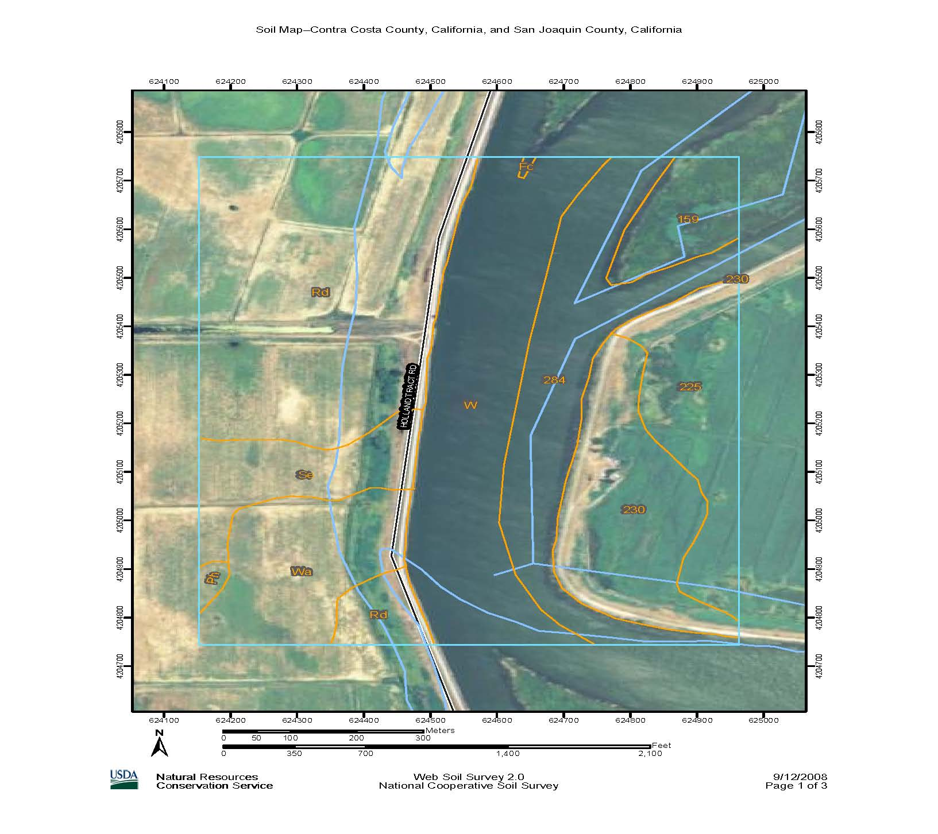
Soils on Old River Study Area.
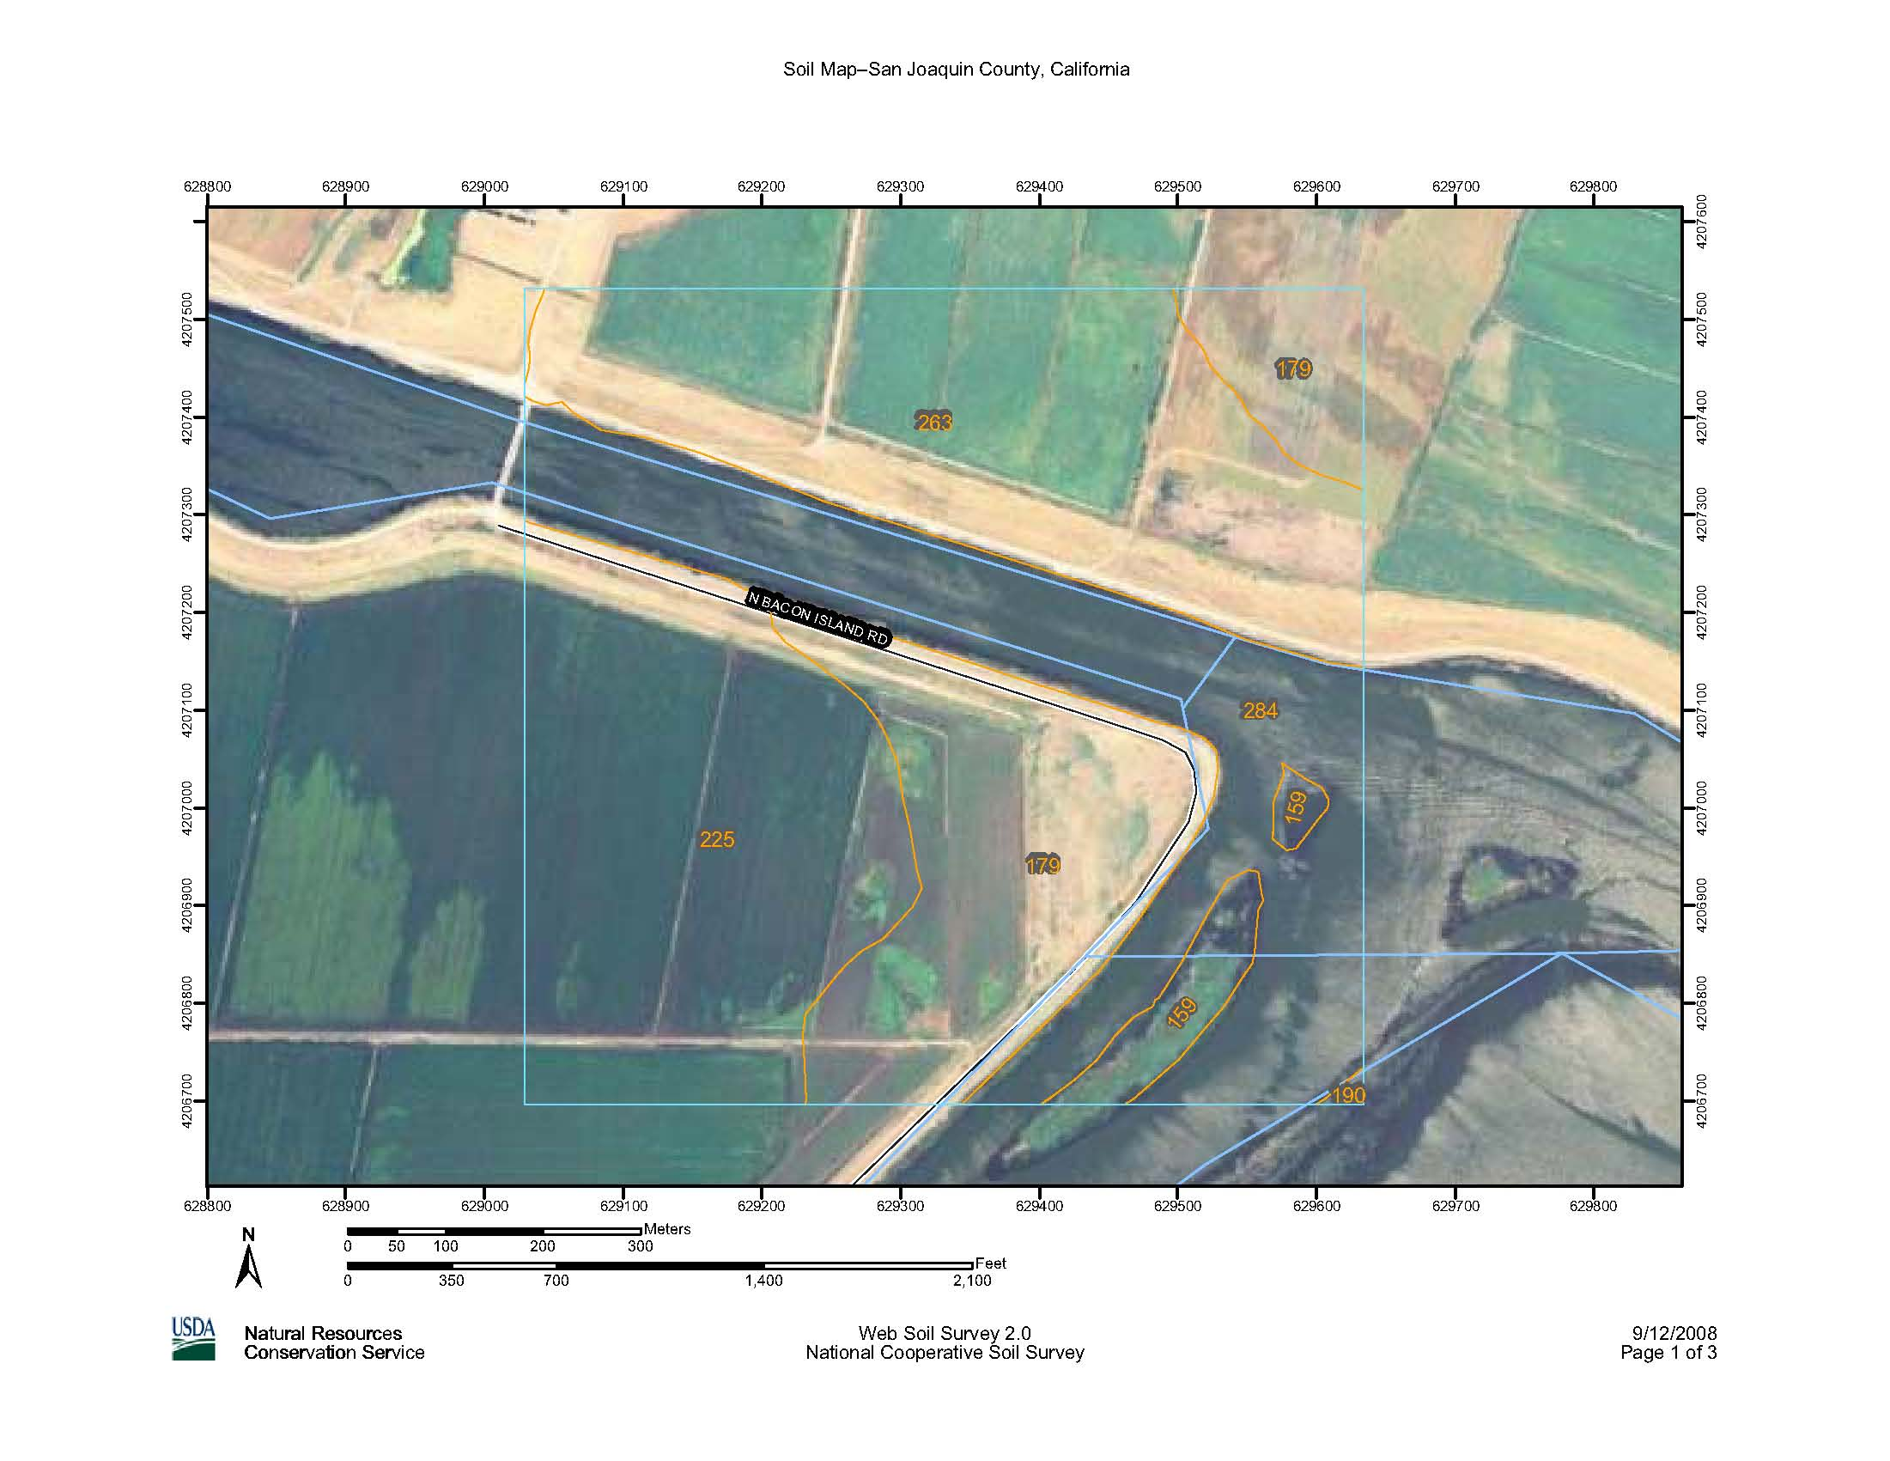

Soils on Connection Slough Study Area.
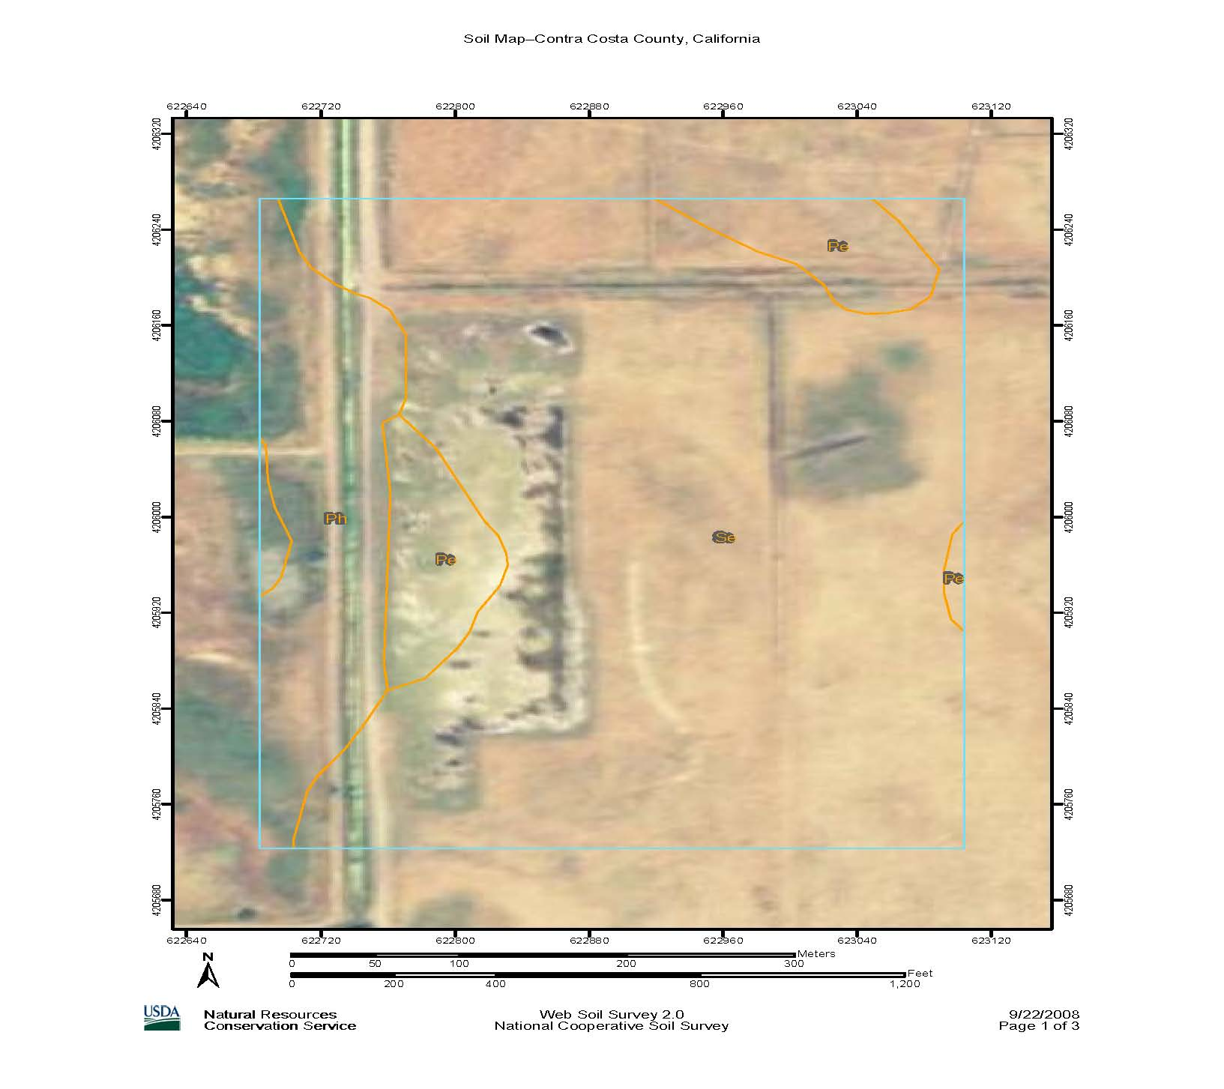

Soils on Holland Alternate Storage Study Area.

