Delineation and Preliminary
Jurisdictional Determination of Wetlands and Other Waters of the U.S. Under Section 404 of the Clean Water Act and
Section 10 of the Rivers and Harbors Act

for the proposed
Two Gates Project
Contra Costa and San Joaquin Counties, California

August 2009

Prepared for

San Luis & Delta-Mendota Water Authority
P.O. Box 2157
Los Banos, CA 93635

Contact:
Ara Azhderian
(209) 826-9696

Prepared by


Mosaic Associates LLC
647 Tennent Ave., Suite 102
Pinole, CA 94564
Ph: (510) 964-0394 Fax: (510) 964-0396
Table of Contents
Introduction 1
Limitations 4
Existing Conditions 5
Setting 5
Vegetation 5
Ruderal Herbaceous 5
Ruderal Scrub 6
Coastal and Valley Freshwater Marsh 6
Seasonal Wetlands 6
Mixed Riparian Woodland 6
Soils and Geology 7
Rindge Muck 7
Ryde Clay Loam, Partially Drained, 0 to 2 Percent Slopes 8
Shima Muck 8
Webile Muck 8
Itano Silty Clay Loam, Partially Drained, 0 to 2 Percent Slopes 8
Rindge Muck, Partially Drained, 0 to 2 Percent Slopes 8
Venice Mucky Silt Loam, Partially Drained, 0 to 2 Percent Slopes, Overwashed 9
Hydrology 9
Preliminary Findings 10
Wetlands and Other Waters of the U.S. 10
Hydrophytic Vegetation 14
Hydric Soils 15
Wetland Hydrology 15
Preliminary Corps Jurisdiction 16
Literature Cited 18

LIST OF TABLES
Table 1. Wetland Plant Indicator Status 4
Table 2. Summary of Potential Jurisdictional Habitats 11
Table 3. Wetland Indicator Status of Plant Species Occurring in the Study Area 14

LIST OF FIGURES
Figure 1. USGS Topographic Map, Old River 20
Figure 2. USGS Topographic Map, Connection Slough 21

LIST OF APPENDICES
Appendix A. Wetlands Delineation Field Data Forms
Appendix B Map of Potential Jurisdictional Wetlands
Appendix C Soils Map and Information
Appendix D WETS Table for Climate Information

Introduction

Mosaic Associates conducted a wetland delineation study to determine the existence and extent of waters, including wetlands, potentially subject to the jurisdiction of the U.S. Army Corps of Engineers under §404 of the 1972 Clean Water Act (CWA) and §10 of the Rivers and Harbors Act (RHA).

The CWA regulates activities that result in the discharge of dredged or fill material into waters of the U.S., including wetlands. Waters of the U.S. include all traditional navigable waters, such as rivers and tidally influenced watercourses; and other waters such as intrastate lakes, rivers, streams (including intermittent streams), mudflats, sandflats, wetlands, sloughs, prairie potholes, wet meadows, playa lakes, or natural ponds. The U.S. Army Corps of Engineers (Corps) has the principal authority to regulate discharges of dredge or fill material into waters of the U.S. Under the RHA, Corps jurisdiction applies to any “navigable waters of the United States”.

This report details the presence and extent of potential Corps jurisdictional wetlands and other waters within three Study Areas: Old River, Connection Slough, and Holland Alternate Storage (see Figures 1 and 2) located in Contra Costa and San Joaquin Counties, California. The Old River Study Area covers 67 acres and is located in both Contra Costa and San Joaquin Counties. The Connection Slough Study Area covers 32 acres and is located entirely within San Joaquin County. The Holland Alternate Storage Study Area covers 12 acres and is located in Contra Costa County.

Project Description

The project proposed for the Study Areas consists of the installation of two gates, one each across Old River and Connection Slough.
Operation of the State Water Project and Central Valley Project pumps causes flow reversals in the Sacramento-San Joaquin Delta (Delta) on the Old and Middle rivers in the vicinity of the export pumps. Salinity and turbidity conditions conducive to Delta smelt are conveyed by these reverse flows towards the pumps, resulting in the entrainment of Delta smelt during export operations. Delta smelt is a federally and state-listed threatened species, and both the U.S. Fish and Wildlife Service and California Department of Fish and Game are considering petitions to change its status to endangered.
The 2-Gate Fish Protection Plan (2-Gate Project) is a mitigation and avoidance measure intended to reduce the take of Delta smelt and other listed species, in compliance with the federal Endangered Species Act, although it also would benefit other aquatic species. The 2-Gate Project provides a means of controlling a portion of the Old River branch of the San Joaquin River restricting and direct entrainment of fish from the western Delta toward the export pumps. This would be accomplished by the installation and operation of operable gates in key channels in the central Delta. These structures would provide additional control of tidal and non-tidal flows, thereby modifying the predominant path of freshwater flow through the Delta. Hydrodynamic and particle tracking computer modeling has shown that these changes would substantially reduce unintended effects of export pumping on the estuarine ecosystem, thereby minimizing or avoiding salvage of Delta smelt and potentially enhancing Delta smelt populations in the western and central Delta while allowing for the export of water to meet critical water needs.

Methods

Tom Mahony of Coast Range Biological and Amy Richey of Mosaic Associates visited the Study Areas on August 1 and 4 and September 9, 23, and 29, 2008. The Study Areas were field checked for indicators of hydrophytic vegetation, wetland hydrology, and hydric soils. A total of 59 sample points were taken within the Study Areas and recorded on Corps data forms provided in the Interim Regional Supplement to the Corps of Engineers Wetland Delineation Manual: Arid West Region (“Interim Manual”) (Environmental Laboratory, December 2006) Data forms are presented in Appendix A.

This wetland delineation and preliminary jurisdictional determination followed the guidelines provided in the Interim Manual and the Corps of Engineers Wetlands Delineation Manual (“Corps Manual”) (Environmental Laboratory 1987). Based on topography and the presence or absence of field indicators including vegetation, hydrology and soils, the limits of potential jurisdictional wetlands and other waters of the U.S. was determined. The extent of potential jurisdictional areas was mapped in the field using a Trimble GPS unit (sub-meter accuracy). In areas where a GPS signal was unavailable (e.g., under a forest canopy), wetland boundaries were drawn directly onto a 2005 geo-rectified aerial map obtained from the California Spatial Information Library (CaSIL). In the office, the field data was differentially corrected in Trimble Pathfinder software, imported into ArcGIS mapping software, and overlain onto the geo-rectified aerial.

Tidal Areas

Under the CWA, Corps jurisdiction in tidal areas extends up to the "high tide line" (“HTL”) (33 CFR 328.4). Waters within the Study Area therefore include all tidally influenced areas, both vegetated and unvegetated, up to the HTL. Areas with hydrophytic vegetation are separately defined as “wetlands” and are a subset of jurisdictional waters.

Corps RHA jurisdiction applies to any “navigable waters of the United States”. In tidally influenced areas, the upper limit of “navigable waters” has been defined as “mean high water” (MHW) (FR Doc 86-25301, 329.12.b). Corps of Engineers RHA jurisdiction includes tidal areas below MHW, as well as wetlands behind levees.

Non-Tidal Areas

In non-tidal areas, the Corps and Interim Manuals recommend a three parameter approach to determining the presence of jurisdictional wetlands based on the presence of 1) hydrophytic vegetation, 2) wetland hydrology, and 3) hydric soils. In normal circumstances and in unproblematic areas, potential jurisdictional wetlands must display at least one positive indicator from each of the three parameters. Criteria to determine the presence of vegetation, hydrology, and soil indicators are discussed in detail below.

Wetlands are defined as "those areas that are inundated or saturated by surface or ground water at a frequency and duration sufficient to support, and that under normal circumstances do support, a prevalence of vegetation typically adapted for life in saturated soil conditions" (§404 Clean Water Act). Indicators of all three wetlands parameters (hydric soils, hydrophytic vegetation, wetlands hydrology) must be present for a site to be classified as a wetland (Environmental Laboratory 1987).

Waters of the U.S. are defined as 1) waters used in interstate or foreign commerce, 2) waters subject to the ebb and flow of tide, 3) all interstate waters including interstate wetlands, intrastate lakes, rivers, streams, mudflats, sandflats, wetlands, sloughs, prairie potholes, wet meadows, playa lakes, natural ponds, the use, degradation, or destruction of which could affect interstate or foreign commerce, and 4) areas that are or could be used for recreation by interstate or foreign travelers, fish or shellfish that is sold in interstate or foreign commerce, or industrial purposes in interstate commerce (§328.3(a). Recent decisions by the U.S. Supreme Court have narrowed the definition of waters of the U.S. to exclude “isolated” wetlands (Solid Waste Agency of Northern Cook County v. U.S. Army Corps of Engineers et al., 2001) and wetlands adjacent to non-navigable and not relatively permanent tributaries where there is no “significant nexus” in hydrologic or ecologic terms (Rapanos v. United States and Carabell v. United States, 2006).

Hydrophytic vegetation includes those plant species that possess physiological features or reproductive adaptations that allow them to persist in soils subject to prolonged inundation and anaerobic soil conditions. Plant species are classified by their probability of being associated with wetlands or uplands (see Table 1). Dominant species are selected using the “50/20 rule”, in which any species in a given stratum that occupies ≥20% cover is considered a dominant species; or, when no species makes up to 20% cover, then each species required to make up 50% of the cover is considered dominant. For a sample point to meet this criterion, more than 50% of the dominant plant species in each of the strata must be OBL, FACW, or FAC indicator species.

Nomenclature used in this report conforms to The Jepson Manual (Hickman, 1993) for plants. Where possible, plant community names conform to Holland (1986) and Sawyer and Keeler-Wolf (1995); wetland community names conforming to Cowardin, et al. (1979) are also given. The wetland indicator status of plant species conforms to Reed (1988), except where the species is not listed in the 1988 list but an indicator status is provided in the 1996 list.

Table 1. Wetland Plant Indicator Status
Indicator  Status | Description | Est. Frequency of Occurrence in Wetlands
OBL | Obligate wetland, almost always found in wetlands | >99%
FACW(+/-) | Facultative wetland, usually found in wetlands | 67-99%
FAC | Facultative, equal occurrence in wetlands or non-wetlands | 34-66%
FACU | Facultative upland, usually found in non-wetlands | 1-33%
UPL / NL | Obligate upland/Not listed, almost always found in non-wetlands | <1%
NI | No Indicator (insufficient information available to determine an indicator status) | Unknown

Hydric soils include non-drained organic soils, mineral soils with a high water table, ponded soils, and flooded soils. Characteristic field indicators of hydric soils include the presence of a histic epipedon, the presence of sulfidic material, the presence of an aquic or peraquic moisture regime, reducing soil conditions, soil color (including gleyed soils or soils with a low matrix chroma, with or without bright mottles), iron or manganese concretions, and soils listed as hydric by the USDA.

For the hydrology parameter to be met, a site must be seasonally inundated or saturated for at least 12.5% of the growing season; areas inundated or saturated for 5-12.5% of the growing season might or might not meet the parameter. The growing season in the location of the Study Area is 349 days (NRCS 2008); thus, this particular site would need to be inundated or saturated to within 12 inches of the soil surface for around 18-44 consecutive days during the growing season to meet the wetland hydrology criterion (18-44 days = 5% x 349, 12.5% x 349 frost free days).

Limitations

This document is intended as a wetland delineation and preliminary jurisdictional determination based on the Corps’ guidelines. Wetlands and other waters within the Study Areas covered herein may be considered potentially jurisdictional by the Corps. The appropriate regulatory agencies make the final jurisdictional determination regarding the location and extent of potentially jurisdictional wetlands and other waters in the Study Areas.

Vegetation communities may vary depending on weather conditions and the time of year. Plants that are dominant at the time of this survey may shift in importance depending on rainfall conditions and the season of the survey, or population shifts over time. Certain plant species, especially annuals, may not be present in a given year. In some cases, plant identifications in the report are tentative due to the absence of morphological characters present only at certain times of year (ie. flower blooming periods). Plants which have a provisional identification, based on vegetative morphology, gestalt, or species range, are identified with a cf in the species table provided below.

The conclusions of this delineation are based on conditions observed at the time of the field survey. The results of the delineation are preliminary, pending jurisdictional verification by the Corps under the CWA and RHA.

Existing Conditions

Setting
The Study Areas are located in the Sacramento-San Joaquin River Delta in eastern Contra Costa and western San Joaquin Counties (the centerline of Old River forms the County boundary (USGS 1978), located east of the town of Oakley) (Figures 1 and 2). Elevations on the Study Areas range from <0 feet to ~20 feet (NGVD) (USGS 1978; 1997). The area forms a complicated network of sloughs and channels connected to the San Joaquin River.

The Study Areas have been altered by channelization of Old River and Connection Slough. Areas inland of constructed levees have been further altered by agriculture, grazing, and associated infrastructure and disturbance, including construction of drainage ditches adjacent to agricultural fields. The Old River Study Area consists of areas of active agriculture and grazing, as well as significant disturbance from old houses, outbuildings, and associated infrastructure. The Connection Slough Study Area primarily consists of agricultural and fallow fields.

Vegetation
Vegetation on all three Study Areas is highly disturbed by past and current land uses, including agricultural operations, cattle grazing, and associated infrastructure. The Study Area consists primarily of six distinct plant communities: ruderal herbaceous, ruderal scrub, coastal and valley freshwater marsh, seasonal wetland, palustrine submergent wetland, mixed riparian woodland, and agricultural.

Ruderal Herbaceous
Ruderal herbaceous habitat has been subjected to surface disturbance and as a result is dominated by non-native grasses and adapted to disturbance. Dominant species include wild oats (Avena spp.), ripgut brome (Bromus diandrus), soft chess (Bromus horceaceus), Italian ryegrass (Lolium multiflorum), yellow star-thistle (Centaurea solstitialis), bristly ox-tongue (Picris echioides), summer mustard (Hirschfeldia incana), wild radish (Raphanus sativus), and barley (Hordeum murinum). Ruderal habitat does not conform to any recognized natural community classification system, though it might be considered a highly disturbed phase of the California annual grassland series (Sawyer and Keeler-Wolf 1995) and Non-native Grassland (Holland 1986), and would be classified as upland following Cowardin, et al. (1979). Ruderal herbaceous habitat is the dominant plant community on the Old River, Connection Slough, and Holland Alternate Storage Study Areas.

Ruderal Scrub
Ruderal scrub habitat consists of disturbed habitat dominated by non-native woody shrubs, primarily dense monocultures of Himalayan blackberry (Rubus discolor) with occasional other non-native species such as poison hemlock (Conium maculatum). Ruderal scrub is not specifically described by Sawyer and Keeler-Wolf (1995) or Holland (1986), and would be classified as upland following Cowardin, et al. (1979). Ruderal scrub is present in patches on the Old River Study Area.

Coastal and Valley Freshwater Marsh
Coastal and valley freshwater marsh (Holland 1986) typically occurs in low-lying sites that are permanently flooded with fresh water. This vegetation community characteristically forms a dense vegetative cover dominated by perennial, emergent monocots 1-15 feet high that reproduce by underground rhizomes (Holland 1986).

Freshwater marsh occurs on the Old River and Connection Slough Study Areas, primarily along and adjacent to levees along Old River and Connection Slough. These sites are dominated by perennial monocots such as California bulrush (Schoenoplectus californicus), tule rush (Schoenoplectus acutus), narrow-leaved cattail (Typha angustifolia), and cattail (Typha latifolia). Small, highly disturbed phases of this habitat are also present on the Old River and Connection Slough Study Areas in man-made drainage ditches with perennial hydrology. Coastal and valley freshwater marsh on the Study Areas conforms to the Bulrush-cattail series, as described in Sawyer and Keeler-Wolf (1995). It would be classified as a palustrine emergent seasonally or permanently flooded wetland according to Cowardin, et al. (1979).

Seasonal Wetlands
Seasonal wetlands occur on all three Study Areas in concave basins with seasonal hydrology, and also in some man-made drainage ditches with intermittent flows. Dominant species include water smartweed (Polygonum amphibium), soft rush (Juncus effusus), curly dock (Rumex crispus), cocklebur (Xanthium strumarium), Bermuda grass (Cynodon dactylon), Italian ryegrass, and nutsedge (Cyperus eragrostis). Seasonal wetland habitat on the Study Areas is highly disturbed and is not easily classified into a single vegetation type, but in some cases represents a mesic (wet) phase of the California annual grassland series (Sawyer and Keeler-Wolfe 1995) and Non-native Grassland (Holland 1986). It would be classified as a palustrine emergent seasonally flooded wetland according to Cowardin, et al. (1979).

Mixed Riparian Woodland
Although not specifically described in Holland (1986), mixed riparian woodland consists of annual and perennial native and non-native riparian herbaceous and woody species. This vegetation type is typically found along stream and river banks, on terraces adjacent to floodplains, and along perennial or intermittent streams, gullies, springs or seeps.

Mixed riparian woodland occurs primarily along drainage ditches and in mesic swales and depressions on the Old River Study Area. This vegetation type conforms most closely to the Mixed Willow series as described in Sawyer and Keeler-Wolf (1995). Canopy species present included red willow (Salix lasiolepis), arroyo willow (Salix lasiolepis), black walnut (Juglans hindsii), and Fremont cottonwood (Populus fremontii ssp. fremontii). Shrub and understory species include stinging nettle (Urtica dioica) and Himalayan blackberry. In addition, Fremont cottonwood, black walnut, and fruit trees (Prunus sp.) occur as widely scattered individuals that were planted or naturally recruited from upland habitats.
Agricultural
The fringes of the Old River and Connection Slough Study Areas are under active cultivation, primarily of sunflower (Helianthus annus). Sunflower forms a dense monoculture to the exclusion of other species. This community type does not conform to any recognized natural community classification system.

Soils and Geology
The delta plain in the vicinity of the Study Areas, along the lower course of the San Joaquin River near the confluence of the Sacramento River, consists of meandering sloughs and channels fringed with natural and man-made dikes and levees and drained by pumping plants. The delta plain consists of former freshwater marsh, and soils were formed in the accumulated remains of marsh vegetation, along with silt from river flooding. Soils are close to or below sea level. Extensive levee construction and associated soil drainage occurred around 1900, and extensive pumping has allowed soils to dry (USDA 1977). Annual average rainfall for the area is approximately 13.34 inches per year (USDA 1977), and occurs mostly in the winter months.

According to National Soil Conservation Service’s web-based soil survey for Contra Costa County and San Joaquin County (NRCS 2008), seven soil units are mapped within the Study Areas: Rindge muck; Ryde clay loam, partially drained, 0 to 2 percent slopes; Shima muck; Webile muck; Itano silty clay loam, partially drained, 0 to 2 percent slopes; Rindge muck, partially drained, 0 to 2 percent slopes; and Venice mucky silt loam, partially drained, 0 to 2 percent slopes, overwashed.

Descriptions for the soil units, taken from NRCS (2008), the Soil Survey of Contra Costa County (USDA 1977), and the Soil Survey of San Joaquin County (USDA 1992), are presented below. All soils found are listed as hydric in the California hydric soils list (NRCS 2008a). Additional soils information and soil maps are included in Appendix C.

Rindge Muck
Rindge series soils consist of very poorly drained organic soils formed in marshes. Rindge muck soils are generally level or nearly level. Soils in the upper 24 inches of soil profile are very dark brown (10YR 2/2) and very dark gray (10YR 3/1), very strongly acid muck. Soils between 24 and 60 inches are black (N 2/0 or 10YR 2/1) very strongly acid muck. The depth to water table is typically ~12 to 48 inches. The depth to a restrictive layer is typically greater than 80 inches. This soil is mapped on the Old River Study Area.

Ryde Clay Loam, Partially Drained, 0 to 2 Percent Slopes
Ryde series soils consist of very poorly drained soils on level to nearly level slopes on the Sacramento-San Joaquin Delta. Ryde clay loam, partially drained, 0 to 2 percent slopes, occurs on flood plains and deltas. Typically, the upper 24 inches of soil profile consists of grayish brown (10YR 5/2) and dark gray (10YR 4/1), mottled clay loam. The underlying material to a depth of 63 inches is very dark gray (10YR 3/1) and dark grayish brown (10YR 4/2), stratified mucky clay loam, silty clay loam, and muck. The depth to water table is typically ~36 to 48 inches. The depth to a restrictive layer is typically greater than 80 inches. This soil is mapped on the Old River Study Area.

Shima Muck
Shima series soils consist of very poorly drained organic soils underlain by sand within the upper 36 inches of soil profile. Shima muck is generally level or nearly level. Typically, the upper 21 inches of soil profile consist of black (10YR 2/1), muck. The subsoil consists of a 4 inch layer of black (10YR 2/1) silty clay, underlain to a depth of 60 inches of dark gray (10YR 4/1 and 5G 4/1) sand. The depth to water table is typically ~24 to 48 inches. The depth to a restrictive layer is typically greater than 80 inches. This soil is mapped on the Old River and Holland Alternate Storage Study Areas.

Webile Muck
Webile series soils consist of very poorly drained soils in freshwater marshes and old river channels. Slopes are less than 1 percent. The upper 16 inches of soil in a typical Webile muck soil profile consists of black (10YR 2/1) and very dark brown (10YR 2/2) muck. Subsurface soils down to 43 inches consist of dark yellowish brown (10YR 3/4 and 10YR 4/4) muck. The depth to water table is typically ~36 to 60 inches. The depth to a restrictive layer is typically greater than 80 inches. This soil is mapped on the Old River Study Area.

Itano Silty Clay Loam, Partially Drained, 0 to 2 Percent Slopes
Itano series soils consist of very deep, poorly drained, nearly level soils on flood plains and deltas. A typical surface soil profile of Itano silty clay loam, partially drained, 0 to 2 percent slopes, consists light brownish gray (10YR 6/2) silty clay loam ~15 inches thick, underlain to a depth of 60 inches by grayish brown (10YR 5/2) mottled silty clay loam ~19 inches thick. The depth to water table is typically ~36 to 54 inches. The depth to a restrictive layer is typically greater than 80 inches. This soil is mapped on the Connection Slough Study Area.

Rindge Muck, Partially Drained, 0 to 2 Percent Slopes
Rindge muck, partially drained, 0 to 2 percent slopes, is a very deep, very poorly drained, nearly level soil that occurs on deltas. In a typical profile, the surface layer is very dark gray (10YR 3/1) muck ~13 inches thick. Underlying this layer to a depth of 60 inches is very dark brown (10YR 2/2)and very dark gray (10YR 3/1) mucky peat. The depth to water table is typically ~36 to 48 inches. The depth to a restrictive layer is typically greater than 80 inches. This soil is mapped on the Connection Slough Study Area.

Venice Mucky Silt Loam, Partially Drained, 0 to 2 Percent Slopes, Overwashed
Venice series soils consist of very poorly drained soils in freshwater marshes and river deltas. Slopes are less than 1 percent. A typical surface soil profile of Venice mucky silt loam, partially drained, 0 to 2 percent slopes, overwashed, soils consists of very dark grayish brown (10YR 3/2) mucky silt loam ~15 inches thick, underlain by black (10YR 2/1) and very dark brown (10YR 2/2) mucky peat to a depth of 60 inches. The depth to water table is typically ~36 to 48 inches. The depth to a restrictive layer is typically greater than 80 inches. This soil is mapped on the Connection Slough Study Area.

Hydrology
Hydrology on the Study Areas has been altered by agricultural development, grazing, and associated infrastructure, installation of drainage ditches, as well as the construction of levees along Old River and Connection Slough. The Study Areas were once part of the broader floodplain prior to levee construction. Currently, the principal hydrologic sources for the Old River and Connection Slough Study Areas are: direct precipitation, water movement (both tidal and watershed runoff) through Old River and Connection Slough, and, for areas inland of the river levees, surface sheet flow, channelized flow in man-made drainage ditches, and seepage through and beneath weak levees and or coarse textured soil on river levees.

Evidence of regular ditch maintenance (e.g., dredged ditch spoils deposited adjacent to the ditches) was observed along numerous man-made ditches, primarily in the Old River and Connection Slough Study Areas. The ditches are a part of the regular farming practice on the islands. In the fall, after crop harvest, they supply water to flood the agricultural fields for weed control and salt leaching. In February, the ditches are used to drain the fields in preparation for planting. Beginning in May, they are used to supply and drain irrigation water 3-4 times over the summer.

Engineering studies conducted for the Study Areas determined that seepage is occurring from Old River and Connection Slough through and beneath river levees, based on soil characteristics (Moffatt & Nichol, 2008). This process appears to provide a major source of hydrologic input to seasonal wetlands located inland of river levees on the Old River and Connection Slough Study Areas. Some delineated wetlands on both Study Areas occurred in areas of coarser textured soils with no visible soil restricting layer and a relatively small watershed, indicating at least some hydrology might be provided through seepage from the river through levee soils, rather than surface inputs such as direct precipitation and surface sheet flow from surrounding uplands.

Preliminary Findings

Wetlands and Other Waters of the U.S.
Ten potential jurisdictional wetlands were observed on the three Study Areas. Potential jurisdictional wetlands had positive indicators of wetland hydrology, hydric soils, and hydrophytic vegetation. Two potential jurisdictional “other waters” were delineated in drainage channels where: (1) wetland hydrology was present but one or more of the other wetland parameters were absent, and (2) an ordinary high water mark (OHWM) was observed. Locations and extent of potential jurisdictional wetlands and other waters are included in Appendix B. Remarks and details for each of the sample points are presented in Table 2 below.

Table 2. Summary of Data Points and Potential Jurisdictional Habitats
Wetland (W)/Other Waters (OW)/Ditch (D)Number | Area  (sq. ft) | Sample point(s) | Remarks |  | Nexus to Navigable Waters
Connection Slough Study Area (CS)
CS-W1 | 21,706 | 22a, 23a, 24a, 25a | Located in broad basin inland of Connection Slough river levee, Bacon Island. Appears to be an isolated basin though may overflow into nearby drainage ditch. |  | Separated from Connection Slough by man-made levee. Considered “adjacent” due to definition in 33 CFR Part 328.
CS-W2 | 59,121 | 28a, 29a, 38a | Located within Connection Slough channel in tidally influenced navigable waters. |  | Located in navigable waters, Connection Slough up to the HTL/wetland edge.
CS-P1 | 37,699 | None | Located within Connection Slough channel in tidally influenced navigable waters. |  | Located in navigable waters, Connection Slough up to the HTL/wetland edge.
CS-OW1 | 471,917 | None | Located within Connection Slough channel in tidally influenced navigable waters. |  | Located in navigable waters, Connection Slough up to the HTL.
CS-D1 | 10,197 | 21a | Located in a man-made drainage ditch draining agricultural areas inland of Connection Slough river levee. |  | Considered exempt from Corps jurisdiction due to man-made hydrology.
CS-D2 | 3,165 | 27a | Located in a man-made drainage ditch draining agricultural areas inland of Connection Slough river levee. |  | Considered exempt from Corps jurisdiction due to man-made hydrology.
CS-PD1 | 17,698 | None | Located in a man-made drainage ditch draining agricultural areas inland of Connection Slough river levee. |  | Considered exempt from Corps jurisdiction due to man-made hydrology.
CS-PD2 | 4,486 | None | Located in a man-made drainage ditch draining agricultural areas inland of Connection Slough river levee. |  | Considered exempt from Corps jurisdiction due to man-made hydrology.
Old River Study Area (OR)
OR-W1 | 35,096 | 1a, 2a | Located in and adjacent to a man-made drainage ditch, with overflow area. East of Old River levee. No outlet culvert observed at ditch. | Separated from Old River by man-made levee. Considered “adjacent” due to definition in 33 CFR Part 328.
OR-W2 | 16,378 | 3a, 4a | Located in and adjacent to a man-made drainage ditch, with overflow area. East of Old River levee. | Separated from Old River by man-made levee. Considered “adjacent” due to definition in 33 CFR Part 328.
OR-W3 | 147,804 | 6a, 6b, 7a | Located within Old River channel in tidally influenced navigable waters. | Located in navigable waters, Old River up to the HTL/wetland edge.
OR-W4 | 17,207 | 9a, 10, 11a | Located in and adjacent to a man-made drainage ditch, with overflow area. West of Old River levee. Ditch continues northbound off the Study Area. | Separated from Old River by man-made levee. Considered “adjacent” due to definition in 33 CFR Part 328.
OR-W7 | 2,508 | 19a, 19b | Located within Old River channel in tidally influenced navigable waters. | Located in navigable waters, Old River up to the HTL/wetland edge.
OR-W8 | 634 | None | Located within Old River channel in tidally influenced navigable waters. | Located in navigable waters, Old River up to the HTL/wetland edge.
OR-OW1 | 1,732,626 | 18a | Located within Old River channel in tidally influenced navigable waters. | Located in navigable waters, Old River up to the HTL.
OR-D1 | 1,075 | 8a | Located in a man-made drainage ditch east of Old River levee. No outlet culvert observed at ditch. | Considered exempt from Corps jurisdiction due to man-made hydrology.
OR-D2 | 225 | None | Located in a man-made drainage ditch east of Old River levee. Ditch continues east off the study area. | Considered exempt from Corps jurisdiction due to man-made hydrology.
OR-D3 | 3,020 | 5a | Located in a man-made drainage ditch east of Old River levee. No outlet culvert observed at ditch. | Considered exempt from Corps jurisdiction due to man-made hydrology.
OR-D4 | 441 | None | Located in a man-made drainage ditch east of Old River levee. Ditch continues northeast off the study area. | Considered exempt from Corps jurisdiction due to man-made hydrology.
OR-D5 | 1,117 | 11a | Located in a man-made drainage ditch west of Old River levee. Ditch continues north off the study area. | Considered exempt from Corps jurisdiction due to man-made hydrology.

Hydrophytic Vegetation
All plant species within the Study Areas were identified and their wetland indicator status was recorded, where possible. Some plants were not identifiable to species due to the timing of the field work. Plant species and indicator status observed within the Study Area are listed in Table 3, below.

In general, wetlands located inland of river levees supported seasonal wetland habitat dominated by a mix of FAC, FACW, and OBL species, including Italian ryegrass, water smartweed, curly dock, Bermuda grass, and/or birdsfoot trefoil (Lotus corniculatus). Wetlands along navigable river channels—along with some drainage ditches inland of river levees—consisted of freshwater marsh dominated by strongly OBL species, including California bulrush, tule rush, and broadleaf cattail. Adjacent upland areas consisted of a mix of UPL-FAC herbaceous species, including Bermuda grass, ripgut brome, soft chess, wild radish, yellow star-thistle, and summer mustard.

Table 3. Wetland Indicator Status of
Plant Species Occurring on the Study Areas

Scientific Name | Common Name | Wetland Indicator Status
Arundo donax | giant reed | FACW
Bromus diandrus | ripgut brome | NL
Bromus hordeaceous | soft chess | FACU-
Centaurea solstitialis | yellow starthistle | NL
Cirsium vulgare | bull thistle | FACU
Conium maculatum | poison hemlock | FACW
Convolvulus arvensis | field bindweed | UPL
Conyza canadensis | Canada horseweed | FAC
Cynodon dactylon | Bermuda grass | FAC
Cyperus eragrostis | tall flatsedge | FACW
Datura sp. | jimson weed | NL
Epilobium sp. | willow herb
Festuca arundinacea | Kentucky fescue | FAC-
Helianthus annus | cultivated sunflower | FAC-
Hirschfeldia incana | summer mustard | UPL
Hordeum marinum | Mediterranean barley | FAC
Hordeum murinum | foxtail barley | NL
Juglans hindsii | northern California walnut | FAC
Juncus effusus | soft rush | OBL
Lactuca serriola | prickly lettuce | FAC
Lemna sp. | duckweed | OBL
Lepidium latifolium | broadleaf peppergrass | FACW
Leymus triticoides | creeping wildrye | FAC+
Lolium multiflorum | Italian ryegrass | FAC
Lonicera japonica | Japanese honeysuckle | NI
Lotus corniculatus | bird's-foot trefoil | FAC
Polygonum amphibium | water smartweed | OBL
Polygonum arenastrum | knotweed | FAC
Polygonum hydropiperoides | swamp smartweed | OBL
Polypogon australis | Chilean beard grass | FACW+
Populus fremontii ssp. fremontii | Fremont cottonwood | FACW
Raphanus sativus | wild radish | UPL
Rubus discolor | Himalayan blackberry | FACW
Rumex crispus | curly dock | FACW-
Salix laevigata | red willow | FACW
Schoenoplectus acutus | tule rush | OBL
Schoenoplectus californicus | California bulrush | OBL
Schoenoplectus sp. | bulrush | OBL
Sonchus asper | prickly sowthistle | FAC
Typha latifolia | broadleaf cattail | OBL
Urtica dioica | stinging nettle | FACW
Vulpia bromoides | six weeks fescue | FACW
Xanthium strumarium | cocklebur | FAC+

Hydric Soils
The primary hydric soil field indicator we detected at various sample points throughout the Study Areas was redox dark surface (F6), with occasional sandy redox (S5). Soils in delineated wetlands generally had a low chroma matrix (e.g., 10YR 2/1, 10YR 3/2), with distinct redoximorphic concentrations (e.g., 10 YR 4/6, 10YR 5/6). Soils in adjacent upland locations often had a similar matrix chroma but either lacked redoximorphic features or had only very faint, diffuse (<1%) redoximorphic concentrations. See data sheets in Appendix A for details on soils.

Wetland Hydrology
Primary field indicators of wetland hydrology we observed on the Study Areas included surface water (A1), saturation (A2), hydrogen sulfide odor (C1), and oxidized rhizospheres along living roots (C3). Secondary indicators observed were primarily along Old River and Connection Slough, and included riverine water marks (B1), sediment deposits (B2), and drift deposits (B3). Hydrologic input for wetlands and “other waters” on the river side of levees was provided primarily by Old River and Connection Slough. Seasonal wetlands inland of river levees were hydrologically supported by a combination of direct precipitation, surface sheet flow from surrounding uplands, channelized flow in drainage ditches, and seepage through and beneath weak levees and or coarse textured soil on river levees. As discussed previously, seepage through river levees appeared to be a source of hydrology to some seasonal wetlands. The combination of low topographic position, concave topography, and coarser textured and/or weaker soils appeared to allow for sufficient hydrologic input to result in wetland hydrology. Upland areas were generally located on higher topographic positions with convex topography, and containing finer texture soils. See Appendix A for data sheets, and Appendix B for the wetland delineation map.

Preliminary Corps Jurisdiction

Section 404 of the CWA

A total of 60.13 acres (2,619,060 square feet) of wetlands and other waters potentially falling under the jurisdiction of the Corps were observed scattered throughout the Study Areas, including 5.69 acres (247,766 square feet) of wetlands and 50.61 acres (2,204,543 square feet) of other waters. Individual jurisdictional features are in Table 2 and are shown on the maps of the Study Areas in Appendix B.

Navigable waters lacking one or more of the three parameters were mapped as other waters of the U.S. Brief statements containing information useful for a “significant nexus” jurisdictional determination analysis for non-contiguous wetlands adjacent to navigable waters are provided below in Table 2, following the guidance issued jointly by the U.S. EPA and the US Army Corps (June 5, 2007).

No direct surface hydrologic connection was observed for wetlands delineated inland of the levees along the traditional navigable waters Old River and Connection Slough. However, a “significant nexus” would occur between the delineated wetlands and the aforementioned traditional navigable waters and still likely fall under Corps jurisdiction under the CWA. According to the June 5, 2007 memorandum issued by the EPA and the Corps, entitled Clean Water Act Jurisdiction Following the U.S. Supreme Court’s Decision in Rapanos v. United States & Carabell v. United States: “The agencies will assert jurisdiction over wetlands adjacent to traditional navigable waters, including over adjacent wetlands that do not have a continuous surface connection to traditional navigable waters.” The term “adjacent” is defined in 33 CFR Part 328 (Definition of Waters of the United States): “The term ‘adjacent’ means bordering, contiguous, or neighboring. Wetlands separated from other waters of the United States by man-made dikes or barriers, natural river berms, beach dunes and the like are ‘adjacent wetlands’.” Therefore, though there is no direct surface connection between the delineated wetlands and traditional navigable waters (Old River and Connection Slough), these wetlands would be considered “adjacent” to these traditional navigable waters and therefore likely jurisdictional by the Corps.

A network of man-made drainage ditches, presumably dug to drain adjacent agricultural fields, occurs throughout the Study Areas. There is some uncertainty regarding the jurisdictional status of man-made, non-tidal drainage ditches constructed in uplands. Corps regulations dated November 13, 1986, state that “non-tidal drainage ditches and irrigation ditches excavated on dry land” are generally not considered waters of the U.S. Indicators of the three wetland parameters were observed in the drainage ditches shown on the maps in Appendix B and listed in Table 2. However, because the hydrology for these ditches is likely artificial; that is, they are fed by river water siphoned into the ditches for agricultural operations, the hydrology for the ditches is man-made. This means that without the human-induced pumping, these ditches would not meet the hydrology parameter. Previous delineations, verified by the Corps (Jones & Stokes, 2002), on adjacent lands that contained extensions of the ditches present on the current Study Areas, did not consider these ditches as potential jurisdictional features, and we therefore consider these ditches as likely exempt from Corps jurisdiction.

Section 10 of the RHA

Portions of the Study Area potentially falling under the jurisdiction of the RHA include all “navigable waters of the United States”, which includes Old River and Connection Slough. Section 10 jurisdiction in these areas extends to MHW, which was determined for the Study Areas to extend to 5.68 feet above mean sea level (NAVD88 datum). In addition, all wetlands behind river levees are considered potentially jurisdictional by the Corps under the RHA. Therefore, all wetlands and other waters on the Study Areas delineated as potentially jurisdictional under the CWA would also likely be considered jurisdictional by the Corps under the RHA.

Literature Cited

Cowardin, L.M., V. Carter, F.C. Golet, and E.T. LaRoe. 1979. Classification of Wetlands and Deepwater Habitats of the United States. U.S. Department of the Interior, Fish and Wildlife Service, Washington, D.C. 131 pp.
Environmental Laboratory, 2006. Interim Supplement to the Corps of Engineers Wetland Delineation Manual Arid West Region. ERDC/EL TR-06-16. U.S. Army Engineer Research and Development Center, Vicksburg, MS. December. 108 pp.
Environmental Laboratory, 1987. Corps of Engineers Wetlands Delineation Manual, Technical Report Y-87-1, U.S. Army Engineer Waterways Experiment Station, Vicksburg, Miss. January. 100 pp.
Hickman, J.C. 1993. The Jepson Manual: Higher Plants of California. University of California Press, Berkeley, California. 1400 pp.
Holland, R. 1986. Preliminary Descriptions of the Terrestrial Natural Communities of California. California Department of Fish and Game, The Resources Agency. 156 pp.
Jones & Stokes Associates. 2002. Final Revisions to the Delta Wetlands Project Delineation Report. April 18.
Moffatt & Nichol, 2008. Preliminary Design Report, 2 Gate Fish Protection Plan. Progress Draft. September 8.
National Soil Conservation Service. 2007. National List of Hydric Soils. USDA Soil Conservation Service, Washington, D.C.
National Soil Conservation Service. 2008. Web Soil Survey for Contra Costa County, CA. http://websoilsurvey.nrcs.usda.gov/app/.
NRCS 2008. National Resource Conservation Service, National Water and Climate Center, WETS Tables for Contra Costa County, available at: ftp://ftp.wcc.nrcs.usda.gov/support/climate/wetlands/ca/06013.txt. Accessed on 8/8/08.
NRCS 2008a. National Hydric Soils List by State (January 2008). Available at: http://soils.usda.gov/use/hydric/lists/state.html. Accessed 6/25/08.
Reed, P.B. 1988. National List of Plant Species that Occur in Wetlands; California (Region 0). National Wetlands Inventory, U.S. Fish and Wildlife Service. Biological Report 88(26.10).
Sawyer, J.O. and T. Keeler-Wolf. 1995. A Manual of California Vegetation. California Native Plant Society, Sacramento. 471 pp.
U.S. Department of Agriculture, Soil Conservation Service. 1977. Soil Survey of Contra Costa County, California.
U.S. Department of Agriculture, Soil Conservation Service. 1992. Soil Survey of San Joaquin County, California.
U.S. Environmental Protection Agency and U.S. Army Corps of Engineers. 2007. Clean Water Act Jurisdiction Following the U.S. Supreme Court’s Decision in Rapanos v. United States & Carabell v. United States. June 5.
U.S. Geological Survey. 1978. Woodward Island 7.5 minute topographic quadrangle.
U.S. Geological Survey. 1997. Bouldin Island 7.5 minute topographic quadrangle.

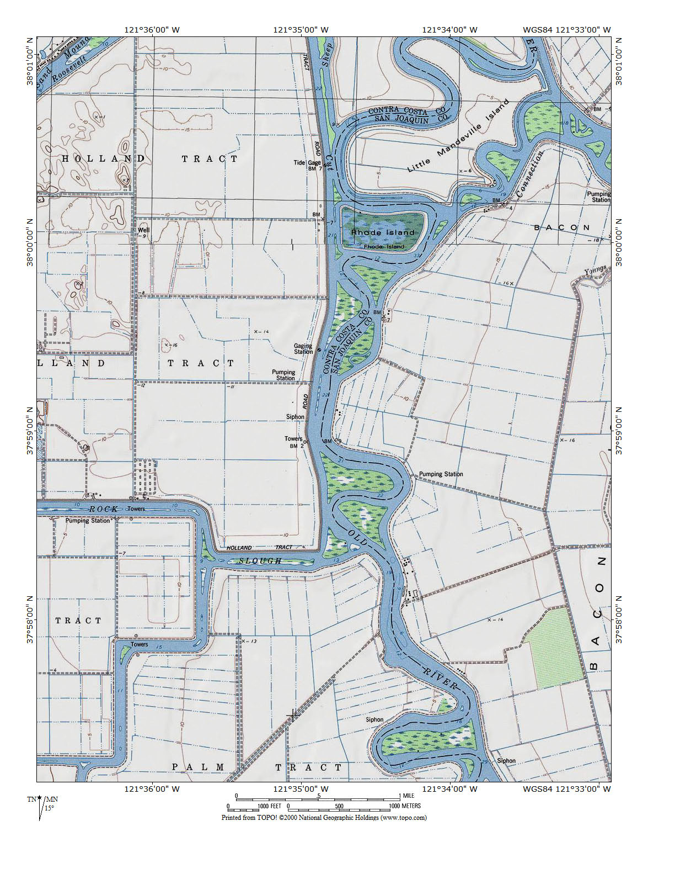
Old River Study Area
Figure 1. Location Map of the Old River Study Area.
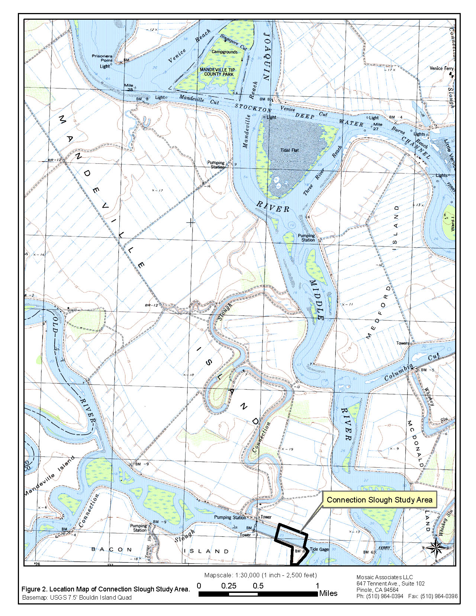

Due to access constraints, the Mandeville Island (north) side of Connection Slough Study Area, and a portion of the Holland Tract adjacent to Old River, were left undelineated. This portion of the Study Area will be delineated as soon as access is granted. This delineation on Mandeville Island and on the Clement property of Holland Tract is therefore provisional due to access constraints.
Listed as Schoenoplectus californicus in Hickman (1993).
Listed as Schoenoplectus acutus in Hickman (1993).

