appendix j
Essential Fish Habitat

Table of Contents

Essential Fish Habitat J-1
Introduction J-1
Description of the Proposed Action and Action Area J-1
Identification of Essential Fish Habitat J-4
Status, Distribution, Life History, and Habitat Requirements of Pacific Salmon J-4
Effects of the Proposed Action J-6
Cumulative Effects J-6
Conclusion J-7
Proposed EFH Conservation Measures for Chinook Salmon J-7
References J-7

Tables
None
Figures
Figure 1 2-Gates Project, Regional Location J-2
Figure 2 Action Area for 2-Gates Project J-3

This Page Intentionally Left Blank

Essential Fish Habitat

Introduction
The Magnuson-Stevens Fishery Conservation and Management Act (MSA), as amended (16 U.S.C. 1801 et seq.), requires that Essential Fish Habitat (EFH) be identified and described in Federal Fishery Management Plans (FMP’s) and that Federal action agencies which fund, permit, or carry out activities that may adversely affect EFH consult with the National Marine Fisheries Service (NMFS). The act also provides that the NMFS “coordinate with and provide information to other Federal agencies to further the conservation and enhancement of essential fish habitat” (16 United States Code. §1855(b)(1)(D). EFH regulations also require that Federal action agencies obligated to consult on EFH provide NMFS with an assessment which must include: (1) a description of the proposed action; (2) an analysis of the effects of the action on EFH; (3) the Federal agency’s views regarding the effects of the action on EFH; and (4) proposed mitigation, if applicable (50 CFR §600.920).
The following EFH assessment is intended to provide NMFS with the information necessary to analyze possible adverse effects to EFH resulting from the 2-Gates Demonstration Project (2-Gates Project or Project). To the extent practical, this assessment relies upon information and analyses provided in the 2-Gates Project Biological Assessment (2-Gates Project BA).

Description of the Proposed Action and Action Area
The proposed 2-Gates Project (the proposed action) is a 5-year demonstration project and will install and operate two temporary, removable gates in the central Delta, one in Old River and one in Connection Slough (Figure 1). The gates will be used to manipulate flows and key water quality components of delta smelt habitat with the objective of reducing entrainment of delta smelt at the Central Valley Project (CVP) and State Water Project (SWP) water export facilities in the southern Sacramento-San Joaquin Delta (Delta).
The Action Area for the 2-Gates Project includes the Sacramento River from Three Mile Slough to the Delta Cross Channel, Three Mile Slough, the Delta Cross Channel, Georgiana Slough, the Mokelumne River channel, including the North and South Forks, from the confluence with the Cosumnes River to the San Joaquin River, Little Potato Sough and Little Connection Slough, the San Joaquin River channel between Dutch Slough and Mossdale, Dutch Slough, Rock Slough and Indian Slough, Old River and Middle River and all interconnected riverine or tidal channels between these identified channels and the south Delta State and Federal fish collection facilities, including Columbia Cut, Turner Cut, Railroad Cut, Woodward Canal, Victoria Canal and the Grantline Canal (Figure 2).
For a more complete description of the proposed Project and the Action Area used in this EFH assessment see Section 2 of the 2-Gates Project BA.
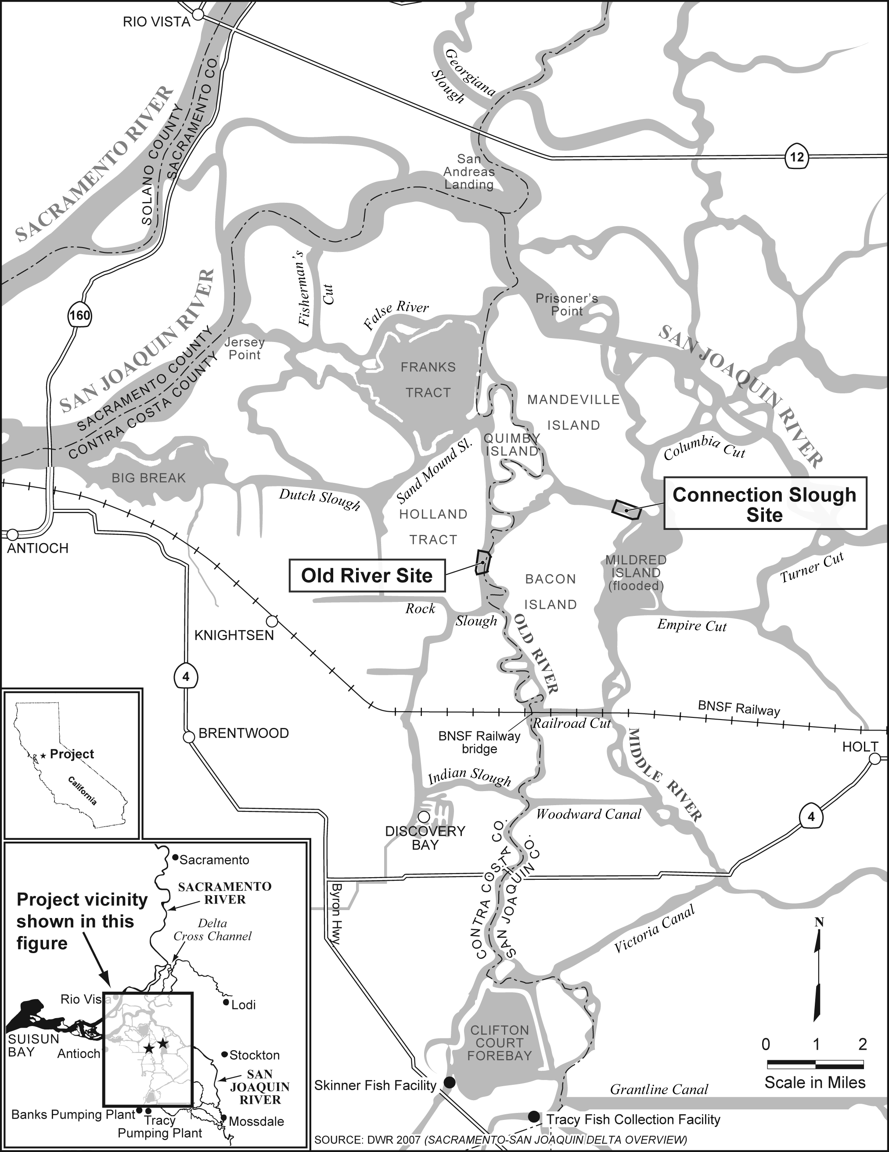
Figure 1 2-Gates Project, Regional Location
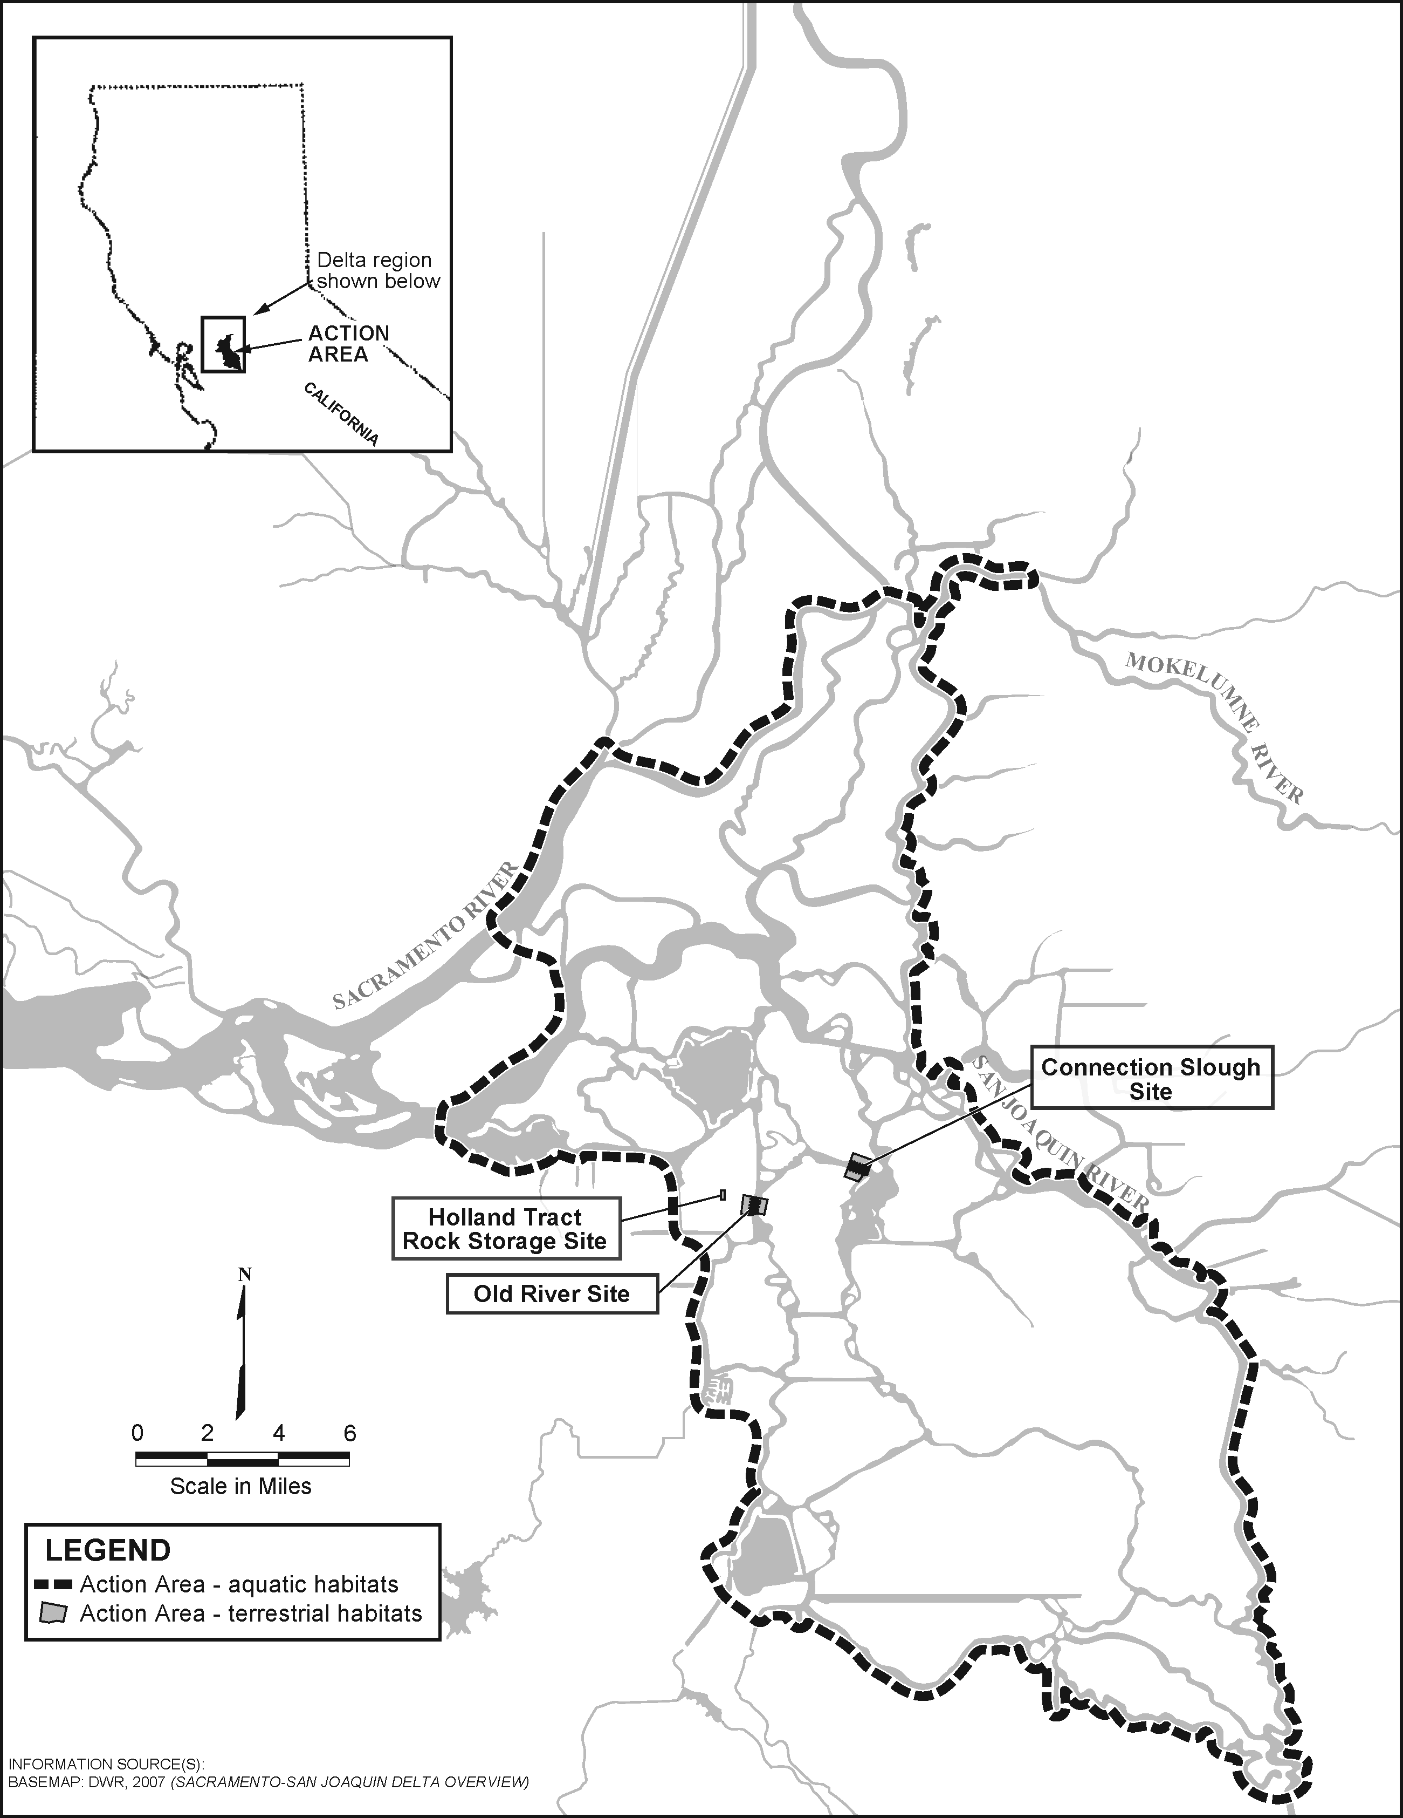
Figure 2 Action Area for 2-Gates Project

Identification of Essential Fish Habitat
Essential Fish Habitat is defined as those waters and substrates necessary to fish for spawning, breeding, feeding, or growth to maturity. For the purposes of interpreting EFH, “waters” includes aquatic areas and their associated physical, chemical, and biological properties that are used by fish, and may include areas historically used by fish where appropriate; “substrate” includes sediment, hard bottom, structures underlying the waters, and associated biological communities; “necessary” means habitat required to support a sustainable fishery and a healthy ecosystem; and, “spawning, breeding, feeding, or growth to maturity” covers all habitat types used by a species throughout its life cycle. Important components of EFH necessary for adequate spawning, rearing, and migration include: 1) substrate composition; 2) water quality; 3) water quantity, depth, and velocity; 4) channel gradient and stability; 5) food; 6) cover and habitat complexity; 7) space; 8) access and passage; and 9) habitat connectivity.
The Pacific Fishery Management Council (PFMC) has identified and described EFH, Adverse Impacts, and Recommended Conservation Measures for Pacific coast salmon species in Amendment 14 to the Pacific Coast Salmon Fishery Management Plan (FMP). Freshwater EFH for Pacific salmon in the California Central Valley includes waters currently or historically accessible to salmon within the Central Valley ecosystem as described in Myers et al. (1998), and includes the Sacramento River Basin hydrologic unit and the San Joaquin Delta (Delta) hydrologic unit (i.e., number 18040003). Sacramento River winter-run Chinook salmon (Oncorhynchus tshawytscha), Central Valley spring-run Chinook salmon (O. tshawytscha), Central Valley fall-run Chinook salmon (O. tshawytscha), and Central Valley late fall-run Chinook salmon (O. tshawytscha) are species managed under the Pacific Coast Salmon FMP. The action area of the proposed 2-Gates Project includes EFH for Central Valley Chinook salmon and is identified and described in Amendment 14 of the Pacific Coast Salmon FMP (PFMC 1999).
Factors limiting salmon populations in the 2-Gates Project action area include reduced instream flows due to water diversion and exports, loss of fish into unscreened diversions, predation by introduced species, and reduction in the quality and quantity of rearing habitat due to channelization, pollution, riprapping, etc. (Dettman et al. 1987; California Advisory Committee on Salmon and Steelhead Trout 1988, Kondolf et al. 1996a, 1996b). Loss of vital floodplain and wetland habitat within the Delta reduce rearing habitat and diminish the functional processes that wetlands provide for the bay ecosystem.

Status, Distribution, Life History, and Habitat Requirements of Pacific Salmon
Chinook salmon are the largest of the Pacific salmon and are highly prized by commercial, sport, and subsistence fishers. Chinook salmon can be found in the ocean along the west coast of North America from south of Monterey, California, to Alaska, but the southern extent of spawning is in the San Joaquin and Kings rivers (Moyle 2002). Historically, approximately 80 percent of the California Chinook salmon catch comes from the Central Valley as opposed to the Klamath River system, although as much as 90% may be of hatchery origin (Barnett-Johnson et al. 2007). These stocks include fall and late-fall run Chinook salmon from the Sacramento and San Joaquin River systems. Fall run Chinook salmon used the major rivers and their tributaries in the Central Valley and in the past have been found from the Kings River in the south to the Pit and McCloud rivers in the north. Late fall-run Chinook salmon probably used the Sacramento River and tributaries above Shasta Dam (Reclamation 2008). The late fall-run was identified as separate from the fall-run in the Sacramento River after the Red Bluff Diversion Dam was constructed in 1966 and fish counts could be more accurately made at the fish ladder there.
A sudden collapse of Sacramento River fall-run Chinook (SRFC) salmon stocks was observed in 2007 and 2008 when spawning escapement of SRFC was estimated at the lowest levels for the first time since the early 1900’s. Many factors have been suggested as the potential causes of the poor escapements recently, including freshwater withdrawals (including pumping from the Sacramento-San Joaquin Delta), unusual hatchery events, changes in fish farming practices, poor fishery management practices, pollution, and large-scale bridge construction during smolt outmigration, and poor ocean conditions in 2005 and 2006 resulting in poor ocean survival. However, available evidence suggests that ocean conditions while likely the cause of the recent sudden decline in SRFC escapement, are acting in combination with a long-term, steady degradation of the freshwater and estuarine environment (Lindley et al. 2009). Lindley et al. (2009) point out that degradation and simplification of freshwater and estuarine habitats over a centaury and a half of development have changed the Central Valley Chinook salmon complex from a highly diverse collection of many wild populations to one dominated by hatchery produced salmon. In addition, the once diverse habitats within the Sacramento-San Joaquin watershed which historically supported a highly diverse collection of populations have been simplified and reduced (Lindley et al. 2009).
General life history information for Central Valley Chinook salmon is summarized below. Information on Sacramento River winter-run and Central Valley spring-run Chinook salmon life histories is summarized in the 2-Gates BA. Further detailed information on Chinook salmon ESUs is available in the NMFS status review of Chinook salmon from Washington, Idaho, Oregon, and California (Myers et al. 1998), and the NMFS proposed rule for listing several Chinook salmon ESUs (63 Federal Rule 11482).
Adult Central Valley fall-run Chinook salmon enter the Delta and the Sacramento and San Joaquin Rivers from July through December and spawn from October through December. Adult Central Valley late fall-run Chinook salmon enter the Delta and the Sacramento and San Joaquin Rivers from late October through early April and spawn from January through April (USFWS 1998). Fall-run Chinook salmon typically spawn in lowland reaches of large rivers and their tributaries utilizing gravel beds in marginally swift riffles, runs, and pool tails with water depths exceeding one foot and velocities ranging from 1 to 3.5 feet per second. Preferred spawning substrate is clean loose gravel ranging from one to four inches in diameter with less that five percent fines (Reiser and Bjornn 1979). Juvenile fall-run Chinook generally emerge from spawning gravels in winter and spring and move downstream within a few months to rear in mainstem rivers and the estuary before migrating to the ocean (Kjelson et al 1982). Juvenile late-fall run Chinook salmon generally rear in freshwater for 7 to 13 months before entering the ocean (Moyle 2002).
Egg incubation occurs from October through March (Reynolds et al. 1993). Shortly after emergence from their gravel nests, most Chinook salmon fry disperse downstream towards the Delta and into the San Francisco Bay and its estuarine waters (Kjelson et al. 1982). The remaining fry hide in the gravel or station in calm, shallow waters with bank cover such as tree roots, logs, and submerged or overhead vegetation. These juveniles feed and grow from January through mid-May, and emigrate to the Delta and estuary from mid-March through mid-June (Lister and Genoe 1970). As they grow, the juveniles associate with coarser substrates along the stream margin or farther from shore (Healey 1991). Along the emigration route, submerged and overhead cover in the form of rocks, aquatic and riparian vegetation, logs, and undercut banks provide habitat for food organisms, shade, and protect juveniles and smolts from predation. Chinook salmon smolts generally spend a short time in the Delta and estuary before entry into the ocean. Whether entering the Delta or estuary as fry or juveniles, Central Valley Chinook salmon depend on passage through the Delta for access to the ocean.

Effects of the Proposed Action
The effects of the proposed action on winter-run Chinook salmon and spring-run Chinook salmon habitat are described at length in Section 5 of the 2-Gates Project BA and are generally expected to apply to Pacific salmon EFH as well. However, the following discussion provides additional analysis and description of potential effects of the 2-Gates Project on fall-run and late fall-run Chinook salmon habitat.
The Delta generally functions as a migratory pathway for both adult and juvenile fall-run and late fall-run Chinook salmon. Adults migrate through the San Francisco estuary (including the Delta) from the Pacific Ocean to their spawning grounds upstream on the Sacramento and San Joaquin Rivers and their tributaries. Subsequently, juvenile fall- and late fall-run Chinook salmon migrate from their natal reaches in the Sacramento and San Joaquin River basins through the Delta to the San Francisco Estuary, then into the Pacific Ocean. While in the Delta, juvenile Chinook salmon utilize available floodplain and tidal wetlands for rearing. Unfortunately, the loss of floodplain and tidal wetlands in the Delta has eliminated a considerable amount of habitat once available for salmon juveniles on their migration to the ocean. The suitability of the Delta migration corridor as part of juvenile salmon rearing EFH may be reduced by centian aspects of the 2-Gates Project. Impacts to EFH related to changes in Delta hydrology within the action area may complicate normal habitat functions important to both adult and juvenile salmon. Such impacts include, but are not limited to, prolongation of migration (i.e., temporary blockage or diversion into complex Delta channels making it difficult for adult salmon to find their way to upstream spawning grounds or for juvenile salmon to find their way downstream, through the Delta, to the ocean), increased exposure to predators, and added direct mortality from salvage and entrainment operations. Protective measures established by NMFS for the CVP/SWP OCAP focuses primarily on winter-run and spring-run Chinook salmon and steelhead (NMFS 2009). However, San Joaquin River flow criteria for the period of April 1 through May 31, while established primarily to protect steelhead outmigrants, in combination with 2-Gate operation which will keep the gates open during this period is expected to provide additional protection to fall and lat fall-run Chinook salmon as well.

Cumulative Effects
Potential impacts of river modification due to the proposed 2-Gates Project include effects on flow, water quality, fish migration pattern, spawning habitat and species diversity within the Action Area. These interactions may have an influence on the abundance and distribution of prey or food items for benthic and pelagic fish species as well as predators of these species within the Action Area. Changes in flow patterns and water quality within the Action Area may affect habitat essential to benthic and pelagic fish species managed under FMPs; however, effects to designated EFH as a whole is expected to be less than significant. This is because the effects are localized, affecting a relative small portion of designated Pacific salmon EFH

Conclusion
Based on the best available information as described above it is believed that the 2-Gates Project may adversely affect identified EFH for fall-run and late fall-run Chinook salmon during. Adverse effects are anticipated to occur during construction and annual operation activities of the Project.

Proposed EFH Conservation Measures for Chinook Salmon
Proposed conservation measures to protect identified EFH for fall-run and late fall-run Chinook salmon include: (1) all Project structures such as the gates, sheet pile wing walls, and locking rip-rap will be designed to minimize entrainment or impingement of fish; (2) mitigation will be provided for the net loss of habitat from placement of the gate structures and associated components (i.e. sheet pile, rip-rap, etc.); and, (3) the gates will be operated (opened and closed) tidally, and in a way that will minimize migration delays and allow migrating salmon to pass through the Project sites in both upstream and downstream directions.

References
Barnett-Johnson, R., C.B. Grimes, C.F. Royer, & C.J. Donohoe. 2007. Identifying the contribution of wild and hatchery Chinook salmon (Oncorhynchus tshawytscha) to the ocean fishery using otolith microstructure as natural tags. CJFAS. 64:1683-1692.
Dettman, D.H., D.W. Kelley, and W.T. Mitchell. 1987. The influence of flow on Central Valley salmon. Prepared for the California Department of Water Resources. Prepared by D.W. Kelley and Associates, Newcastle, California. Revised July 1987.
Healey, M.C. 1991. Life History of Chinook Salmon (Oncorhynchus tshawytscha). In C. Groot and L. Margolis, editors. Pacific Salmon Life Histories, pp 396-445. University of British Columbia Press, Vancouver, Canada. 564 pages.
Kjelson, M.A., P.F. Raquel, and F.W. Fisher. 1982. Life History of Fall-Run Juvenile Chinook Salmon, Oncorhynchus tshawytscha, in the Sacramento-San Joaquin Estuary, California. Pages 393-411 in V.S. Kennedy, Editor. Estuarine Comparisons. Academic Press, New York, New York.
Kondolf, G.M., J C. Vick, and T.M. Ramirez. 1996a. Salmon spawning habitat rehabilitation in the Merced, Tuolumne, and Stanislaus Rivers, California: an evaluation of project planning and performance. University of California Water Resources Center Report No. 90, ISBN 1-887192-04-2, 147 pages.
Kondolf, G.M., J.C. Vick, and T.M. Ramirez. 1996b. Salmon spawning habitat on the Merced River, California: An evaluation of project planning and performance. Transactions of the American Fisheries Society 125:899-912.
Lindley, S.T., C.B. Grimes, M.S. Mohr, W. Peterson, J. Stein, J.T. Anderson, L.W. Botsford, D. L. Bottom, C.A. Busack, T.K. Collier, J. Ferguson, J.C. Garza, A.M. Grover, D.G. Hankin, R.G. Kope, P.W. Lawson, A. Low, R.B. MacFarlane, K. Moore, M. Palmer-Zwahlen, F.B. Schwing, J. Smith, C. Tracy, R. Webb, B.K. Wells, and T.H. Williams. 2009. What caused the Sacramento River fall Chinook stock collapse? Pre-publication report to the Pacific Fishery Management Council. March 18. 57 pages plus a 61-page appendix.
Lister, D. B. and H. S. Genoe. 1970. Stream habitat utilization by cohabiting underyearlings of Chinook (Oncorhynchus tshawytscha) and coho (O. kisutch) salmon in the Big Qualicum River, British Columbia. Journal of the Fisheries Research Board of Canada 27:1215-1224.
Moyle, P. 2002. Inland Fishes of California, 2nd Ed. University of California Press. Berkeley. California.
Myers, J.M., R.G. Kope, G.J. Bryant, D. Teel, L.J. Lierheimer, T.C. Wainwright, W.S. Grant, F.W. Waknitz, K. Neely, S.T. Lindley, and R.S. Waples. 1998. Status Review of Chinook Salmon from Washington, Idaho, Oregon, and California. U.S. Department of Commerce, NOAA Technical Memo. NMFS-NWFSC-35, 443 p.
NMFS. 2009. Endangered Species Act - Section 7 Consultation Biological Opinion and Conference Opinion: On the Long-Term Operations of the Central Valley Project and State Water Project. NMFS, Southwest Region, Long Beach, California. June 4.
Pacific Fishery Management Council (PFMC). 1999. Identification and description of essential fish habitat, adverse impacts and recommended conservation measures for salmon. Amendment 14 to the Pacific Coast Salmon Plan. PFMC, Portland, OR.
Reiser, D.W. & T.C. Bjornn. 1979. Habitat requirements of anadromous salmonids. U.S. Forest Service, Pacific Northwest Forest and Range Experiment Station, Portland (OR) General Technical Report PNW–96. 54 p.
Reynolds, F.L., T.J. Mills, R. Benthin, & A. Low. 1993. Restoring Central Valley streams: a plan for action.
USFWS. 1998. Central Valley Project Improvement Act Tributary Production Enhancement Report. Draft Report to Congress on the Feasibility, Cost, and Desirability of Implementing Measures Pursuant to Subsections 3406(e)(3) and (e)(6) of the Central Valley Project Improvement Act. U.S. Fish and Wildlife Service, Central Valley Fish and Wildlife Restoration Program Office, Sacramento, California.

