Appendix J
Habitat Assessment for the Giant Garter Snake

2-Gate Fish Protection Demonstration Project

Habitat Assessment for the Giant Garter Snake (Thamnophis gigas)

Prepared for:

Mosaic Associates
647 Tennent Avenue, Suite 102
Pinole, CA 94564

Prepared by:

Swaim Biological, Inc
4435 First Street, PMB #312
Livermore, CA 94551

September 24, 2009
Table of Contents

1.0 Executive Summary 2
1.0 Executive Summary 2
2.0 Introduction 2
2.1 Project Location and Environmental Setting 2
2.2 Natural History and Status of the Giant Garter Snake 3
3.0 Methods 4
4.0 Results 4
4.1 Occurrences within the Project Vicinity 5
4.2 Habitat Assessment 5
5.0 Conclusion 6
6.0 Figures 8
7.0 Literature Cited 11

List of Figures

Figure 1. California Natural Diversity Database records of GGS in the project vicinity 8
Figure 2. West bank of Old river, small canal parallel to road. 9
Figure 3. West bank of the Old River, diked canal perpendicular to the levee road. 9
Figure 4. West bank of Old River, view of diked canal. 10
Figure 5. Seasonal wetland at Connection Slough site. 10

List of Tables

Table 1. Summary of GGS habitat features present at each site. 6

1.0 Executive Summary

Swaim Biological conducted a habitat assessment for the federally and state threatened giant garter snake (Thamnophis gigas) for the 2-Gate Fish Protection Demonstration Project. The project area is located within the historic and current range of the garter snake and contains habitat suitable to support the species. Its presence in the project area should be assumed, and appropriate minimization and mitigation measures should be implemented during construction activities.

2.0 Introduction

This report assesses the suitability of habitat in the vicinity of the 2-Gate Fish Protection Demonstration Project for the giant garter snake or GGS. The purpose of this report is to assess the suitability of the habitat to support the GGS in order to determine the likelihood of the species and its habitat being affected by the project.

2.1 Project Location and Environmental Setting

The proposed 2-Gate Fish Protection Demonstration Project is located in western San Joaquin and eastern Contra Costa counties. The project would involve the installation and operation of operable gates on the Old River between Holland and Bacon Islands and on Connection Slough near Middle River between Bacon and Mandeville islands. Initial construction activities would be conducted in summer 2010. Between 2010 and 2015, the gates would be operated between December and March and in June. Project activities would include:

- The excavation of peat from beneath the gate foundations, estimated at 15,700 cubic yards at the Old River site and 8,200 cubic yards at Connection Slough
- Deposition of excavated materials at the Bacon Island spoils disposal site southeast of the Connection Slough gate
- Installation on the river bottom at Old River and Connection Slough of two commercial barges of approximately 200 feet in length, converted to a butterfly gate structure
- Installation of a combination of sheet piles and/or rock to secure the barges in place and to extend the structure to the adjacent levees
- Construction of pile supported boat ramps and a turn-around at the gates on Mandeville Island and on Bacon Island
- Construction of a toe berm to reinforce the levee on Bacon Island extending 500 feet upstream and downstream of the gate.

These activities could result in impacts to GGS habitat and individuals located within the project area.

The proposed project area consists primarily of open-water riverine habitat. Adjacent property is mainly privately owned agricultural land irrigated by canals. Vegetation types in the project vicinity include mixed riparian woodland, freshwater marsh, seasonal wetland, ruderal, and planted trees including cottonwood and walnut.

2.2 Natural History and Status of the Giant Garter Snake

The state and federally threatened GGS (USFWS 1993) is one of the most aquatic garter snake species in California. It is a large snake ranging from 94 to 165 cm in length (Stebbins 2003). Coloration is highly variable, but GGS often have a brown head and a dorsum characterized by small dark spots in a checkered arrangement between two indistinct yellowish stripes (Stebbins 2003). Prey preferences include small fish and amphibians (USFWS 2005). The distribution of GGS corresponds with historical flood plains, freshwater marshes, and tributary streams of the Central Valley of California (Hansen and Brode 1980).

The GGS overlaps in range with the common garter snake (Thamnophis sirtalis) and the western terrestrial garter snake (Thamnophis elegans) and can be differentiated from these other species by examining color patterns, scale numbers, and head shape USFWS 1999). The GGS does not display the red markings of the common garter snake and does not always have well-defined stripes. Furthermore, the GGS has a maximum of 21 or 23 scale rows and 8 supralabials. The 7th supralabial is wider than the 6th and the head is elongated with a pointed muzzle (Stebbins 2003).

Distribution and Demography

The GGS is endemic to California’s central valley, the lowland area between the Sierra Nevada and Coast Ranges (Hansen and Brode 1980). GGS are typically found in fresh water marshes and wetland areas. They can also be found in modified habitats like agricultural canals and ditches often associated with rice farming and flooding. There are 13 separate populations of GGS in 11 counties including Butte, Colusa, Glenn, Fresno, Merced, Sacramento, San Joaquin, Solano, Stanislaus, Sutter and Yolo (USFWS 1999). Although Contra Costa County is not specifically mentioned, it is only because surveys have not been done in the project region, which is contiguous with the populations in San Joaquin and Sacramento County, with no barriers to dispersal or colonization.

The GGS is active from early spring (April –May) through mid-fall (October-November), although patterns vary with weather (Brode 1988). During the winter season they are inactive and rarely emerge from wintering burrows. When active they usually remain near wetland habitat, although they can move up to 8 km in a day (USFWS 1999). The GGS breeds primarily in March-May, although some mating takes place in September. They are viviparous and the young are born late July to early September. Litter size ranges from 10-46, with an average of 23. Males reach sexual maturity at three years and females at five years of age (U.S. Fish and Wildlife Service 1999).

Habitat

The GGS has four main habitat requirements as outlined by the draft recovery plan: (1) adequate water during active season to support prey species (i.e., blackfish (Orthodox microlepidotus), Pacific tree frog (Psudacris regilla), carp (Cyprinus carpio), mosquito fish (Gambusia affinis) and bullfrogs (Rana catesbeiana)); (2) emergent wetland vegetation (i.e., cattails Typha spp.) and bulrushes (Scirpus spp.) for foraging habitat and cover from predators; (3) upland habitat with grassy banks and openings in vegetation for basking; (4) higher elevation upland habitats for cover and refuge (i.e., burrows and crevices) from flood waters during winter (USFWS 1999).

Status

The GGS is listed as a threatened species at the state and federal level. Recovery priorities, objectives and criteria, and further conservation efforts have been outlined in a draft recovery plan by U.S. Fish and Wildlife Services (USFWS 1999). Some threats to GGS populations include habitat loss and adverse habitat alteration. They may also be negatively affected by selenium pollution, livestock grazing, hunting, introduction of predatory fish and bullfrogs, and victim to road kills and parasites (USFWS 1999; USFWS 2005).

3.0 Methods

Information on the distribution of giant garter snakes in the vicinity of the project area was compiled from several sources prior to conducting fieldwork. These included the California Natural Diversity Database (CNDDB), The Draft Recovery Plan for the Giant Garter Snake (USFWS 1999), A Field Guide to Western Reptiles and Amphibians (Stebbins 2003), published accounts of surveys conducted in the area, and email communications with other biologists who conducted surveys in the vicinity. Habitat that could support giant garter snakes and geographic features that could facilitate or deter snake movement were identified to the extent possible on topographic maps and aerial photographs.

In addition to gathering information from the above sources, we conducted field assessments to evaluate habitat suitability for the species within the proposed project area. SBI biologists Karen Swaim, Tammy Lim, and Jeff Mitchell visited the project area on 15 September 2008 to assess habitat suitability. We recorded habitat data including water availability, presence of prey species, presence of emergent vegetation, presence of basking sites, and presence of suitable upland refugia.

4.0 Results

4.1 Occurrences within the Project Vicinity

The project site is located within the historic and current range for GGS (Fitch 1940 in Hansen 1988). The nearest recent observations of GGS recorded in the California Natural Diversity Database (CNDDB) (CDFG 2008) are a 2002 record of an adult snake captured on the levee on the southwest corner of Webb Tract approximately five miles northwest of the project area, and a 1996 record of a shed skin recovered from the southwest edge of Medford Island, approximately 1.5 miles northeast of the project area (Figure 1.). Two other CNDDB observations of GGS individuals both located approximately 8.5 miles from the project area include a 1998 observation of an adult snake on a levee south of Brannan State Recreation Area, and another in the San Joaquin River at the north end of the Antioch Bridge. Multiple GGS observations were documented during the 1970s and 1980s from the area near Coldani Marsh, located 0.8 miles west of the intersection of Thornton Road and State Highway 12 approximately nine miles from the project area. These include three GGS sightings at Coldani Marsh proper, one at nearby White Slough, and one on Shin Kee Tract, 1.5 miles south of State Highway 12.

4.2 Habitat Assessment

Habitat quality is generally good at all sites within the project area. The main waterways, including the Old River, are likely not highly preferred habitat, but may provide corridors for movement. These contain the basic features necessary for GGS, including emergent vegetation and cover. The banks of the Old River are lined with rip-rap with interstitial spaces that provide cover from predators and that also may aid in thermoregulation. Much of the Old River is also lined by cattails and bulrush. Both plants provide cover and are positively associated with GGS presence. The results of the habitat features associated with each site are summarized in Table 1 and discussed in greater detail below.

Old River Gate Site

The west bank of the Old River is adjacent to high-quality GGS habitat. A small canal that runs parallel to the levee road (Figure 2) may provide foraging habitat though the deep banks and quantity of emergent vegetation creates a fair amount of shade that may inhibit thermoregulation. The larger, diked canal perpendicular to the levee road provides better foraging habitat for GGS (Figure 3 and 4). The banks are moderately sloped with abundant emergent vegetation for cover, and with adequate exposure for thermoregulation. The canal itself appears to have slow-flowing water, and a silt substrate, features positively associated with GGS. We visually identified small schools of catfish (Ictalurus spp.) in the canal. These are generally regarded as predatory game fish, but young catfish may also be a prey source for GGS (USFWS 1999). The levee provides upland habitat and winter refugia above the high water mark. California ground squirrels (Spermophilus beecheyi) are absent, but other rodents such as California meadow voles (Microtus californicus) are likely present and provide burrows that may be used as retreats.

The west bank of the Old River site has suitable habitat and there are seasonal wetlands that provide potential forage and cover habitat during the GGS active season that are just to the west across the dirt road. The wetlands directly fringing the riverbank comprise the best GGS habitat on the east of the Old River.

Connection Slough

This site is adjacent to an irrigation ditch with shallow water flowing over silt. During our site visit we observed abundant bullfrogs and mosquitofish in the ditch, both prey species for GGS. The presence of bullfrogs suggests that the channel provides water year-round since bullfrog tadpoles do not metamorphose until their second season, overwintering in their larval form. Other crucial habitat features such as emergent vegetation and upland habitat were present at the site. We observed California ground squirrels whose burrows provide ideal hibernacula for GGS. A seasonal wetland (Figure 5) may provide additional foraging areas in the spring.

Table 1. Summary of GGS habitat features present at each site.

Site Location | Water Availability | Prey Species | Emergent Vegetation | Basking sites | Upland refugia and burrows
Old River Gate Site | Year-round. | Fish present. | Present. | Present. | Present.
Connection Slough Gate Site | Year-round. | Fish present  Bullfrogs present. | Present. | Present. | Present.

5.0 Conclusion

The California Natural Diversity Database contains two records of GGS within a five-mile radius of the project location. Two additional sightings are within eight miles of the project location, and there are multiple sightings within nine miles at Coldani Marsh. This likely represents the largest population of GGS in the vicinity of the project site. The sightings were reported in the 1970’s and 1980’s, but are presumed extant.

These localities are within dispersal distances for GGS. They have been known to move up to eight kilometers (five miles) within a few days in search of appropriate habitat (Wiley et al. 1997). The Old River, and other large waterways in the Delta may facilitate long distance movements by sweeping individuals in currents to new locations.

Given the proximity of the project to known GGS sightings and suitable habitat at both the Old River and Connection Slough sites, its presence should be assumed in the project area.

If the construction activities begin during the summer (April-October), take-avoidance measures described in the Programmatic Biological Opinion issued by the US Fish and Wildlife Service for GGS may be implemented.

6.0 Figures
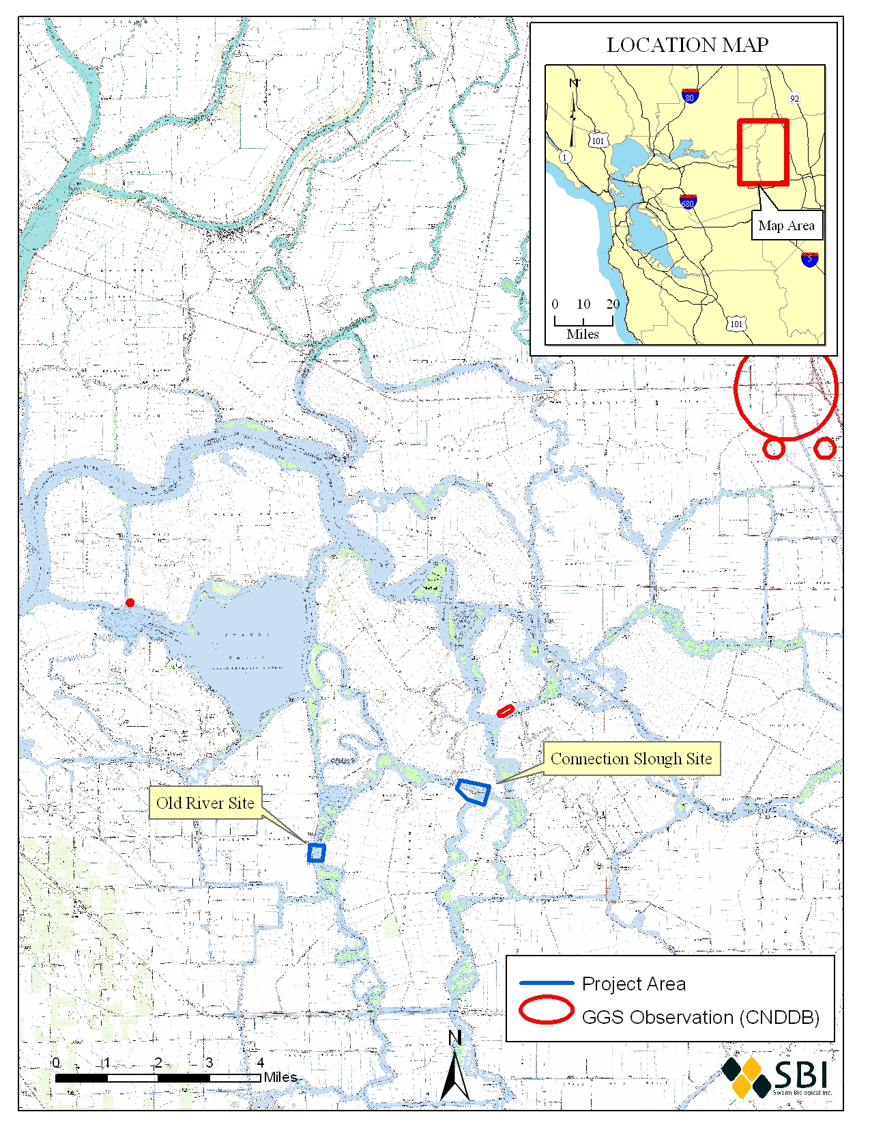
Figure 1. California Natural Diversity Database records of GGS in the project vicinity

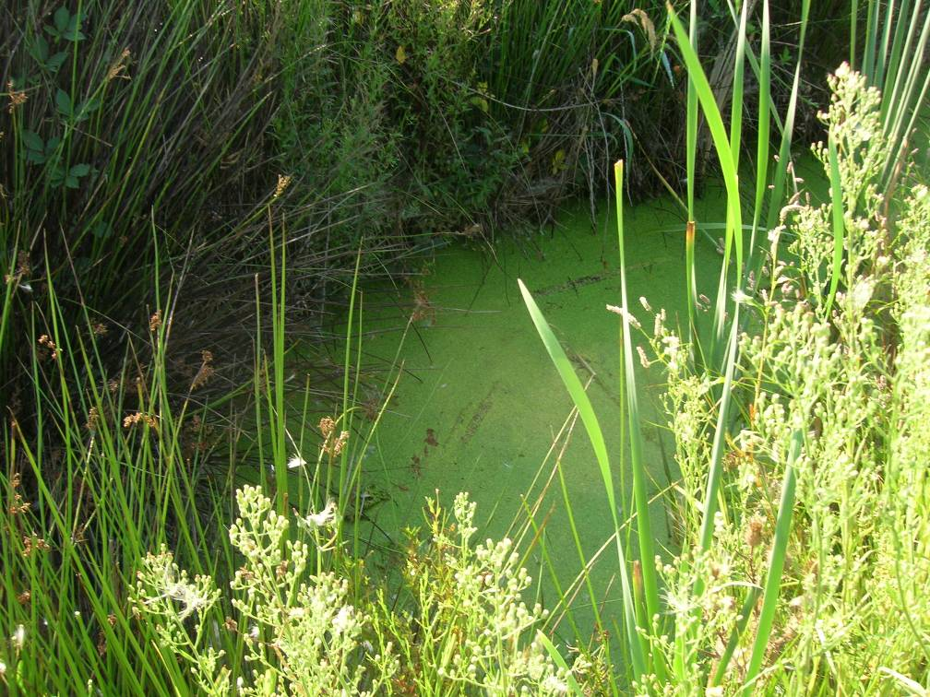
Figure 2. West bank of Old river, small canal parallel to road.

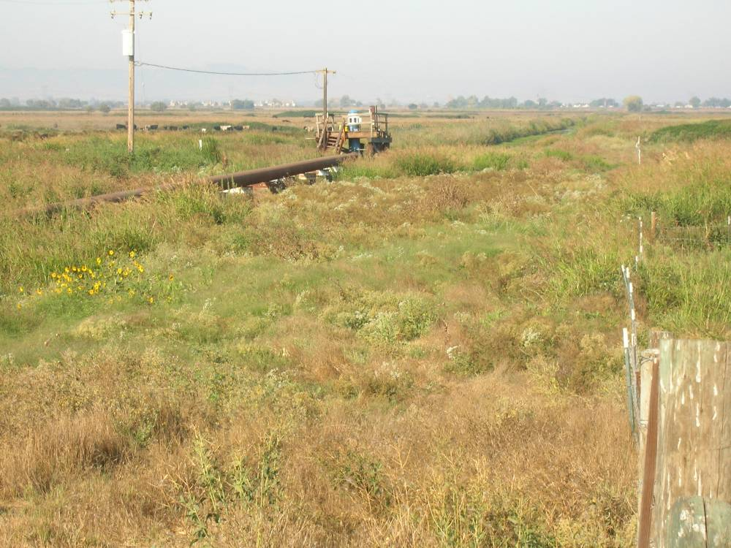
Figure 3. West bank of the Old River, diked canal perpendicular to the levee road.

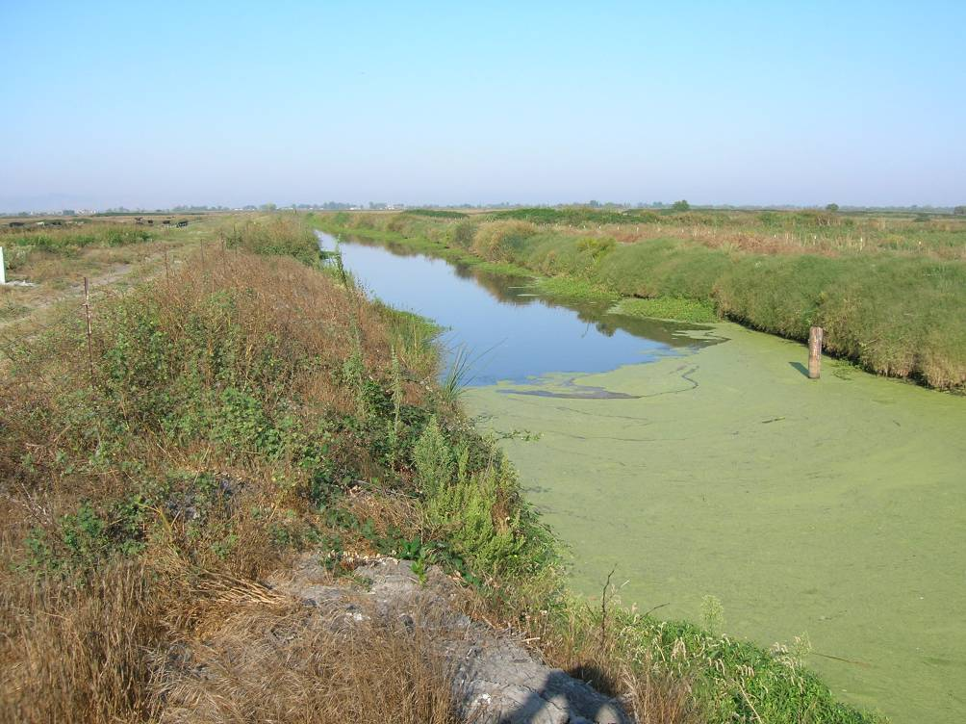
Figure 4. West bank of Old River, view of diked canal.

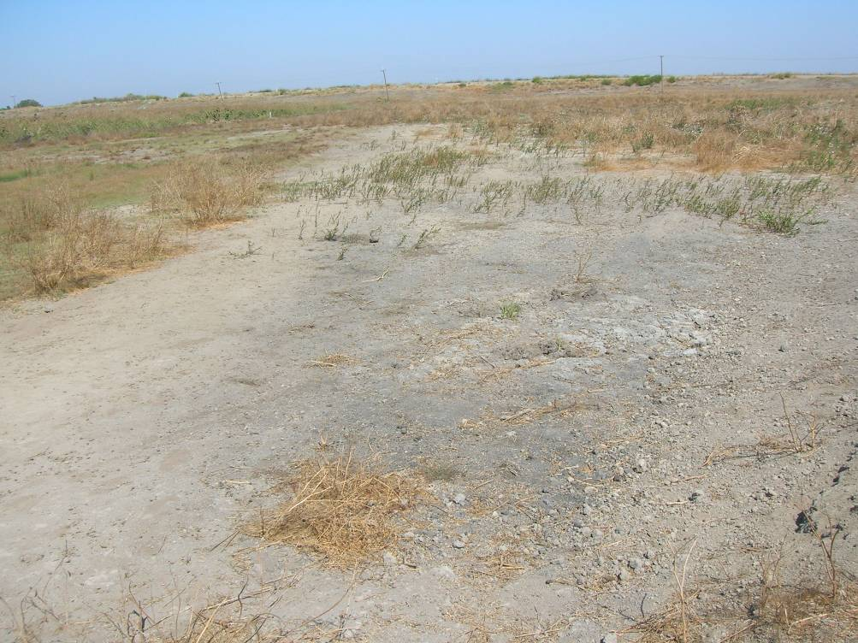
Figure 5. Seasonal wetland at Connection Slough site.

7.0 Literature Cited

Brode, J.M. 1988. “Natural History of the Giant Garter Snake (Thamnophis couchii gigas).” Pages 25-28 in: Proceedings of the Conference on California Herpetology. H.F. DeListe, P.R. Brown, B. Kaufman, and B.M. McGurty (eds.). Southwestern Herpetologists Society, Special Publication No. 4

California Department of Fish and Game (CDFG). 2008. California Natural Diversity Database (CNDDB). Database query for the Jersey Island, Brentwood, Bouldin Island, Woodward Island, Terminous and Holt 7 ½ - minute quadrangles. September 2008.

Fitch, H.S. 1940. A biogeographical study of the ordinoids Artenkras of garter snakes (genus Thamnophis). University of California Publications in Zoology 44(1):1-50.

Hansen, G. E. and J. M. Brode. 1980. Status of the giant garter snake Thamnophis couchii gigas (Fitch): Special Publication Report Number 80-5. Inland Fisheries Endangered Species Program: California Department of Fish and Game: 14 pp.

Stebbins, R. C. 2003. A Field Guide to Western Reptiles and Amphibians. Boston, Houghton Mifflin Book Co.

U.S. Fish and Wildlife Service (USFWS). 1993. Determination of threatened status for the giant garter snake / RIN 1018-AB73. Federal Register. 58: 1654 lines.

______. 1999. Draft recovery plan for the giant garter snake (Thamnophis gigas). U.S. Fish and Wildlife Service, Portland, Oregon: 192 pp.

______. 2005. "Species account: giant garter snake (Thamnophis gigas)." 2005, available online at: http://sacramento.fws.gov/es/animal_spp_acct/giant_garter_snake.htm.

Wiley, G. D., M. Cassaza, and J. K. Daugherty. 1997. 1996 Progress report for the giant garter snake study. Preliminary report, U.S. Geological Survey, Biological Resources Division.

