aTTACHMENT 1
Salmon Smolt Migration Analysis
The following attachment evaluates the influence of the Proposed Action on the survival of salmonid smolt from the Sacramento River system Cramer Fish Sciences conducted a preliminary model-based assessment using the Delta Passage Model (DPM) that was run DSM2-HYDRO data provided by RMA. The DPM simulates migration and mortality of juvenile Chinook salmon through the Delta and provides quantitative estimates of Delta survival to Chipps Island.


Technical Memorandum
TO: Metropolitan Water District of Southern California
FROM: Brad Cavallo (lead), Paul Bergman, and Mark Teply
SUBJECT: Preliminary assessment of the 2-Gates Project effects on Sacramento River origin salmonid smolts
DATE: October 2nd, 2009

In order to assess how salmonid smolt survival to Chipps Island might be influenced by the proposed 2-Gates Project, we conducted a model-based assessment using the Delta Passage Model (DPM) developed by Cramer Fish Sciences, running on DSM2-HYDRO data provided by RMA. The DPM simulates migration and mortality of juvenile Chinook salmon through the Delta and provides quantitative estimates of Delta survival to Chipps Island. Though the DPM is primarily based on studies of winter run Chinook surrogates (late fall run Chinook) it is applicable to steelhead and Chinook smolts with similar emigration timing. The biological functionality of the DPM is based upon the foundation provided by Perry et al. (2009) as well as other acoustic tagging based studies, and earlier Coded Wire Tag (CWT) analyses provided by Newman (2003), Kimmerer (2008), among others. A manuscript describing the DPM has been completed and is currently in review for publication in a peer reviewed journal. This analysis provides a useful, preliminary assessment of likely Delta-wide effects for Sacramento River origin juvenile salmonids. However, it does not provide an assessment of local, direct effects which could be associated with the 2-Gates Project. For example, the DPM as applied here does not include predation mortality occurring at the specific location of the proposed gates structure. It also important to note that this analysis does not represent likely effects to salmonid smolts entering the Delta from the Mokelumne River or the San Joaquin River; though the DPM is actively being adapted for this purpose.

Methods
The DPM is based on a detailed accounting of migratory pathways and reach-specific mortality as smolts travel through a network of Delta channels (Figure 1). Smolt movement and survival in the DPM relies on three major functional relationships (Figure 2). Consistent with the findings of Perry et al. (2009), salmon smolts arriving at distributaries enter downstream reaches in proportion to the flow diverted. Reach-specific survival estimates and associated error estimates were obtained from three separate Delta acoustic tagging studies (Burau et al. 2007; Perry et al. 2009; SJRGA 2007). Similar to the analyses of Newman (2003) and Newman and Rice (2002) reach-specific survival is calculated as a logarithmic function of flow. Smolt movement in the DPM occurs daily and is a function of reach-specific length and migration speed informed by acoustic tagging studies. Smolt migration speed is calculated as a reach-specific logarithmic function of flow. Direct loss of migrating smolts at the CVP and SWP pumps is modeled as an exponential function of Delta export flow based on Kimmerer’s (2008) analysis of coded-wire tagged Chinook smolts in the Delta.

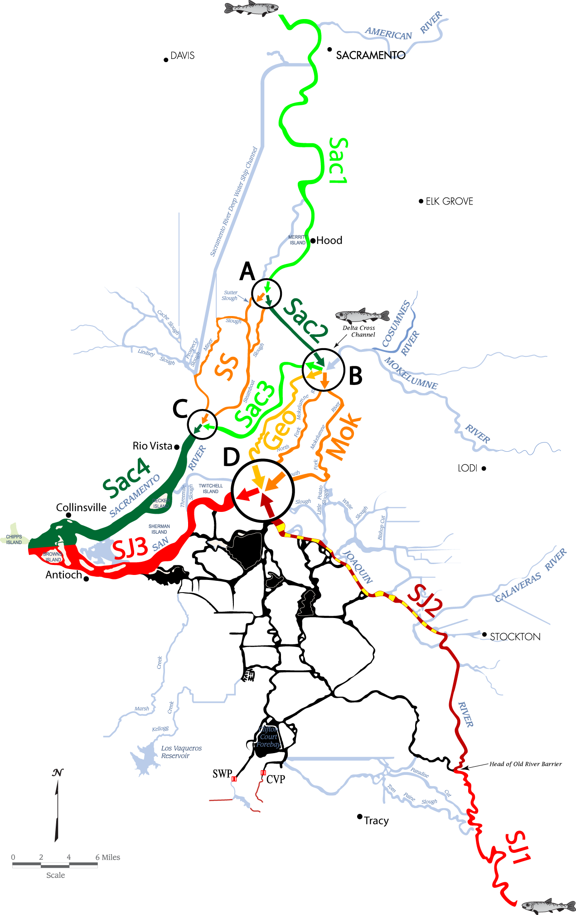
Figure 1. Map of the Sacramento-San Joaquin Delta showing the modeled reaches and junctions of the Delta Passage model. Reaches in the model are represented as colored segments of waterway. Reach labels are colored to match the reach. Junctions in the model are represented as circles containing arrows that correspond to the various flows entering and exiting each junction. Junctions are labeled by black letters, A-D. Salmonid symbols indicate locations where fish may be injected into the DPM.
Perry et al. (2009) describe in detail how tag detection, survival and route selection probabilities can be estimated from recovery of acoustic tagged salmon smolts. A complete mathematic expression for fish transit and survival through the Delta is provided in Appendix A. Given the complexity of the Delta, we provide a simplified example (Figure 2) to illustrate the conceptual basis for the DPM. In our simplified example, the number of smolts reaching the bay (N_{B}) can be calculated as:

smolts lost in A
smolts lost in B1
smolts lost in B2

1) N_{B =} (N_{R} - N_{R}*M_{A}) - (N_{R}*1-M_{A})*P_{B1}*M_{B} - (N_{R}*1-M_{A})*P_{B2}*M_{B2}

- (((N_{R}*1-M_{A})*P_{B1}*1-M_{B1}) + ((N_{R}*1-M_{A})*P_{B2}*1-M_{B2}))*M_{C}

smolts lost in C

where N_{B} is the number of smolts reaching the bay, N_{R} is the number of smolts entering from the river, M_{i} is reach specific smolt mortality for the i^{th} reach, and where P_{i} is the proportion of fish entering the i^{th} reach. In our simplified example, and in the DPM itself, M_{i} is a function of reach specific flow, P_{i} is a function of junction flow proportions, and M_{C} is a function of export pumping (Figure 2).
Route selection and mortality are influenced by south Delta exports, operations of the Delta Cross Channel gates (DCC), and by numerous other pathway-specific physical and biological factors. Similar to Kimmerer (2008) and NMFS (2009), we define a conceptual model where juvenile salmon migrating through the Delta are subject to one of four possible fates: background mortality (M_{B}), direct export mortality (M_{D}), indirect export mortality (M_{I}), or survival to Chipps Island (S_{T}). Total mortality (M_{T}) for juvenile salmon migrating through the Delta can then be defined as:
2) M_{T} = M_{B} + M_{D} + M_{I}
where M_{B} is mortality resulting from inflows, food, habitat, predation, water quality and disease, M_{D} is mortality which occurs at or near the CVP and SWP export facilities as a function of export pumping, and M_{I} is the additional, incremental mortality resulting from exports and DCC operations which alter Delta hydrodynamics and disrupt salmon out-migration cues.
For all of the analyses conducted in this paper, survival to Chipps Island is the response variable used to assess survival outcomes and to evaluate model function and sensitivity. Following from equation (2) survival to Chipps Island or total Delta survival (S_{T}) can be defined as:
3) S_{T} = 1/M_{T}
or from the example depicted in Figure 2 and equation (1):
4) S_{T} = N_{B}/N_{R}
Building on this conceptual framework, the DPM relies on empirical data from tagging studies of Delta salmon migration and Delta flow conditions to inform mechanisms affecting S_{T}. Survival estimates from acoustic tagging studies used to inform reach-specific survival parameters include all potential sources of mortality (M_{B}, M_{D}, and M_{I}). During experimental releases, tagged smolts were vulnerable to background mortality, and also to indirect and direct mortality associated with export facilities. Where supported by literature, functional relationships were created between Delta flow conditions (e.g. reach-specific flow, export flow) and fish survival and behavior (e.g. route selection, migration speed) to represent fish-habitat interactions as accurately as possible. Many environmental conditions besides flow (e.g. water temperature, predator densities, food availability) may influence the survival of migrating smolts, however, reach-specific data for many of these variables were not available to inform the creation of model functions.
The DPM was designed to model migration and mortality of juvenile Chinook salmon entering the Delta from one of three possible sources: the Sacramento River, the Mokelumne River, or the San Joaquin River. For simplicity, this paper focuses exclusively on salmon entering from the Sacramento River basin. The DPM depicts a simplified Delta channel network following the reaches and junctions depicted in Perry et al. (2009). Specifically, the DPM is composed of 10 reaches and four reach junctions (Figure 1). These reaches and junctions were selected to represent primary salmonid migration corridors where high quality fish and hydrodynamic data were available. For simplification, Sutter Slough and Steamboat Slough are combined as reach SS and the forks of the Mokelumne River are combined as reach Mok (Figure 1). At junction B, fish exit reach Sac2 and enter either Sac3, Georgiana Slough (Geo), or Mok (Figure 1).
The DPM operates on a daily time step using simulated daily tidally average flows, exports and DCC operations. Reach specific flow data were generated by the Delta Simulation Model II (DSM2-HYDRO) hydrology module and provided by RMA. We were provided with daily tidally averaged flows for the following six scenarios for the 2-Gates Project:
We injected smolts into the DPM at reach Sac1 using a typical emigration distribution for winter run Chinook salmon (Figure 2). For each of the six scenarios, we conducted 100 Monte Carlo simulations of smolt passage to allow for uncertainty estimates to be placed about predicted Delta survival values. Uncertainty and stochasticity associated with model parameters (reach-specific survivals, migration speeds, and route selections at junctions) are modeled using error estimates from acoustic tracking experiments. Parameter error values inform normal probability distributions that are sampled from each timestep (daily) to determine daily parameter values. For each Monte Carlo simulation we calculated survival to Chipps Island for each of the six scenarios reported mean, minimum and maximum response.
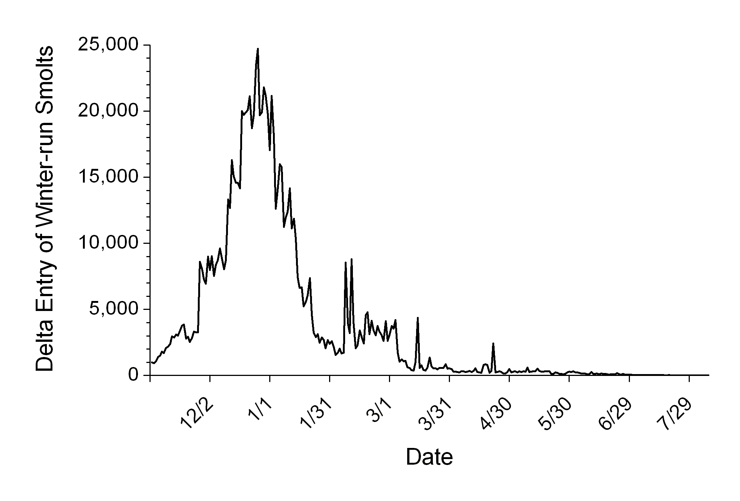
Figure 2. Estimated timing for winter run Chinook smolts reaching the Delta. Based on catch at Red Bluff Diversion Dam from 1997-2006 delayed for typical travel time to the Delta.

Results and Discussion
Our result found survival to Chipps Island for the 2003-2004 hydrology ranged between 34% and 42% for all the scenarios we evaluated. We observed only small differences in survival between any of the 2-Gates Project scenarios (Figure 3), and no significant survival differences between “No Project” and “With Project” conditions. These results are perhaps not surprising given that the scenarios have relatively little influence on flow patterns outside of the South Delta region. While the DPM cannot (at this time) address site specific effects which may occur in the immediate vicinity of the 2-Gates structure; our analysis found that roughly 20% of Sacramento River will migrate through the San Joaquin River reach where they might be exposed to direct effects of the 2-Gates Project.
These results provide a useful preliminary assessment of the 2-Gates Project likely population-level effects for Sacramento River origin juvenile salmonids. We did not observe any change in survival to Chipps Island which would be described as either biological or statistically significant. It is important to note again however, that we did not attempt to evaluate direct, site specific mortality which may be associated with the proposed project. However, our DPM runs suggest that only 1 in 5 Sacramento River origin smolts will pass through the region of the Delta where they might approach or be entrained toward the proposed project. A more detailed analysis of available acoustic tagging data from the South Delta would make it possible to better assess the local effects of the 2-Gates Project on Sacramento, Mokelumne and San Joaquin origin smolts. With additional South Delta details included in the DPM it would be possible to assess critical uncertainties related to possible Two Gate Project effects. The DPM could help identify these critical uncertainties and also provide a framework for planning and interpreting the results of new field studies and acoustic tagging experiments.
REFERENCES

Burau, J., A. Blake, and R. Perry. 2007. Sacramento/San Joaquin River Delta regional salmon outmigration study plan: Developing understanding for management and restoration. http://baydeltaoffice.water.ca.gov/ndelta/salmon/documents/RegionalSalmonStudyPlan_2008.01.07.pdf

Kimmerer, W. 2008. Losses of Sacramento River Chinook salmon and delta smelt to
entrainment in water diversions in the Sacramento-San Joaquin Delta. San Francisco Estuary and Watershed Science. 6(2).

Newman, K. B. & Rice, J. 2002. Modeling the survival of Chinook salmon smolts outmigrating through the lower Sacramento River system. Journal of the American Statistical Association 97, 983-993.

Newman, K. B. 2003. Modeling paired release-recovery data in the presence of survival and capture heterogeneity with application to marked juvenile salmon. Statistical Modeling 3, 157-177.

Perry, R. W., P.L. Brandes, P.T. Sandstrom, A. Amman, B. MacFarlane, A.P. Klimley and J. R. Skalski. 2009. Estimating survival and migration route probabilities of juvenile Chinook salmon in the Sacramento–San Joaquin River Delta. North American Journal of Fisheries Management. In Press.

San Joaquin River Group Authority. 2007. 2007 Annual Technical Report.

