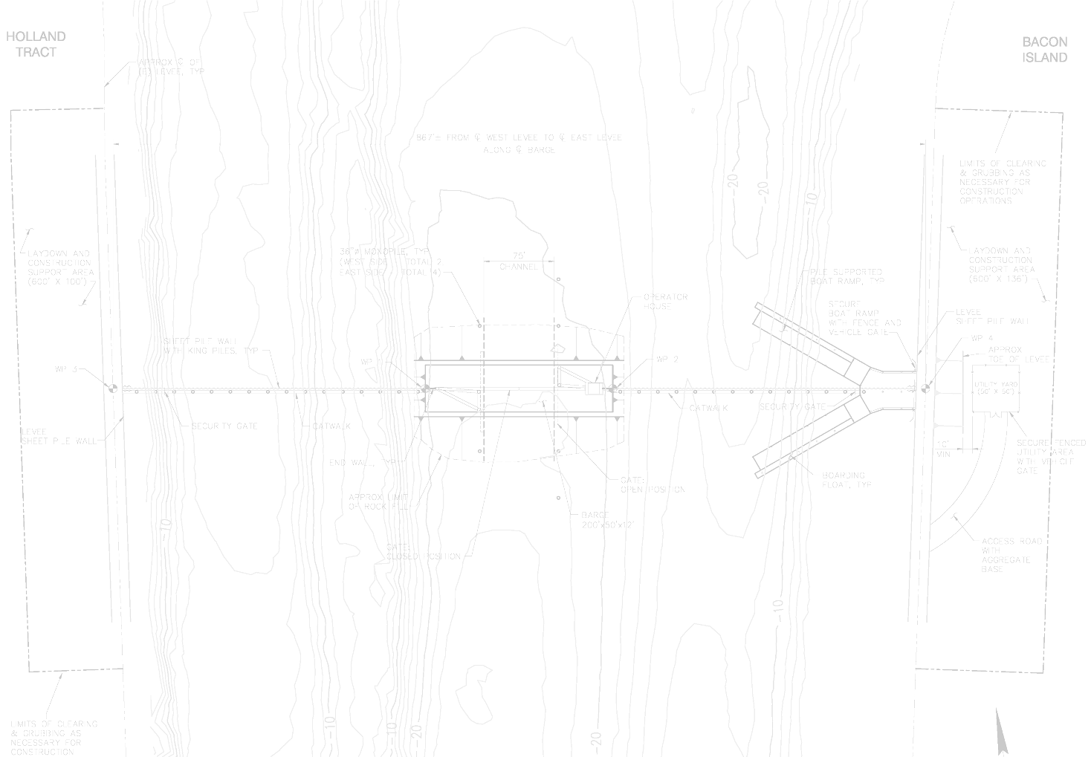
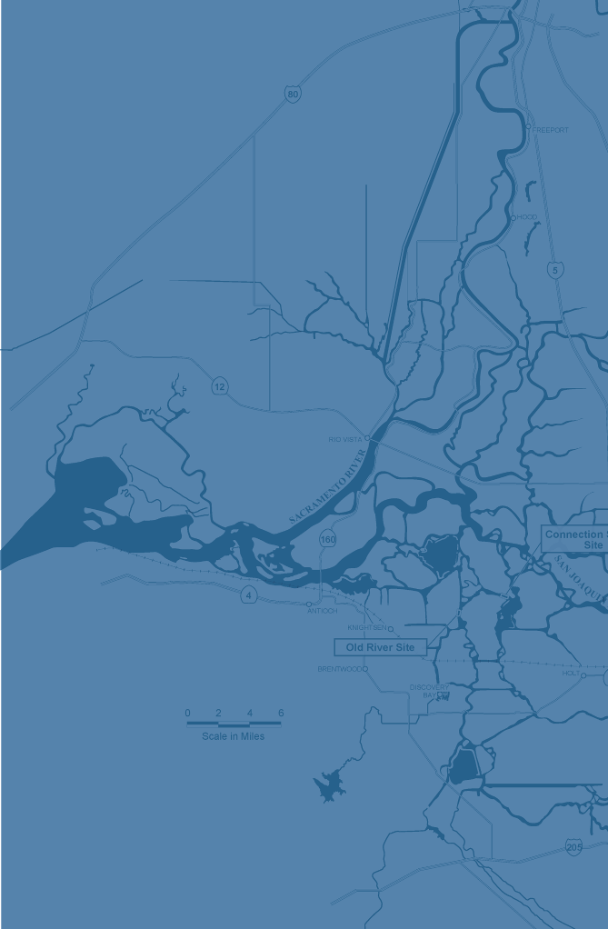
2-Gates
Fish Protection Demonstration Project
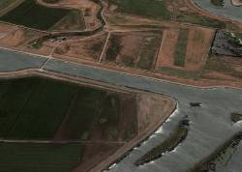
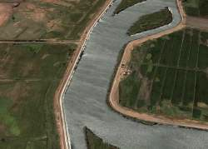
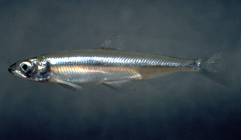
2nd Administrative Draft Mitigated Negative Declaration and Environmental Assessment

Not for Public Distribution-
For Internal Review Only

AUGUST 19, 2009

mitigated negative declaration • environmental assessment
Not for Public Distribution-
For Internal Review Only
2-Gates Fish Protection
Demonstration Project
2nd Administrative draft
AUGUST 19, 2009

Prepared for
 | 
San Luis and Delta-Mendota Water Authority  P.O. BOX 2157  Los Banos, CA. 93635 | U.S. Bureau of Reclamation  2800 Cottage Way, MP-152  Sacramento, CA 95825

