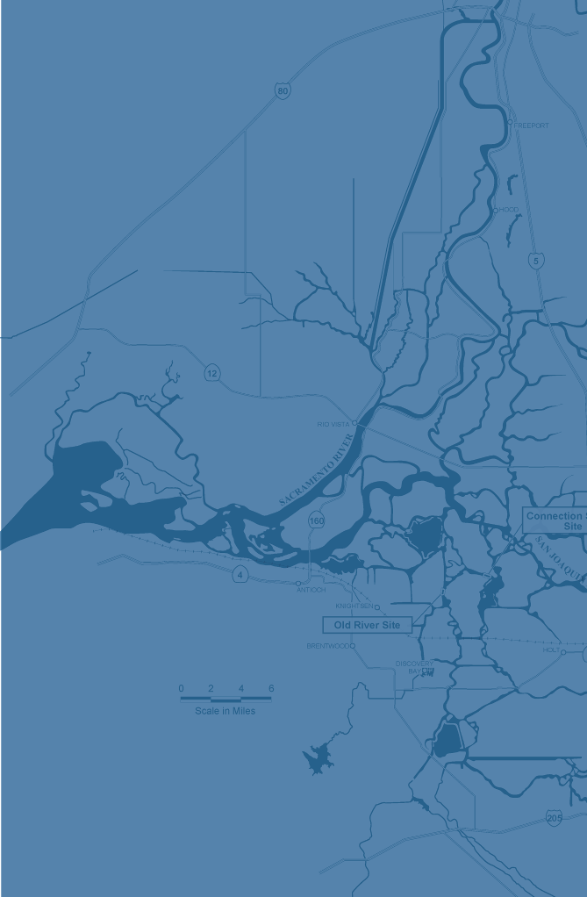
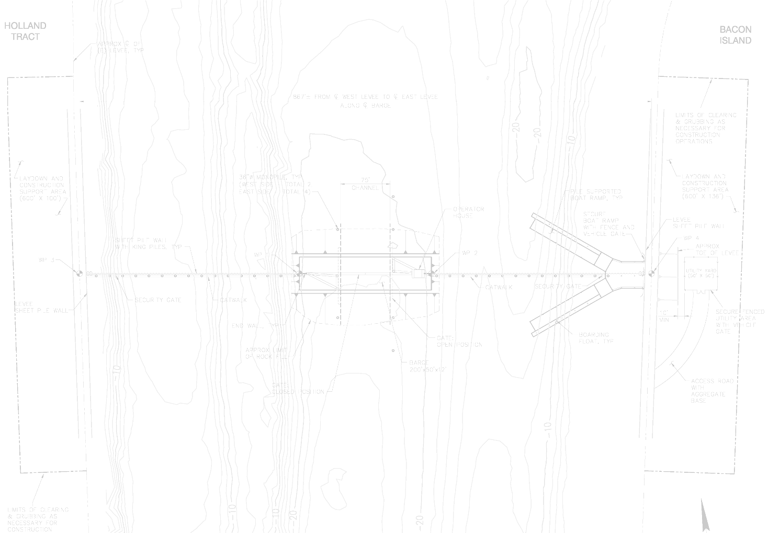
2-Gates Fish Protection
Demonstration Project
biological assessment

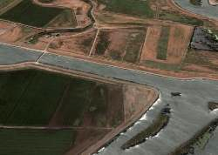
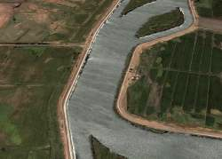
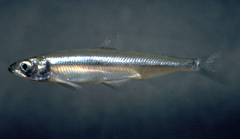

SECOND ADMINISTRATIVE DRAFT, SUBJECT TO REVISION

AUGUST 19, 2009

NOT FOR PUBLIC DISTRIBUTION • FOR INTERNAL REVIEW ONLY

2-GATES FISH PROTECTION DEMONSTRATION PROJECT
Biological Assessment
second ADMINISTRATIVE draft • subject to revision

AUGUST 19, 2009

not for public distribution • for internal review only

Prepared for

U.S. Bureau of Reclamation
2800 Cottage Way, MP-152
Sacramento CA 95825

Table of Contents
Foreword 1

Foreword
The 2-Gates Fish Protection Demonstration Project (2-Gates Project) is intended to illustrate and validate the value of operable gates, strategically placed within the Sacramento-San Joaquin River Delta (Delta), with regard to the protection of delta smelt and the management of a reliable water supply to municipal and agricultural water users south of the Delta. The Delta provides habitat for several sensitive species such as the delta smelt, salmon, steelhead, and green sturgeon. It is a vital source of drinking water for over 23 million Californians, and supports more than 1.3 million acres of irrigated agricultural lands. The 2-Gates Project would install and operate removable gate structures in two key channels in the central Delta in order to control flows and thereby provide reduced entrainment of delta smelt and other sensitive aquatic species at the State Water Project (SWP) and federal Central Valley Project (CVP) export pumping facilities. The 2-Gates Project is designed to be compatible with SWP and CVP water management operation criteria established by State and federal water quality and environmental regulators.
The concept of the 2-Gates Project evolved from information developed by several research efforts documenting relationships between high entrainment events and population declines and high salvage of pre-spawning adult delta smelt and occurrence of high turbidity in the south Delta. An idea evolved to install gates that would allow operations to influence the turbidity plume and therefore the distribution of adults, and a similar approach could be used with larval and juvenile smelt. Development of the 2-Gates Project employed a deliberate, iterative process of modeling and model improvement, starting with a conceptual framework and baseline assumptions, and then progressing through initial site selection, development of project operational parameters and eventually through the analysis of potential effects on sensitive fish and wildlife species and water supply.
Early in the investigative process, it was determined that complex delta smelt behavioral models would be useful to predict distribution, abundance, and fate of delta smelt under baseline and 2-Gates Project operational conditions. Because the development of such a model was time-consuming and its success could not be accurately predicted, a decision was made to initially use the One-Dimensional (1D) DSM2 model formulation for hydrodynamic, water quality, and particle tracking to determine the most favorable location of gates, their region of control and their effects on baseline flow conditions. Concurrent with this effort a delta smelt behavioral model was being developed by Resource Management Associates (RMA), which recognized that delta smelt do not react simply as neutrally buoyant passive particles floating in the water column. RMA used a Two-Dimensional (2D) formulation, modified to characterize both adult and larvae/juvenile delta smelt behavior. The 2D behavioral models were refined against historical data and eventually used to determine anticipated effects of the 2-Gates Project on delta smelt under several hydrodynamic conditions, with and without the gates operating, within the Delta. Subsequent model runs and refinements in modeling capabilities helped enhance an understanding of the likely effects of project operations on Delta hydrodynamics, water quality, and delta smelt entrainment. Iterative analyses over a period of time improved the evaluation process and helped formulate project operations.
The California Department of Water Resources (DWR) and the U.S. Bureau of Reclamation (Reclamation) are co-leads in the development of the proposed 2-Gates Project. Reclamation has also prepared the following biological assessment (BA) in compliance with requirements of the federal Endangered Species Act (ESA). The two agencies intend to apply for all applicable permits and enter into required coordination and consultations.

