**Physical and Biological Drivers of Longfin Smelt Vertical Distribution**

Lenny Grimaldo1 and Fred Feyrer2

1ICF International

620 Folsom St, Suite 200, San Francisco, CA 94107

(415) 677-7185; lenny.grimaldo@icfi.com

2California Water Science Center, U.S. Geological Survey Placer Hall, 6000 J Street, Sacramento, CA 95819

(916) 278-3232; ffeyrer@usgs.gov

December 19th, 2014

**Introduction and Background**

Longfin smelt (*Spirinchus thaleichthys*) is a small pelagic fish found in estuaries and coastal waters along the Pacific Coast of North America. In the Upper San Francisco Estuary (SFE), longfin smelt populations declined in abundance following a crash in lower trophic level food production associated with the overbite clam invasion of 1987 (Thomson et al. 2010; Rosenfield and Baxter 2011). Longfin smelt abundance has declined further during an era known as the Pelagic Organism Decline (POD), which is defined as a period (2002 to present) where populations of other key pelagic fishes in the upper estuary also declined and have remained suppressed at record low abundances (Sommer et al. 2007). In 2009, longfin smelt was listed as a threatened species under the California Endangered Species Act (CDFW 2009). In 2012, longfin smelt was warranted for listing under the Federal Endangered Species Act (ESA) but precluded from formal listing at this time due to the need to address higher priority listing actions.

Longfin smelt exhibits an anadromous life history strategy, although there are some landlocked populations. Rearing and growth takes place in estuarine and coastal habitats for 2-3 years before longfin smelt spawn in upstream portions of estuaries. In the SFE, most spawning takes place in brackish or freshwater during winter from December to March. Longfin smelt feed on copepods as larvae and primarily on mysids as juveniles and adults. Many studies have highlighted a positive relationship between the abundance of age longfin smelt and freshwater flow (Stevens and Miller 1983; Jassby et al. 1995; Kimmerer 2002) but the mechanisms underlying that relationship remains unclear (Kimmerer et al. 2009).

There are several monitoring programs that sample longfin smelt throughout their life history in the San Francisco Estuary (Table 1) but only one of those monitoring programs (Smelt Larval Survey) was designed with the intent to target longfin smelt abundance and distribution. Although many of these programs collect various life stages of longfin smelt in time and space, are useful for describing relative changes in abundance, these programs may not fully capture the abundance, distribution, and habitat use of longfin smelt (Rosenfield and Baxter 2011). Additionally, gear efficiency studies for longfin smelt have not been conducted for the monitoring programs so interpretation of relative annual abundances may not fully capture observational error that can arise from water quality, total fish abundance, changes in habitat use, and other factors. Management actions (D-1641, SWP and CVP Export Reductions, etc) for longfin smelt should be based on the most robust understanding of their distribution, abundance, and survival rates.

Recent evidence suggests that variability in longfin smelt vertical distribution may affect the interpretation of data on the spatial distribution and abundance of longfin smelt collected in long-term monitoring programs (Rosenfield and Baxter 2011). Specifically, the ratio of longfin smelt catches in midwater versus demersal habitats has decreased through time in some regions of the SFE (Fig. 1). As both water clarity and station depth increased, the ratio has shifted to smaller values. These analyses suggest that longfin smelt catches in the surface trawls (where catches are abundant in the otter trawls) are lower because a) the net does not sample the same fraction of the water column as it did historically (i.e., the fish are deeper than the habitat sampled by the net), b) longfin smelt are avoiding the net in clearer waters, or c) that longfin smelt has shifted its vertical distribution towards deeper water below the coverage of the Midwater Trawl where turbidity is sufficient to avoid predation and food is more abundant.

The purpose of this study is to investigate if longfin smelt shift their vertical distribution under different environmental and biological conditions. Using smelt cam technology, this study will sample fixed sample depths throughout continuous tidal cycles to ascertain if longfin smelt are positioning in the water column with respect to light (turbidity and day vs night), food, or salinity stratification. This study is designed to understand the mechanisms underlying vertical distribution and to resolve why catches in surface trawls and otter trawls may be affected by environmental conditions and/or monitoring methods. Further, this study should help resolve why longfin smelt catches vary in surface and demersal habitats, which can help to inform about potential biases in the long-term monitoring programs.

**Conceptual Model and Goals**

Our conceptual model explaining the divergent patterns in longfin smelt catch in otter trawl and midwater trawl samples from the CDFW Bay Study at site 325 is that longfin smelt are not evenly distributed vertically in the water column. The conceptual model posits that longfin smelt are distributed near the bottom of the water column (Fig. 2). This results in larger catches in the otter trawl samples than the midwater trawl samples because the otter trawl is positioned along the bottom of the water column for the entire duration of a tow, while the midwater trawl is pulled obliquely through the water column and is therefore positioned near the bottom of the water column for only a short duration of a tow. Therefore, the otter trawl collects more longfin smelt than the midwater trawl because it is towed for a longer duration through longfin smelt habitat (i.e, turbid water) than is the midwater trawl. Thus, the primary objective of this study is to determine the vertical distribution of longfin smelt. This will be done by sampling for longfin smelt at fixed depth strata to confirm or refute the conceptual model that longfin smelt are distributed near the bottom of the water column (Fig. 3). The secondary objective of this study is to determine how variability in vertical distribution influences observations and inferences from the CDFW Bay Study in order to improve interpretations of longfin smelt spatial structure and abundance generated from the CDFW Bay Study.

If our conceptual model that longfin smelt are not evenly distributed vertically in the water column is confirmed, the observed patterns may be due to a wide range of related environmental processes and cues that ultimately control the vertical distribution, including life stage, tidal currents, salinity and turbidity gradients, ambient light, diel cycle, or food abundance. Thus, we will need to sample under sufficiently diverse environmental conditions (particularly, tidal and diel cycles, hydrologic conditions) to distinguish among all of the various factors that may control vertical distribution. Therefore, we are proposing a 2-year study (Table 1) with intensive field sampling during approximately 2-4 weeks each year to address three key questions:

1. Are longfin smelt evenly distributed vertically in the water column?
2. Does longfin smelt vertical distribution respond to environmental cues, including gradients in tidal currents, turbidity, salinity and ambient light, diel cycle or food abundance?
3. Do longfin smelt need to achieve a threshold age or size before they respond to environmental cues for vertical distribution?

**Study Design and Sampling Protocols**

This 2-year study will include three individual elements, 1 pilot effort and 2 separate field efforts examining vertical distribution of longfin smelt (Table 1). The purpose of the pilot effort will be to refine sampling logistics and obtain preliminary information on the efficacy of non-lethal sampling methods for longfin smelt using the SmeltCam (Feyrer et al. 2013). The SmeltCam is an open-ended underwater video camera codend that automatically collects information on the number and species of fishes that pass freely through a trawled net without handling. The SmeltCam has previously been successfully applied in a study of the vertical and lateral distribution of delta smelt over tidal cycles in the upper San Francisco Estuary (Feyrer et al. 2013). The pilot study will determine the efficacy of the SmeltCam for similar non-lethal studies of longfin smelt. Specifically, we will test the ability to identify and distinguish longfin smelt from other fishes using images obtained with the SmeltCam. We will also be evaluating other study logistics during the pilot effort, including optimal tow length durations, coordinated sampling of fish with other physical and biological parameters, and the collection of some preliminary data to use in a power analysis to refine estimates of samples sizes required for the assessment of vertical distribution, and potentially detection probabilities.

The first vertical distribution study will take place within approximately a few months of the pilot study and the second will take place the following calendar year. Vertical distribution studies will be conducted in San Pablo Bay at site 325 of the CDFW Bay Study (Fig. 4). This site was chosen because it is where divergent patterns in catch in otter trawl and midwater trawl samples from the CDFW Bay Study are strongest The site is also located in a key deep (12.3 m), main center channel location of San Pablo Bay where strong tidal currents generate vertical structure in physical habitat features important to elucidating vertical distribution of longfin smelt (Fig. 6). A single fixed site in these studies is sufficient because tidal currents can move water and fish habitat approximately 10 miles past the site, allowing us to effectively sample the equivalent of about 20 miles of longitudinal habitat.

The general design of the vertical distribution studies will be to sample physical and biological parameters approximately every 2 hours for 48 consecutive hours in order to obtain consistent data over a full range of tidal and diurnal cycles. All sampling will be conducted aboard the USGS R/V Turning Tide. Physical measurements will be made with a vertical acoustic Doppler current profiler (V-ADCP) and a YSI EXO sonde. The V-ADCP will be used to measure vertical flow structure and the YSI EXO will be used to obtain vertical profiles of water temperature, turbidity, conductivity, dissolved oxygen concentration, FDOM (surrogate for dissolved organic carbon), pH, Chlorophyll *a* fluorescence (surrogate for phytoplankton biomass) and Phycocyanin (surrogate for blue-green algal biomass). A submersible low light autoradiometer will be used to measure ambient light. At each sampling interval, physical condition measurements will be made first and examined in real time in order to determine the most appropriate vertical spatial structure for sampling fish. Based upon the tidally-averaged depth of site 325 (12.3 m) and the vertical dimension of the mouth of the midwater trawl (3.6 m), fish density could potentially be measured at 3 or 4 independent depth strata, depending upon tidal stage. Prevailing physical conditions as measured by the V-ADCP and the YESI EXO Sonde will determine if the vertical distribution structure of the fish sampling should be adjusted relative to the maximum number of independent depth strata available to be sampled.

Fish will be sampled using a midwater trawl with the same dimensions as the one that is used for the CDFW Bay Study. All fish sampling will be conducted with a midwater trawl because, unlike an otter trawl, it facilitates sampling at fixed depth strata (Feyrer et al. 2013). The midwater trawl used by the CDFW Bay Study has a mouth opening of 3.7 m (width) × 3.7 m (height) with mesh graduated in nine sections from 20.3 cm stretch mesh at the mouth to 1.3 cm stretch mesh at the codend. The CDFW protocol is to tow the midwater trawl obliquely through that water column for 12 minutes against the current. For this study, we anticipate also towing the midwater trawl for 12 minutes against the current obliquely through the water column to obtain a sample representative of what would be collected by the CDFW Bay Study. This is in addition to towing the midwater trawl for 12 minutes against the current at fixed depth strata to evaluate vertical distribution. Thus, if water depth permits sampling 4 independent depth strata, a total of 5 separate tows will be conducted during each 2-hour sampling interval (4 tows conducted at individual depth strata and one tow conducted obliquely through the water column). Conducting the additional oblique tow at each sampling interval will contribute to directly addressing the secondary objective of this study, which is to determine how variability in vertical distribution influences observations and inferences from the CDFW Bay Study in order to improve interpretations of longfin smelt spatial structure and abundance generated from the CDFW Bay Study.

Food abundance will be measured at each depth strata in which fish are sampled by measuring densities of macrozooplanton (mysids and amphipods) and mesozooplankton (all stages of copepods) using the methods of Kimmerer et al. (1998). Macrozooplankton will be sampled with 60-cm, 0.5mm-mesh, opening-closing Bongo nets affixed with flow meters. Mesozooplankton will be sampled with a 100-l min-1 submersible pump equipped with a noncollapsable intake hose with the discharge filtered through 35-µm mesh net into a container of known volume.

Data analyses will involve examining the available data using a variety of summarization and statistical approaches to address the three key research questions. The basic approach to the data analysis will consist of two stages: (a) data exploration, which includes generating summary statistics and graphical representations of the data, and (b) model building and the development of statistical tests. The 33 years (1980-2012) of data collected in the CDFW Bay Study at site 325 indicate that longfin smelt catches are zero-inflated and non-normally distributed (Fig. 7). Thus, in order to appropriately test hypotheses we may ultimately fit log linear Poisson models which control for overdispersion (the quasi-Poisson and negative binomial), or models allowing for excess zeroes (the zero inflated negative binomial) which control for overdispersion and excess zeroes with the Poisson distribution (Martin et al. 2005). Model fitting will likely be done using the statistical computing environment R, version 2.15.1, along with the R package ‘pscl’ (Jackman 2012). To make between model comparisons, we may calculate AIC values, AIC = 2*k – 2*log(Likelihood), where k = the number of parameters. AIC simultaneously quantifies goodness of fit, as defined by the likelihood of the data, and model complexity (as measured by k), and models with the smallest AIC values are considered preferable.

A preliminary power analysis was conducted with the historical (1980-2012) CDFW Bay Study catches of age-0 longfin smelt at site 325 to get a general sense of the sample size required to reject a basic null hypothesis that there is no treatment level effect across 4 independent depth strata on longfin smelt catch per unit effort (CPUE). CPUE in the CDFW Bay Study midwater trawl samples is traditionally calculated as the total number of individuals collected standardized to the total volume of water filtered by the net x10,000. We calculated CPUE of age-0 longfin smelt for samples at site 325 in the month of June across the history of the CDFW Bay Study for use in the power analysis, the standard deviation of which = 10. Based upon the standard deviation of 10, α = 0.05, and potential sample sizes of 24, 48, 96 or 120 replicates, the estimated maximum detectable differences in CPUE units were approximately 12, 8, 6 and 5, respectively (Fig. 8). This can be interpreted as, for example, with 48 replicate samples (the likely number that will be collected in this study as it is currently envisioned) there is a 95% probability of detecting a difference of at least 8 CPUE units between the treatment means. Thus, the null hypothesis that there is no effect of depth would be rejected if there was a difference of at least 8 CPUE units between treatment means. Although generally informative, this power analysis should be considered only as a preliminary, conservative guideline because: (a) it is based on data using oblique tows which may differ in unknown ways from data that will be collected at specific depth strata, (b) it is based on aggregating 33 years of historical data which may or may not represent future conditions for the time period when the study is conducted, (c) the number of depth strata sampled ultimately may differ from 4, and (d) it considered only a test of the null hypothesis that there is no overall effect of depth strata on CPUE and therefore does not consider the potential effects of covariates.

**ESA Take Considerations**

The field work conducted for this study could potentially result in the take of State- and Federally-listed fish species. The potential take of listed species for this study was estimated using data from the 33 years (1980-2012) of midwater trawl sampling conducted at site 325 in the CDFW Bay Study. In the entire history of sampling at site 325 in the CDFW Bay Study, there have been no green sturgeon, and only a single delta smelt and a single steelhead collected, thus we do not anticipate collecting any of these species during this study. During this time period there have been 4,355 age-0 longfin smelt, 1,925 age-1+ longfin smelt, and 125 juvenile Chinook salmon (of unknown race) collected at site 325. Thus, we anticipate collecting age-0 and age-1+ longfin smelt (indeed, they are the focus of this study) and also possibly collecting juvenile Chinook salmon during this study.

The occurrence of age-0 longfin smelt, age-1+ longfin smelt, and juvenile Chinook salmon in midwater trawl samples at site 325 is highly seasonal (Figs. 9 and 10). We considered data collected during the month of June to estimate the take of age-0 longfin smelt, age-1+ longfin smelt, and juvenile Chinook salmon for this study. The average number of individuals collected per tow was as follows: juvenile Chinook salmon =1, age-0 longfin smelt = 76, and age-1+ longfin smelt = 5. Extrapolating these average values to the approximately 48 tows that we anticipate conducting in this study results in total estimated take levels as follows: juvenile Chinook salmon = 96, age-0 longfin smelt = 3,648, age-1+ longfin smelt = 288.

The take of individual longfin smelt and juvenile Chinook salmon during this study is not expected to affect the status of either species. It should first be noted that the juvenile Chinook salmon collected during this study are expected to consist primarily of fall- and late-fall run individuals. Although it is possible that individual juvenile spring-run or winter-run Chinook salmon could be collected, it is unlikely based upon outmigration timing. To the extent possible, sampling will be conducted with the SmeltCam affixed to the midwater trawl in order to maximize the opportunity for non-lethal take. Any individual juvenile Chinook salmon collected in nets with traditional cod ends will be gently handled and released back to the water alive. Longfin smelt collected in nets with traditional cod ends will be retained for further examination in the laboratory at a later time. Potential uses for these individual include examining their stomach contents for diet characterization, and examining their otoliths to determine age, growth, natal origin, migration history, as well as numerous other applications. Overall, the results of this study are expected to provide net benefits to the species by improving our understanding of their ecology and habitat use that can guide management decisions and habitat restoration actions.

**Budget**

The total budget for this study is $370,680 (see attached USGS and ICF Budget sheets for details). This includes all labor, equipment, and identification services. This budget estimate does not include services provided by Sureworks. Sureworks budget might be available through the existing SFCWA budget. Budget estimates for ICF ($206,878) and USGS ($163,802) are provided separately because we assume they will go under different contract vehicles.

|  |  |  |  |
| --- | --- | --- | --- |
| **Longfin smelt vertical distribution studies** | | | |
|
| **Labor** | | | **Totals** |
| ICF International | | | $158,705 |
| USGS | | | $127,022 |
| staff benefits @ _______% | | | included |
| **TOTAL LABOR** | | | $285,727 |
|  |  |  |  |
| **OPERATING EXPENSES** | | | |
| Travel and Per Diem | | |  |
| ICF | | | $8,173 |
| USGS | | | $15,089 |
| Boat (Turning Tide) and vehicle rental | | | $16,976 |
| Equipment | | |  |
| ICF | | | $17,500 |
| USGS | | | $4,715 |
| Subcontractor (BSA)-Identification services | | | $22,500 |
| **TOTAL OPERATING EXPENSES** | | | $84,953 |
| **SUBTOTAL LABOR + OPERATING EXPENSES** | | | $370,680 |
| OVERHEAD @ % (Less Equipment) | | | Included |
| **GRAND TOTAL** | | | $370,680 |

**Deliverables**

Deliverables will include at least one manuscript submitted to a peer reviewed journal and, as requested, presentations at conferences and to representatives, designees and staff of Metropolitan Water District.

**Literature Cited**

Feyrer. F, D. Portz, D. Odom, et al. (2013) SmeltCam: underwater video codend for trawled nets with an application to the endangered delta smelt. PLoS ONE 8(7): e67829. doi:10.1371/journal.pone.0067829

Jackman S (2012) pscl: Classes and Methods for R Developed in the Political Science Computational Laboratory, Stanford University. Department of Political Science, Stanford University. Stanford, California. R package version 1.04.4. URL <http://pscl.stanford.edu/>

Jassby, A.D., W.J. Kimmerer, S.G. Monismith, C. Armor, J.E. Cloern, T.M. Powell, J.R. Schubel, and T.J. Vendlinski. 1995. Isohaline position as a habitat indicator for estuarine populations. Ecological Applications 5:272–289

Kimmerer, W. J., Burau, J. R., & Bennett, W. A. (1998) Tidally oriented vertical migration and position maintenance of zooplankton in a temperate estuary. Limnology and Oceanography 43: 1697-1709.

Kimmerer, W.J. 2002. Effects of freshwater flow on abundance of estuarine organisms: physical effects or trophic linkages. Marine Ecology Progress Series 243:39–55

Kimmerer, W.J., E.S. Gross, and M.L. MacWilliams. 2009. Is the response of estuarine nekton to freshwater flow in the San Francisco Estuary explained by variation in habitat volume? Estuaries and Coasts 32:375–389.

Martin TG, Wintle BA, Rhodes JR, Kuhnert PM, Field SA, et al. (2005) Zero tolerance ecology: improving ecological inference by modelling the source of zero observations. Ecology Letters 8: 1235-1246.

Rosenfield, J. A., andR. D. Baxter. 2007. Population dynamics and distribution patterns of longfin smelt in the San Francisco Estuary. Transactions of the American Fisheries Society 136:1577-1592.

Sommer, T., C. Armor, R. Baxter, R. Breuer, L. Brown, M. Chotkowski, S. Culberson, F. Feyrer, M. Gingras, B. Herbold, W. Kimmerer, A. Mueller-Solger, M. Nobriga, and K. Souza. 2007. The collapse of pelagic fishes in the upper San Francisco Estuary. Fisheries 32(6):270–277.

Stevens, D. E., and L. W. Miller. 1983. Effects of river flow on abundance of young Chinook salmon, American shad, longfin smelt, and delta smelt in the Sacramento-San Joaquin River system. North American Journal of Fisheries Management 3:425–437.

Thomson, J.R., W.J. Kimmerer, L.R. Brown, K.B. Newman, R. Mac Nally, W.A. Bennett, F. Feyrer, and E. Fleishman. 2010. Bayesian change-point analysis of abundance trends for pelagic fishes in the upper San Francisco Estuary. Ecological Applications 20:1431–1448.

Table 1. Fish Monitoring Surveys in the San Francisco Estuary

|  |  |  |  |  |
| --- | --- | --- | --- | --- |
| **Survey** | **Life Stage** | **Duration** | **Habitat/Gear Type** | **Location** |
| Fall Midwater Trawl  1967-Present | Age 0, Adult | Sept-Dec | Oblique/ Midwater trawl | San Pablo to Delta |
| Chipps Island Trawl  1976-Present | Age 0, Adult | Jan-Dec | Oblique/Midwater trawl | Chipps Island |
| Bay Study  1980-Present | Age 0, Adult | Jan-Dec | Oblique/Midwater  Demersal/Otter Trawl | Estuary wide |
| Smelt Larval Survey  2009-Present | Larvae | Jan-Mar | Oblique tow/Larval net (505 µ mesh) on sled | San Pablo to Delta |
| 20 mm Survey  1995-Present | Larvae, post larvae | Mar-July | Oblique tow/ Larval net (1600 µ mesh) on sled | San Pablo to Delta |
| Townet Survey  1959-Present | Post-larvae,  Juveniles | May-Aug | Oblique tow/Net on sled | San Pablo to Delta |

Table 2. Approximate time frame for study elements.

Calendar year Element Approximate timing

2015 Pilot study Late Spring/early Summer 2015

2015 First vertical distribution study Late Summer/early Fall 2015

2016 Second vertical distribution study Summer 2016

Figure 1. Ratio of Midwater Trawl (MW) to Otter Trawl (OT) longfin smelt CPUE from the Bay Survey from 1980 to 2011. The ratio over time has decreased, suggesting there has been a change in detection, catchability, or habitat use of longfin in the MW trawl over time.



Figure 2. Schematic diagram demonstrating the conceptual model explaining the divergent patterns in longfin smelt catch in otter trawl and midwater trawl samples from the CDFW Bay Study at site 325. The conceptual model posits that longfin smelt are distributed near the channel bottom. This results in larger catches in the otter trawl samples than the midwater trawl samples. This is because the otter trawl is positioned along the channel bottom for the entire duration of a tow, while the midwater trawl is pulled obliquely through the water column and is therefore positioned near the channel bottom where longfin smelt are distributed for only a short duration of tow.

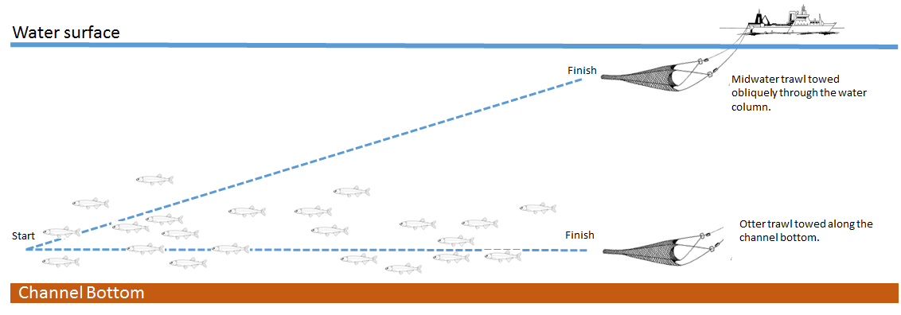

Figure 3. Schematic diagram demonstrating the sampling strategy that will be employed to test the conceptual model explaining the divergent patterns in longfin smelt catch in otter trawl and midwater trawl samples from the CDFW Bay Study at site 325. The conceptual model posits that longfin smelt are distributed near the channel bottom. This will be tested by sampling for longfin smelt at up to 4 fixed independent depth strata, and also with an oblique tow for direct comparisons to samples representative of the CDFW Bay Study.

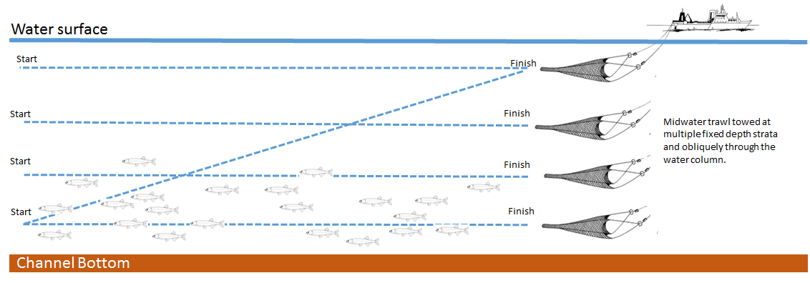

Figure 4. Map of the San Francisco Estuary shown with study sites from the CDFW Bay Study. Site 325, highlighted in red, is the location where the longfin smelt vertical distribution studies will be conducted.

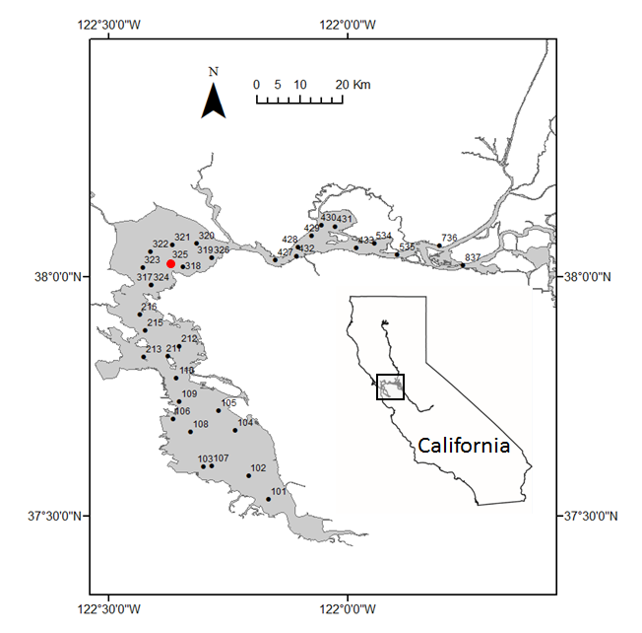

Figure 5. Catch frequency of longfin smelt in the OT and MW by station.



Figure 6. Map showing the bathymetry of San Pablo Bay and that site 325 is located in the deep, main center channel where strong tidal currents generate vertical structure in physical habitat features important for elucidating vertical distribution of longfin smelt. Hotter colors indicate greater depth.

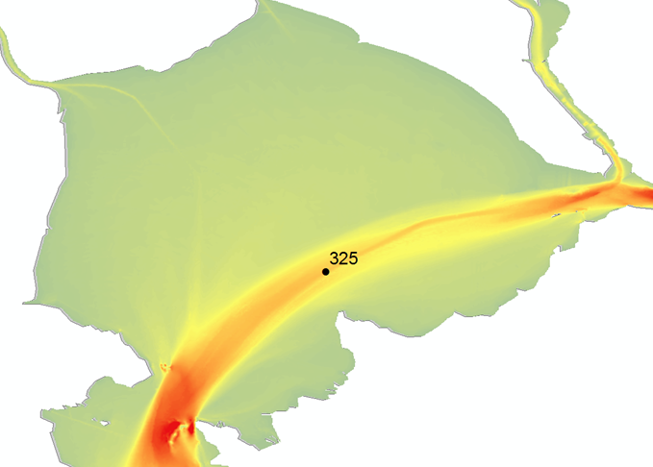

Figure 7. Frequency histograms of the count of age-0 longfin smelt collected per tow across months at CDFW Bay Study site 325, 1980-2012. Note that both the vertical and horizontal axes are truncated and do not show the full range of the data.

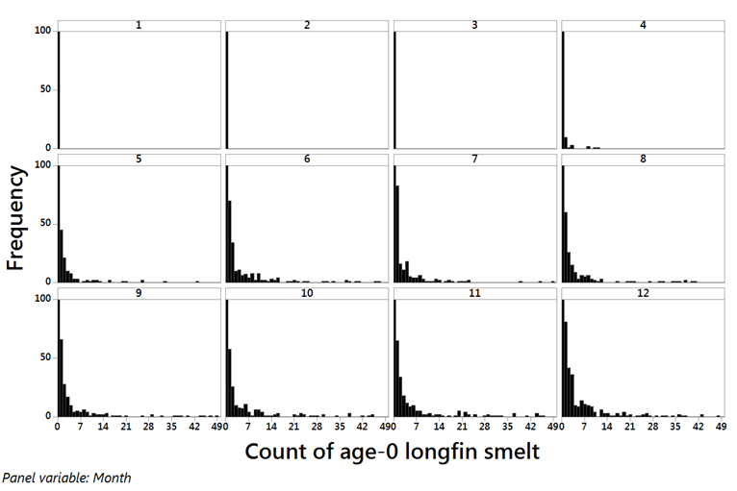

Figure 8. Graphical display of the results of a power analysis testing the null hypothesis that there is no overall treatment effect of 4 independent depth strata on age-0 longfin smelt CPUE. The horizontal dashed line is set to α = 0.05.

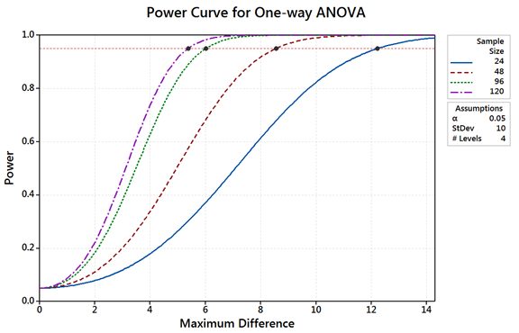

Figure 9. Boxplot representation of the number of longfin smelt collected per tow across months at CDFW Bay Study site 325, 1980-2012.

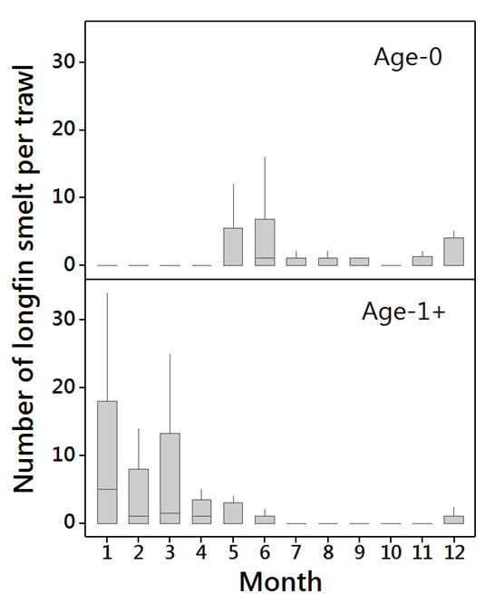

Figure 10. Boxplot representation of the number of juvenile Chinook salmon collected per tow across months at CDFW Bay Study site 325, 1980-2012.

