RECLAMATION
Managing Water in the West

Final Administrative Draft of Biological Assessment

2-Gates Fish Protection Demonstration Project
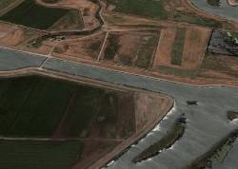

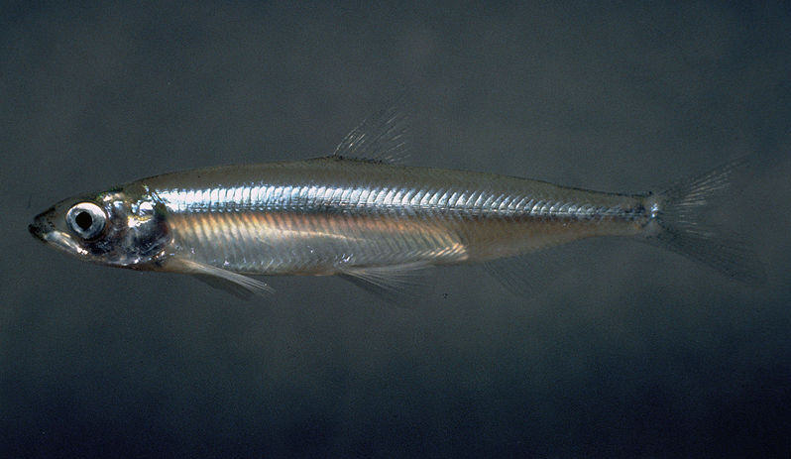

Not for Public Distribution – For Internal Review Only
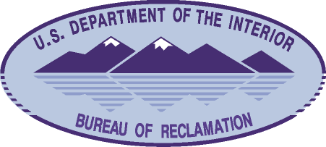

U.S. Department of the Interior
Bureau of Reclamation October 2009

Mission Statements

The mission of the Department of the Interior is to protect and provide access to our Nation’s natural and cultural heritage and honor our trust responsibilities to Indian Tribes and our commitments to island communities.

The mission of the Bureau of Reclamation is to manage, develop, and protect water and related resources in an environmentally and economically sound manner in the interest of the American public.

