

**Navigation:**







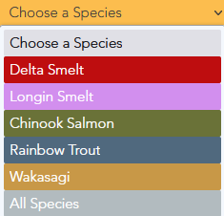





**Maps:**

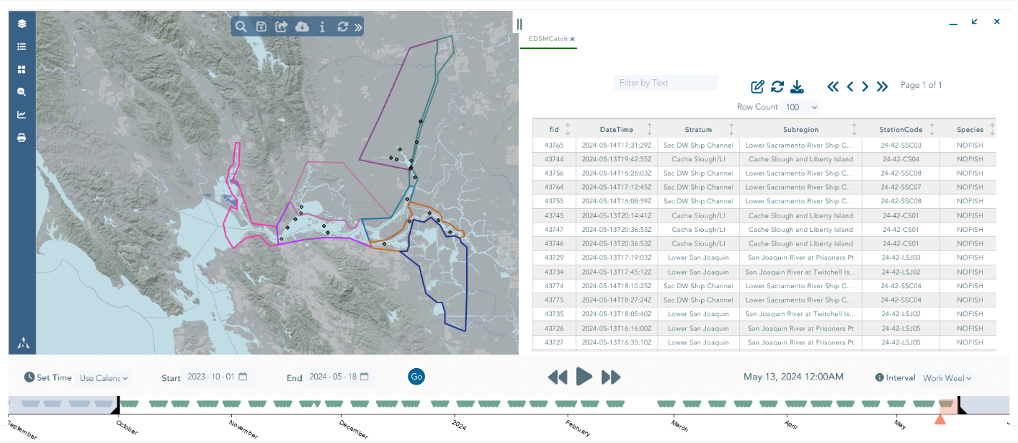

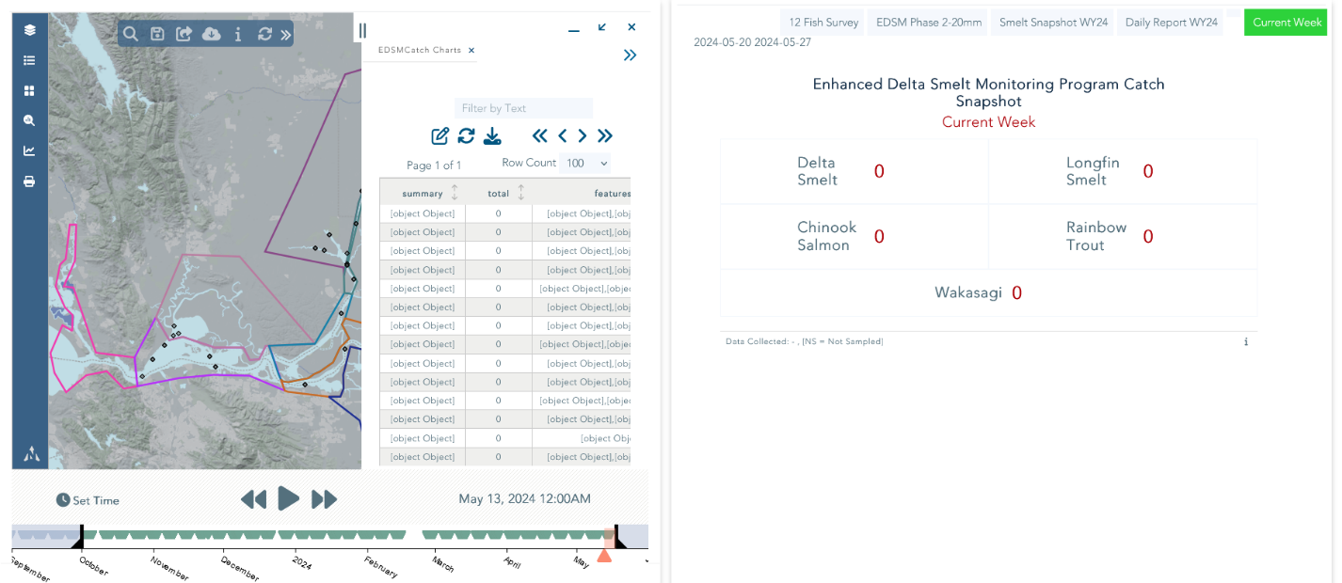

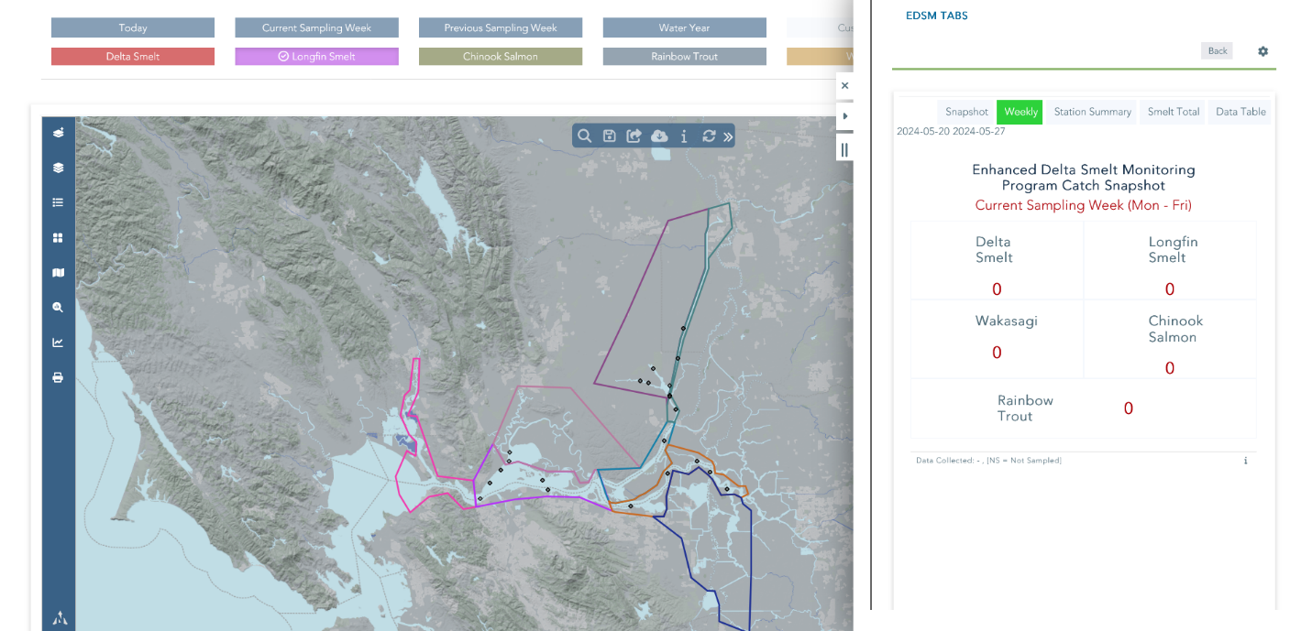

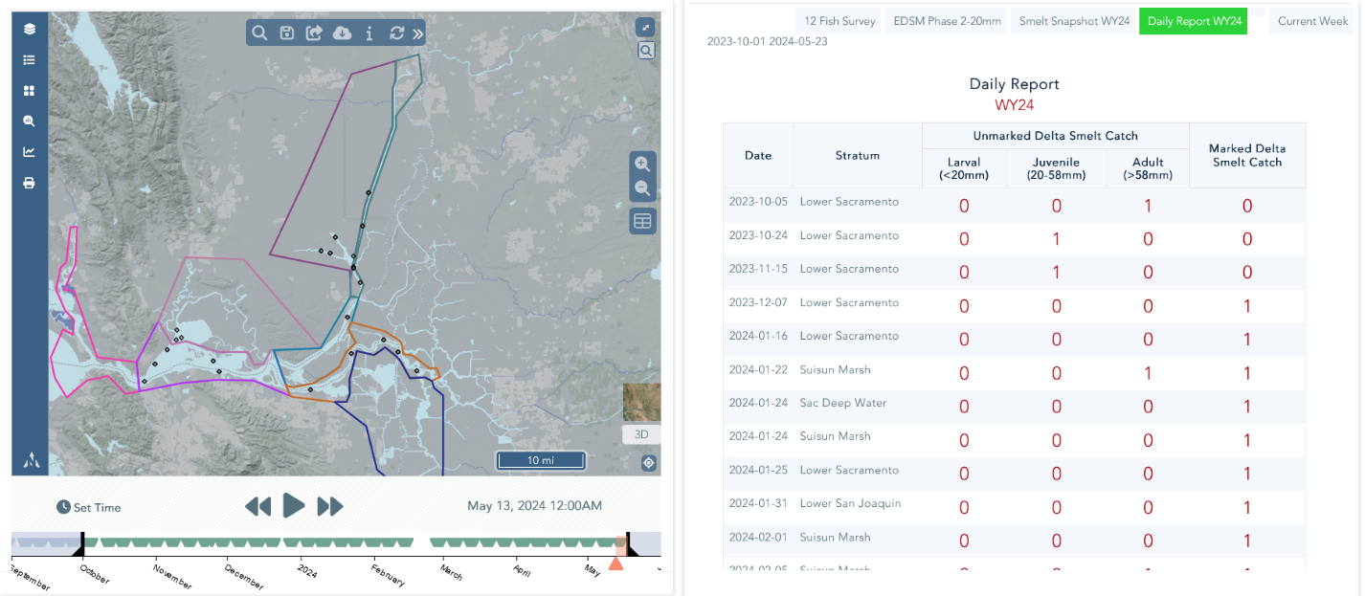

**Tables:**

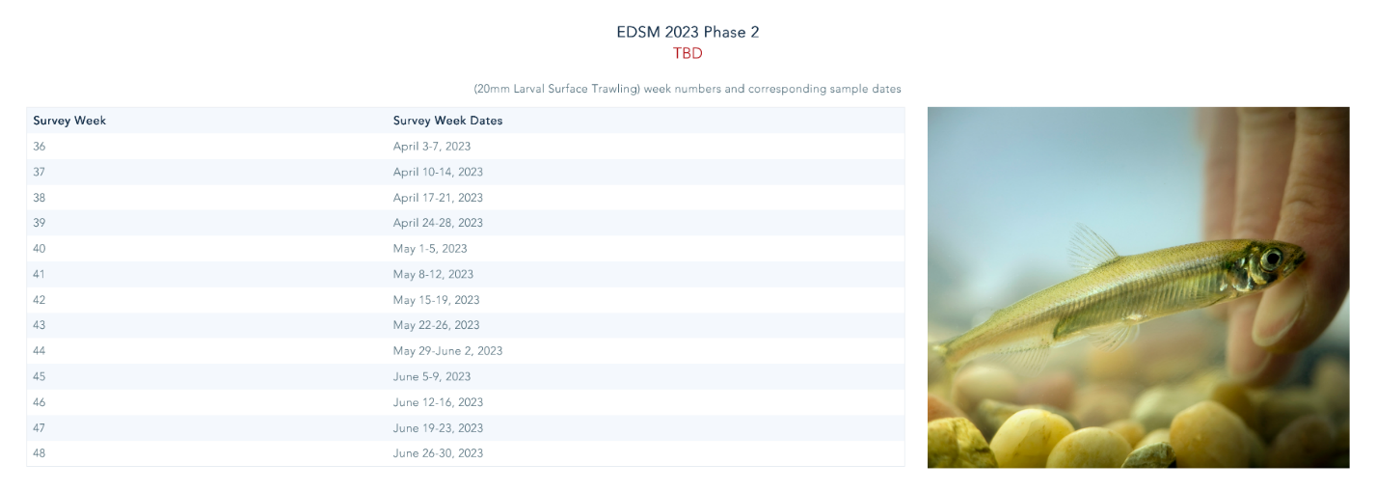

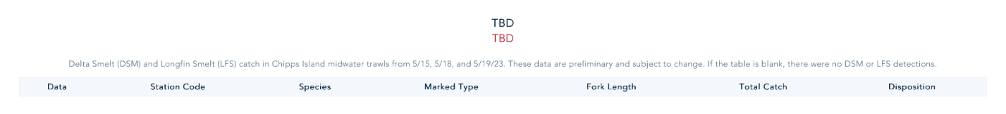

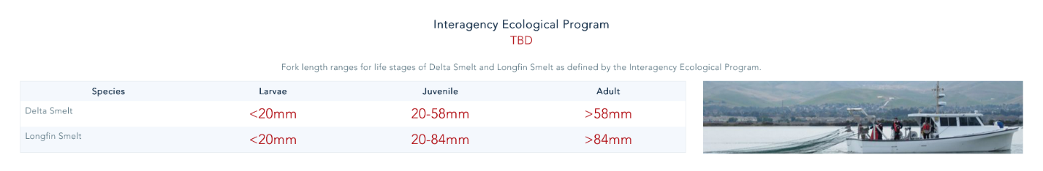

**Graph Types:**

**Data Reporting Widgets:**

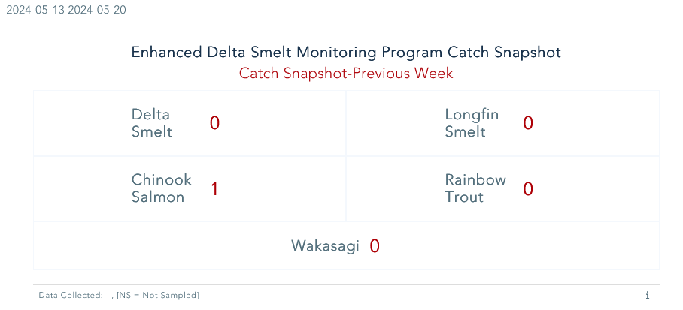

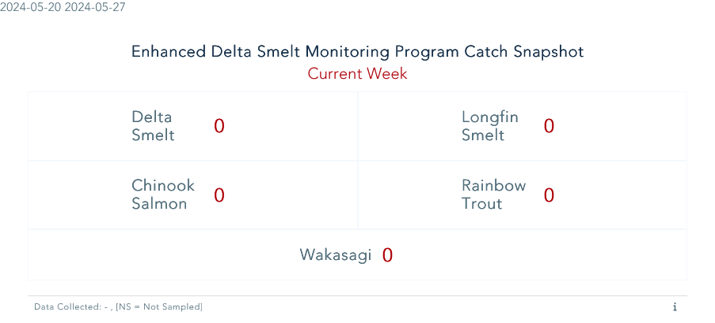

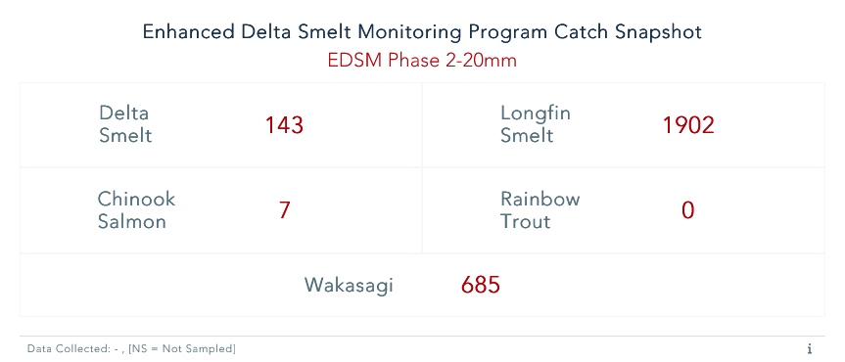

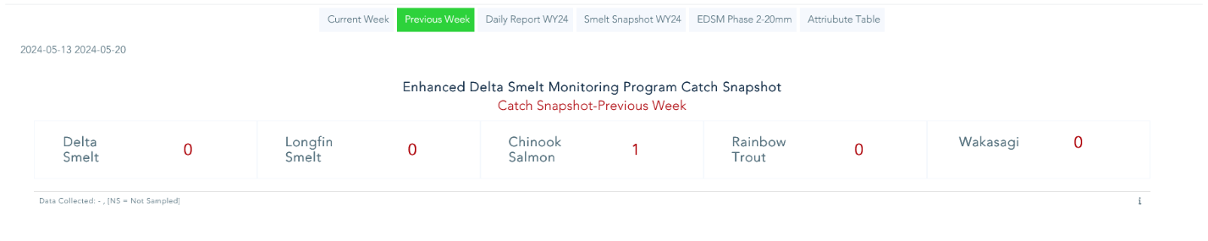







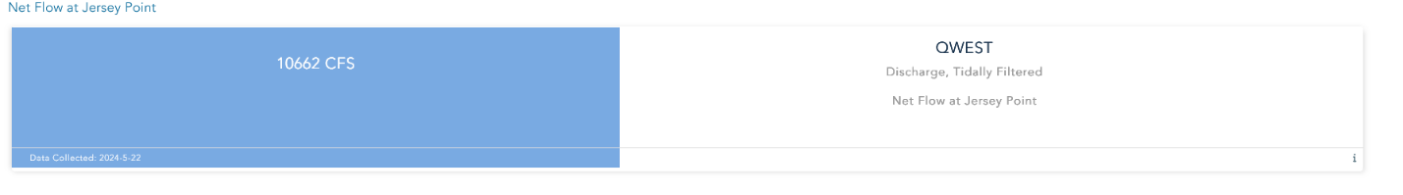

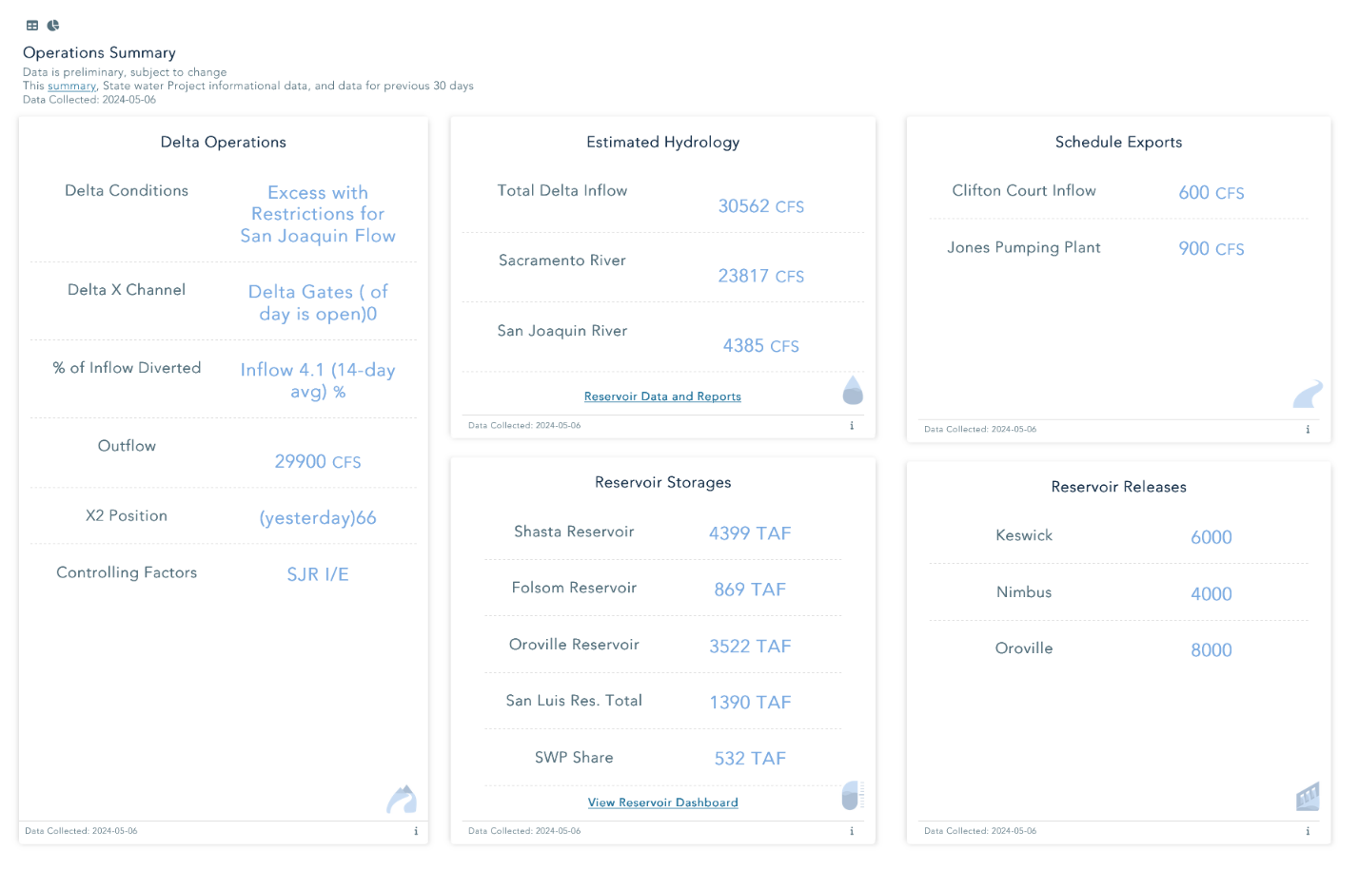

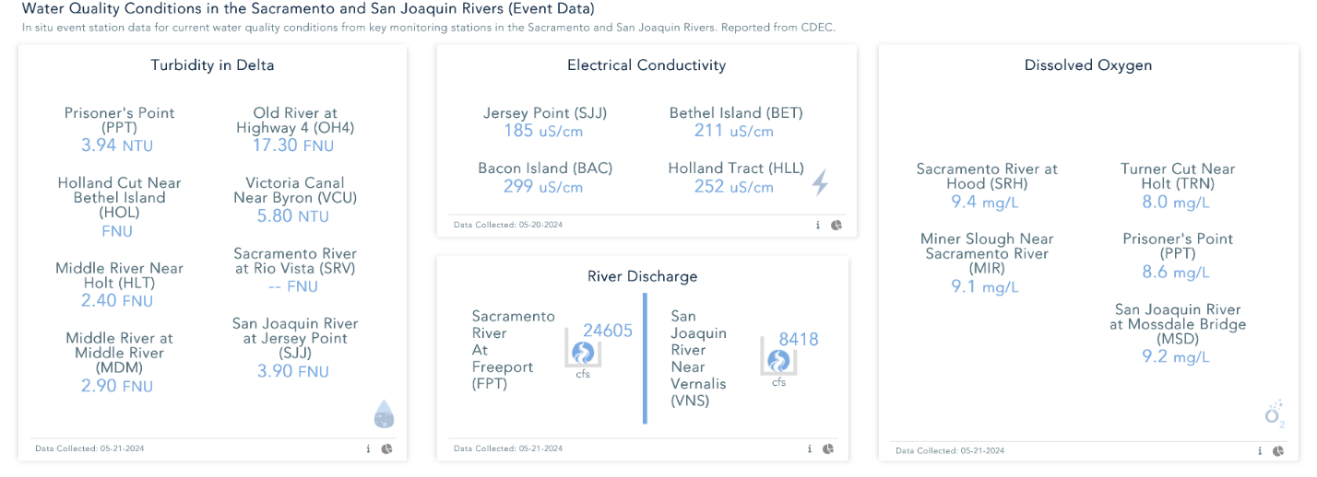

**Informational Widgets:**

