Franks Tract Pilot Project
DRAFT2

Summary Paper

March 19, 2007

Introduction
The Flooded Islands Pre-Feasibility Study Report identified several project alternatives to alter the Delta hydrodynamics in the vicinity of Franks Tract to reduce salinity intrusion into the central and south Delta during the late summer and fall months. The Franks Tract Pilot Project proposes to design, construct, and operate one of four alternative tidal gate structures and evaluate its performance over a minimum period of three years. The proposed gates will be used to regulate tidal flows in strategic channels near Franks Tract to provide a physical barrier to salt water intrusion, reduce mixing of freshwater and Bay-derived salt water within Franks Tract, and/or hydraulically isolate Franks Tract from the South Delta. The primary objectives of the Pilot Project are to:
- Confirm water quality benefits predicted by numerical models;
- Evaluate benefits and adverse impacts to ecosystem, fisheries, and recreation; and
- Modify project operations to improve benefits and minimize impacts.

The Pilot Project provides opportunities to evaluate potential water quality and ecosystem benefits, test various operational criteria, and assess potentially adverse impacts. The Pilot Project must also satisfy numerous constraints including no increase in flood stage (i.e., flood neutral), no decrease in minimum (low-flow) stage levels, no adverse impact to surrounding levees (i.e., no increase to scour potential), maximum differential head of 3 feet, and minimal impacts to navigation.
The four Pilot Project alternatives are discussed in detail below and include:
- Alternative #1: West False River;
- Alternative #2: East Levee + 2 Gates;
- Alternative #3: Cox Alternative (Holland Cut and Old River), and
- Alternative #4: Three Mile Slough.

The first three Pilot Project alternatives were evaluated in the Pre-Feasibility Study Report (EDAW, 2005). The fourth alternative, Three Mile Slough, was developed by the Department of Water Resources’ (DWR) Bay Delta Office Delta modeling group. The Three Mile Slough location is the current preferred alternative. This alternative is projected to provide the greatest water quality benefits (based on preliminary modeling results), lowest estimated construction cost, and least potential adverse impacts.

Operations and Potential Benefits
For each alternative, the gates would only be operated in the dry portions of the year, typically August through November, when freshwater outflows from the Delta are typically low and saltwater intrusion is high. To date, modeling efforts have focused on changes in hydrodynamics and water quality improvements (primarily salinity reduction), thus the potential impacts to fisheries and local ecosystem are currently being investigated.
Four operating criteria have been developed for the Pilot Project:
- Salinity Intrusion (gates closed during peak salinity intrusion);
- Gates 20% open during operating season;
- Tide Sipping (gates open during flood tide, closed during ebb tide); and
- Flood operations (gates fully open during non-operating period).

Operating criteria selected for modeling are discussed in the detailed alternative descriptions below.
The numerical model analyses use the finite element method to simulate Delta hydrodynamics and water quality using electrical conductivity (EC) was as a surrogate measure for salinity. The efficacy of each alternative is evaluated by comparing the predicted EC concentrations at various locations in the Delta to the baseline (current) conditions. These modeled locations typically reflect current water quality sampling stations and water supply diversion locations. A summary of EC modeling results for all four alternatives is presented in Table 1. Additional modeling is currently in progress to optimize operating criteria for each alternative and may result in predicted water quality benefits greater than the results presented in Table 1. Additional ecosystem benefits may also be achieved with the modified operating criteria.

Potential Adverse Impacts
Each of the four alternatives has the potential to create adverse impacts to fisheries, local ecosystem, water quality, and/or recreation. Some impacts such as navigation restrictions, possible increased predation of native fish species, and impediments to migrating fish may be common to all four alternatives, though the magnitude of these impacts varies among the alternatives.
Local ecology and water quality may be impacted by the modified circulation patterns in the vicinity of Franks Tract. Changes in channel velocities, residence time with Franks Tract, and other freshwater/salt water mixing mechanisms may hinder or promote the growth of various aquatic species including phytoplankton, invasive submerged (i.e., Egeria) and floating (i.e., hyacinth) aquatic vegetation, and algae. Potential impacts to fisheries and the local ecosystem are not well-understand and are currently being investigated.
Recreational impacts from the Pilot Project and full-scale operations are generally limited to restriction of boat traffic along channels where the tidal gate structure(s) would be constructed. Bethel and Brannon Islands are home to numerous marinas with boaters that transit the Franks Tract Recreational Area and nearby channels. The proposed tidal gate structures would limit navigation in one or more channels for certain times of the year depending on the selected gate type. Boat locks are proposed for all four alternatives, though the increased transit time through the locks are still considered an impediment to navigation. The proposed locations of the gate structures dictate the magnitude of this navigation impact (i.e., gates constructed in high traffic channels would create a greater impact to navigation than gates located in channels with less boat traffic or nearby alternate routes).

Gate Types
Several types of tidal gate systems were considered for the Pilot Project. Various gate types were evaluated and categorized as navigable or non-navigable. Navigable gates were defined as those that would permit boat passage when the gates were left in the open position for the non-operating period (typically December through July). Boat locks would be required to allow passage during the operational season (typically August through November). Navigable gates considered for the Pilot Study included wicket gates, bottom hinge gates, sliding gates, and radial segment gates.
Non-navigable gates were defined as those requiring a boat lock for passage regardless of the operating conditions. These gate types typically included piers and overhead structures that remain in the waterway year round. Non-navigable gates evaluated for the project included radial gates, hinged crest gates, vertical lift gates, roller gates, butterfly gates, flap gates, pendants, and louvers.
The bottom hinge gate developed by Obermeyer Hydro (Figure 2) is currently the preferred navigable gate alternative. This gate system uses an inflatable air bladder system to raise and lower the steel gates. The life expectancy of the rubber bladders is 50 years. Restraining straps allow the gates to accommodate several feet of differential head on either side of the barrier which makes the system well-suited for tidal flow conditions. Multiple gate modules can be installed to create flow control barriers of various lengths and allow portions of the gate structure to be raised and lowered independently or simultaneously. The modular system depicted in Figure 2 also allows for in-the-wet construction as DWR has planned for the South Delta Improvements Program permanent flow control structures.

Preliminary Construction Costs
Preliminary cost estimates are primarily a function of the control structures length (i.e., number of Obermeyer gates needed). The cost of levee rehabilitation is a significant contributor to the cost of Alternative #2 (East Levee + 2 gates). Limited access and need for improvements to roads, bridges, etc. also factor into the preliminary construction costs summarized in Table 2.

Description of Pilot Project Alternatives

Alternative #1: West False River
This alternative includes constructing a 790-feet long control gate structure on False River near the confluence with the lower San Joaquin River (Figures 1 and 3). This alternative would provide a physical barrier to salt intrusion entering Franks Tract via False River.
The West False River alternative would block flow on False River near the western junction with the San Joaquin River. Three operating criteria were modeled for this alternative: a) gates fully-closed, b) gates 20% open, and c) gates tidally operated. For this alternative, the fully-closed operation produces the greatest reduction in salinity at the State Water Project (SWP) pumping plant, though other hydraulic criteria make the tidally-operated sequence more favorable. Modeling results for this alternative indicate salinity reductions of 2% to 19% may be achievable throughout the central and south Delta (Table 1).
The currently preferred operating criteria for this alternative anticipates closing the gates approximately 12 hours per day. Base condition peak tidal flow in False River is about 50,000 cfs. With False River closed, this flow would be largely diverted to the San Joaquin River north of Bradford Island and Webb Tract. A portion of the flow would reenter the western end of Franks Tract along Fisherman’s Cut. Tidal flow in Fisherman’s Cut would increase from about 2,000 cubic feet per second (cfs) to approximately 10,000 cfs. Channel velocities would increase from about 0.5 feet per second (fps) to about 2.5 fps. The bulk of the diverted flow would reenter the northeast corner of Franks Tract along the Old River channel connecting Franks Tract to the San Joaquin River. Peak tidal flow would increase from the 13,000 cfs base condition value to approximately 40,000 cfs. South of Franks Tract, the gate closure would reduce tidal flow in Old River near Bacon Island approximately 20%. Tidal flow in Middle River near Bacon Island would remain largely unchanged, and tidal flow increases for Turner Cut are predicted, although peak velocity would remain under 1 fps.
This option poses navigation impacts to boats traversing False River between the San Joaquin River and Franks Tract. However, because of its location, this alternative may pose the least disruption to navigation. Boaters could avoid delays through the boat locks by using Fisherman’s Cut and the San Joaquin River.
Preliminary construction costs are estimated at $36 million, based on the size of the large gate structure (Table 2).

Alternative #2: East Levee + 2 Gates
This alternative includes the reconstruction approximately 8,700 feet of the east levee on Franks Tract and control gate structures on the east end of False River and Sand Mound Slough to isolate Franks Tract from Old River. The False River and Sound Mound Slough gate structures would be 400 feet and 500 feet long, respectively (Figures 1 and 4). Tidal flow would be permitted into Franks Tract from the west, but blocked on the east end. This alternative would allow salt water mixing within Franks Tract, but provide a physical barrier to reduce salt intrusion into Old River.
Two operational scenarios were modeled: a) gates fully-closed and b) gates tidally operated. For this alternative, the fully-closed operation produces the greater reduction in salinity at the SWP. Modeling results for this alternative indicate salinity reductions of -14% (i.e., increase) to 21% may be achievable throughout the central and south Delta (Table 1).
Franks Tract itself represents significant tidal prism, so less tidal flow would be diverted from False River to the San Joaquin River in order to fill Franks Tract. Still, tidal flow on Fisherman’s Cut would increase to about 8,500 cfs from 2,000 cfs, with peak tidal velocities about 1.8 fps. With gates closed, current velocities in the eastern half of Franks Tract are small. Opening the operable gate on the east end of False River would restore some current velocities in the northern portion of Franks Tract. The tidal flow to the southern Delta normally conveyed by Franks Tract would be transferred to the Old River channel connecting the northeast corner of Franks Tract to the San Joaquin River. Peak velocities in this channel would more than double to about 2 fps when the gates are closed. Tidal flows in Old River and Holland Cut immediately south of Franks Tract would be reduced about 25%. Corresponding tidal flow increases are predicted in Middle River to the east. Further south, flows in Old River and Middle River near Bacon Island would approximate the base condition.
Depending on gate operation, this alternative may increase residence time, promote Egeria production, and adversely affect Chinook salmon, Delta smelt, and native fish species during the late fall and early winter. This alternative poses the greatest navigation impacts to boats traversing False River between the San Joaquin River and Franks Tract as boaters would experience delays passing through the boat locks.
Preliminary construction costs are estimated at $65 million with approximately half the cost attributed to the levee construction (Table 2).

Alternative #3: Cox Alternative (Holland Cut and Old River)
This alternative includes a 600-foot long control gate structure on Old River, 550-foot long gate across Holland Cut (Figures 1 and 5), and a temporary bridge across Holland Cut. This alternative would partially isolate Franks Tract from the central Delta during flood tides.
Two operational scenarios were modeled: a) gates fully-closed and b) gates tidally operated. For this alternative, the fully-closed operation produces the greater reduction in salinity at the SWP. Modeling results for this alternative indicate salinity reductions of -22% (i.e., increase) to 20% may be achievable throughout the central and south Delta (Table 1).
This alternative largely maintains tidal flow through Franks Tract. However, flow which in the base condition exited out the southeast corner of Franks Tract to the Holland Cut and Old River channels would be redirected out the northeast corner of Franks Tract to the San Joaquin River. Peak tidal flow in this channel would approximately double. Flow formerly conveyed via Old River would be transferred to Middle River. Flow in the Middle River channel north of Mildred Island to the San Joaquin River would nearly double when the gates are closed. The excess flow from Middle River would travel back to Old River south of the barriers mainly through Connection Slough, north of Bacon Island. Peak flows through the Connection Slough channel would nearly double the peak base condition flows. The two east-west channels, north and south of Woodward Island transfer additional flow from the Middle River to Old River. Flow in Victoria Canal would remain relatively unchanged. With the Cox Alternative gates closed, peak flows in Turner Cut would be more double the base condition values. Of the four alternatives, the Cox Alternative has the greatest modeled effect on south Delta stage. When the export pumps are in operation, average stage for Old River near the Contra Costa Water District (CCWD) intake is lower about 0.15 feet.
This alternative poses navigation impacts to boats traversing the heavily-traveled Old River and Holland Cut channels near the lower San Joaquin River and Franks Tract.
Preliminary construction costs for this alternative are estimated at $49 million (Table 2).

Alternative #4: Three Mile Slough
This alternative includes construction of a 600-feet long control gate structure on Three Mile Slough between the Sacramento and San Joaquin Rivers north of Franks Tract (Figures 1 and 6). Under this alternative, the gates would be closed during portions of the ebb tide to force more central Delta freshwater down the lower San Joaquin River channel rather than the allowing it to enter the Sacramento River via Three Mile Slough. Preliminary modeling results for this alternative indicate salinity reductions of 19% to 31% may be achievable throughout the central and south Delta (Table 1).
The Three Mile Slough Gate alternative should affect the Delta hydrodynamics the least of the four alternatives. Three Mile Slough connects the two major tidal flow channels in the western Delta, the Sacramento River and the San Joaquin River. Peak tidal flow for the Sacramento River near Emmaton and the San Joaquin River near Jersey Point are over 120,000 cfs. Blocking ebb flow at Three Miles Slough for a few hours each day has only minor effects on the tidal flows and velocities in the Delta. The Three Mile Slough alternative is designed to divert a few thousand cfs in daily averaged flow from the Sacramento River to the San Joaquin River.
This option poses recreational impacts to boats traversing Three Mile Slough between the Sacramento and San Joaquin Rivers. There is also potential for this facility to be operated during other times of the year as a fish control barrier similar to the temporary rock barrier and proposed permanent barrier at the Head of Old River. This is the most-recently developed alternative. Thus, potential benefits, operating criteria, and adverse impacts are currently being evaluated.
Preliminary construction costs are estimated at $23 million (Table 2).
Table 1. Comparison of EC Reduction – September 2002 (Dry Year)
Alternative | SWP | CVP | CCWD  (Old River) | CCWD  (Rock Slough) | CCWD (Victoria Canal)
West False River | 13.3% | 10.2% | 16.9% | 18.9% | 2.0%
East Levee + 2 Gates | 9.1% | 5.4% | 16.0% | 21.2 | -13.6%
Cox Alternative (Holland Cut and Old River) | 6.8% | 2.4% | 15.7% | 19.7% | -22.4%
Three Mile Slough | 27.5% | 22.5% | 30.0% | 31.1% | 18.6%

Table 2. Alternative Features and Cost Summary
Alternative | Length of Control Structure | Length of Levee Repair | Est. Construction Cost ($M)
West False River | 790 ft | –– | $36M
East Levee + 2 Gates | Sand Mound Sl: 500 ft  False River: 400 ft | 8,682 ft | $65M
Cox Alternative (Holland Cut and Old River) | Holland Cut: 550 ft  Old River: 600 ft | –– | $49M
Three Mile Slough | 600 ft | –– | $23M

Figure 1. Location Map

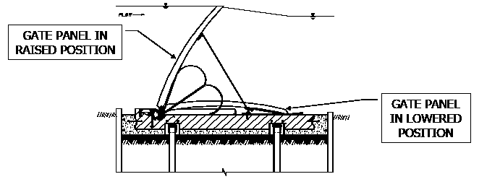

Figure 2. Obermeyer Gate Schematic

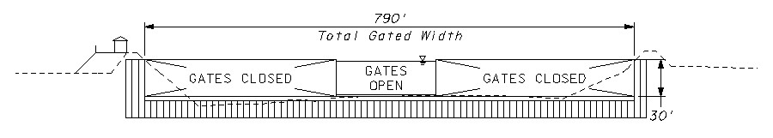

Figure 3. West False River Gate Schematic
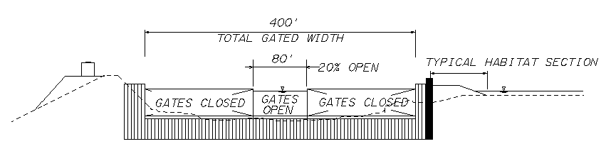
a) False River
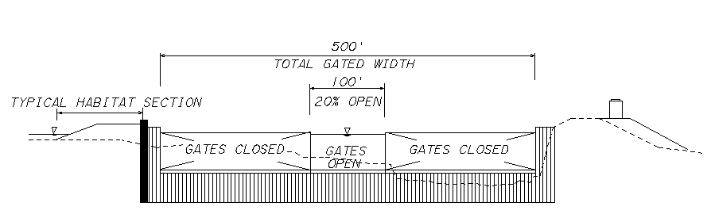
b) Sand Mound Slough

Figure 4. East Levee + 2 Gates Schematic

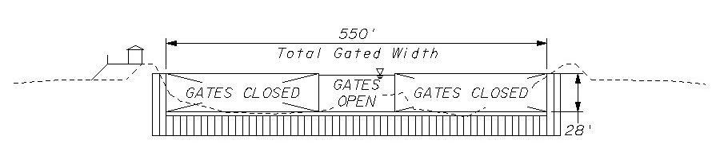
a) Holland Cut
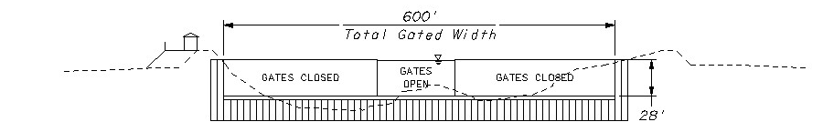
b) Old River

Figure 5. Cox Alternative (Holland Cut and Old River) Gate Schematic

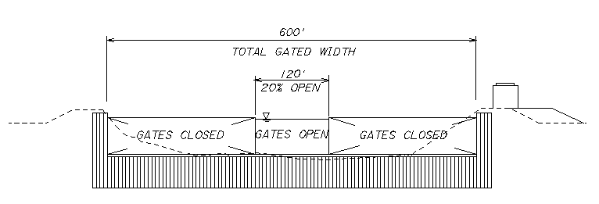

Figure 6. Three Mile Slough Gate Schematic

